# Describe AI workloads and considerations

## Identify features of common AI workloads

### Question 1 – Predict/Forecast

**Question 1: Which scenario is an example of the forecasting AI workload?**

Choose the correct answer

Detecting pedestrians in the real-time video stream of an autonomous vehicle

Detecting the language in the provided text document

Providing answers to a customer in a chatbot dialog

Predicting whether an airplane arrives early, on-time, or late

**Explanation**

Predicting whether an airplane arrives early, on-time, or late is an example of the forecasting AI workload. In a forecasting AI workload, a machine learning model analyzes patterns in the provided data, such as time of departure, weather conditions, air traffic volumes, etc., and associates historical patterns to predict or forecast the possible outcome.  
  
Detecting the language in the provided text document is an example of the natural language processing AI workload. In this type of AI workload, a machine learning model evaluates the text input and returns the language identifiers with a score between 0 and 1 to reflect its confidence in detecting the relevant language.  
  
Providing answers to a customer in a chatbot dialog is an example of the conversational AI workload. In this type of AI workload, a chatbot backend processes input from the customer and sends back answers based on a knowledge base.  
  
Detecting pedestrians in the real-time video stream of an autonomous vehicle is an example of the computer vision AI workload. In this type of AI workload, a machine learning model trained to recognize pedestrians can identify them in the real-time video stream and return the bounding box coordinates for each of them.  
  
**References**  
  
[Overview of the prediction model](https://docs.microsoft.com/en-us/ai-builder/prediction-overview)  
  
[What is the Text Analytics API?](https://docs.microsoft.com/en-us/azure/cognitive-services/text-analytics/overview)  
  
[How bots work](https://docs.microsoft.com/en-us/azure/bot-service/bot-builder-basics?view=azure-bot-service-4.0&tabs=csharp)  
  
[What is Computer Vision?](https://docs.microsoft.com/en-us/azure/cognitive-services/computer-vision/home)

### Question 2: NLP

Which scenario is an example of the natural language processing AI workload?

Choose the correct answer

Using graphics and menus to improve the user experience with an ecommerce website’s chatbot

Predicting whether a customer would buy certain items based on their purchase history

Analyzing customer feedback on an ecommerce website to determine whether it is positive or negative

Detecting whether people in online-posted images are celebrities

**Explanation**

Analyzing customer feedback on an ecommerce website to determine whether it is positive or negative is an example of the natural language processing AI workload. In this type of AI workload, a machine learning model evaluates the content of the provided feedback and returns sentiment labels and confidence scores for each sentence and overall content.  
  
Predicting whether a customer would buy certain items based on their purchase history is an example of the prediction / forecasting AI workload. In this type of AI workload, a machine learning model analyzes patterns in the previous purchase history to predict the likelihood of a customer buying certain items.  
  
Using graphics and menus to improve the user experience with an ecommerce website’s chatbot is an example of the conversational AI workload. In this type of AI workload, a chatbot’s functionality is extended beyond the default text interface with more interactive components such as graphics, menus, and buttons to improve the user experience.  
  
Detecting whether people in online-posted images are celebrities is an example of the computer vision AI workload. In this type of AI workload, a machine learning model trained on the domain-specific content, in this case celebrities, can determine whether they are among the people detected in the online-posted images.  
  
**References**  
  
[How to: Detect sentiment using the Text Analytics API](https://docs.microsoft.com/en-us/azure/cognitive-services/text-analytics/how-tos/text-analytics-how-to-sentiment-analysis?tabs=version-3)  
  
[Overview of the prediction model](https://docs.microsoft.com/en-us/ai-builder/prediction-overview)  
  
[How bots work](https://docs.microsoft.com/en-us/azure/bot-service/bot-builder-basics?view=azure-bot-service-4.0&tabs=csharp)  
  
[What is Computer Vision?](https://docs.microsoft.com/en-us/azure/cognitive-services/computer-vision/home)

### Question 3: Conversational AI workload

Which scenario is an example of the conversational AI workload?

Choose the correct answer

Generating automatic descriptions for published images

Predicting whether customers should be targeted by a new marketing campaign

Using a chatbot to answer common customer questions

Extracting key phrases from student essays

**Explanation**

Using a chatbot to answer common customer questions is an example of the conversational AI workload. In this type of AI workload, a chatbot can be integrated with other cognitive services and knowledge bases to find relevant answers to customer questions.  
  
Predicting whether customers should be targeted by the new marketing campaign is an example of the forecasting AI workload. In this type of AI workload, a machine learning model analyzes patterns in historical data, such as previous marketing engagements with the customers and their responses. This is done to predict whether they should be targeted by the new campaign.  
  
Extracting key phrases from student essays is an example of the natural language processing AI workload. In this type of AI workload, a machine learning model evaluates provided essays, discards non-essential words, and returns single terms or phrases that appear to be the subject or object of the relevant sentences.  
  
Generating automatic descriptions for published images is an example of the computer vision AI workload. In this type of AI workload, a machine learning model analyzes published images and generates human-readable sentences describing the image content. Sentences are ordered by the confidence score that the model assigns to each sentence as per the visual features detected.  
  
**References**  
  
[Use QnA Maker to answer questions](https://docs.microsoft.com/en-us/azure/bot-service/bot-builder-howto-qna?view=azure-bot-service-4.0&tabs=cs)  
  
[Overview of the prediction model](https://docs.microsoft.com/en-us/ai-builder/prediction-overview)  
  
[Example: How to extract key phrases using Text Analytics](https://docs.microsoft.com/en-us/azure/cognitive-services/text-analytics/how-tos/text-analytics-how-to-keyword-extraction)  
  
[What is Computer Vision?](https://docs.microsoft.com/en-us/azure/cognitive-services/computer-vision/home)

### Question 4: Anomaly Detection

To complete the sentence, select the appropriate option from the drop-down menu.

Choose the correct options

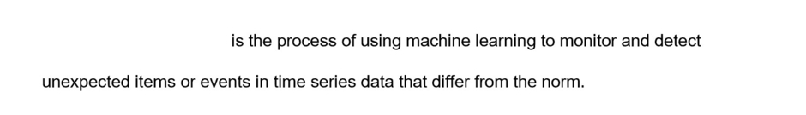



Anomaly Detection

**Explanation**

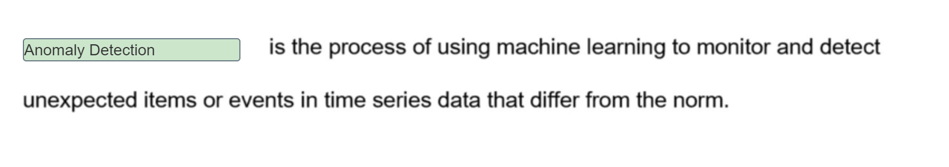

Anomaly Detection is the process of using machine learning to find unexpected values or events. With the use of machine learning, the best-fitting model can analyze your time series data to determine the boundaries of expected values and detect abnormalities that differ from the expected norm.  
  
Prediction analyzes the patterns in provided data and associates historical patterns to predict possible outcomes. Prediction is not designed to detect abnormalities.  
  
Knowledge Mining (KM) can use the power of AI to help you deeply understand and explore vast amounts of information to get better insight and uncover hidden relationship and patterns in your data. KM is not designed to detect unexpected abnormalities.  
  
**References**  
  
[What is the Anomaly Detector API?](https://docs.microsoft.com/en-us/azure/cognitive-services/anomaly-detector/overview)  
  
[Overview of the prediction model](https://docs.microsoft.com/en-us/ai-builder/prediction-overview)  
  
[Knowledge mining](https://azure.microsoft.com/en-gb/solutions/knowledge-mining/)

### Question 5: Computer vision

For each of the following statements, select Yes if the statement is true. Otherwise, select No.

|  |  |  |
| --- | --- | --- |
| **Statement** | **Yes** | **No** |
| Computer Vision can be used to analyze static images. |  |  |
| Computer Vision can be used to analyze live video streams. |  |  |
| Computer Vision can be used to analyze live audio streams. |  |  |

**Explanation**

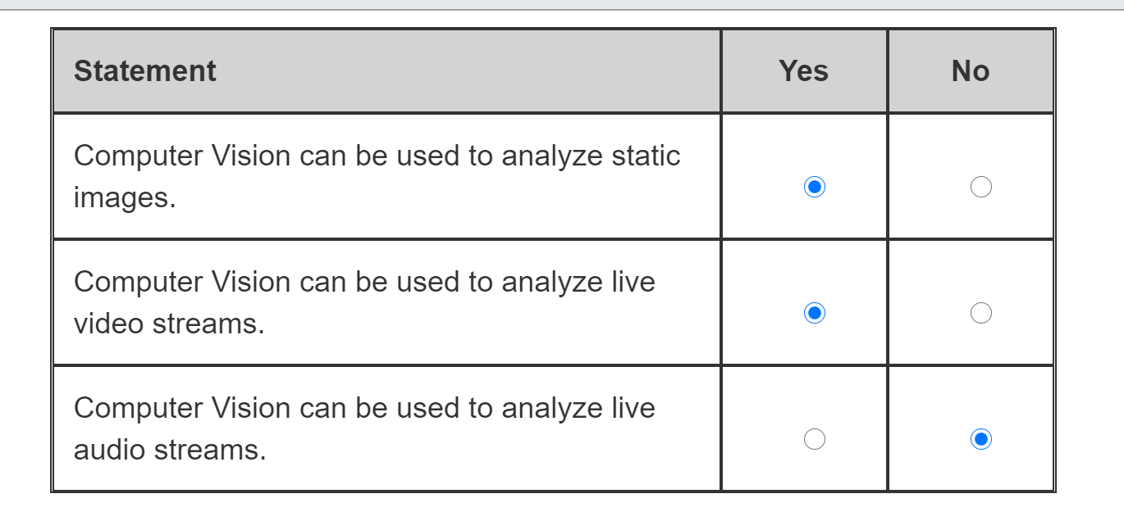

Computer Vision can be used to analyze static images. Its model is trained on sets of similar images, so that it can process the new images and return information for the required visual features, such as recognized objects, living things, scenery, or actions.  
  
Computer Vision can be also used to analyze live video streams. Because the machine learning model is originally trained on the image sets, processing the live video stream would require acquiring the individual frames first. AI processing results can be then be overlaid on top of the video source in a near real-time mode.  
  
Computer Vision is intended to work with visual features, so it cannot be used to analyze live audio streams. To process audio data, you should instead use one of the AI speech processing services or models from within the natural language processing workload, such as Speech-to-Text or Speech Translation.  
  
**References**  
  
[What is Computer Vision?](https://docs.microsoft.com/en-us/azure/cognitive-services/computer-vision/home)  
  
[Analyze videos in near real time](https://docs.microsoft.com/en-us/azure/cognitive-services/computer-vision/vision-api-how-to-topics/howtoanalyzevideo_vision)  
  
[What is the Speech service?](https://docs.microsoft.com/en-gb/azure/cognitive-services/speech-service/overview)

### Question 6: Anomaly Detection

For each of the following statements about the anomaly detector workload, select Yes if the statement is true. Otherwise, select No.

|  |  |  |
| --- | --- | --- |
| **Statement** | **Yes** | **No** |
| Anomalies can be detected by AI as they occur in real time. |  |  |
| Anomalies can be detected by AI throughout a historical dataset. |  |  |
| Anomaly detection boundaries that are automatically created by AI are immutable. |  |  |

**Explanation**

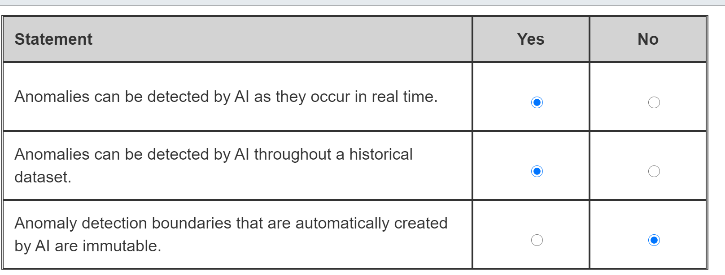

Anomalies can be detected by AI as they occur in real time. The machine learning model can derive the possible boundaries of the norm from previously seen data points in the streamed data and then determine whether the latest data point in the time series is an anomaly or not.  
  
Anomalies can also be detected by AI throughout a historical dataset. A model can be trained on the entire dataset with the data about past events, and each data point would then be analyzed to detect any anomalies over a given time range.  
  
Anomaly detection boundaries that are automatically created by AI are not immutable. AI automatically generates anomaly detection boundaries for the data points seen in the streamed or batch data. However, you still can manually adjust those boundaries to make your model more or less sensitive to the data anomalies as required.  
  
**References**  
  
[What is the Anomaly Detector API?](https://docs.microsoft.com/en-us/azure/cognitive-services/anomaly-detector/overview)  
  
[How to: Use the Anomaly Detector API on your time series data](https://docs.microsoft.com/en-us/azure/cognitive-services/anomaly-detector/how-to/identify-anomalies)

### Question 7: Prediction/Forecast

For which of these scenarios should you use an AI-based prediction solution?

Choose the correct answer

Determining the likely repair costs for an accident involving a vehicle

Detecting abnormal events in a vehicle's engine

Detecting the speed limit using roadside signage

Determining the distance to the vehicle in front

**Explanation**

Determining the likely repair costs for an accident involving a vehicle is an example of the prediction workload. In a prediction AI workload, a machine learning model finds patterns in the provided information, such as the amount of damage, the location of the damage, and the parts damaged. This is compared with historical data to predict the amount of time required to repair the damage and consequently, the cost of the repair.  
  
Detecting abnormal events in a vehicle's engine is an example of Anomaly Detection workload. Anomaly detection detects unusual patterns or events in a stream of data.  
  
Detecting the speed limit using roadside signage is an example of the Computer Vision workload. Computer vision can take images or video streams and extract text from, for example, signs on the roadside.  
  
Determining the distance to the vehicle in front is another example of the Computer Vision workload. Computer vision can also be used to detect objects from 2D images and video streams. The distance to these objects can then be calculated.  
  
**References**  
  
[Artificial intelligence (AI)](https://docs.microsoft.com/azure/architecture/data-guide/big-data/ai-overview)  
  
[What is the Anomaly Detector API?](https://docs.microsoft.com/azure/cognitive-services/anomaly-detector/overview)  
  
[What is Computer Vision?](https://docs.microsoft.com/azure/cognitive-services/computer-vision/home)  
  
[To Go the Distance, We Built Systems That Could Better Perceive It](https://blogs.nvidia.com/blog/2019/06/19/drive-labs-distance-to-object-detection/)

### Question 8: Anomaly Detection

For each of the following statements about anomaly detection, select Yes if the statement is true. Otherwise, select No.

|  |  |  |
| --- | --- | --- |
| **Statement** | **Yes** | **No** |
| Anomaly detection enables pre-emptive action to be taken before a problem occurs. |  |  |
| Anomaly detection predicts when problems will occur. |  |  |
| Anomaly detection analyzes data over time. |  |  |

**Explanation**

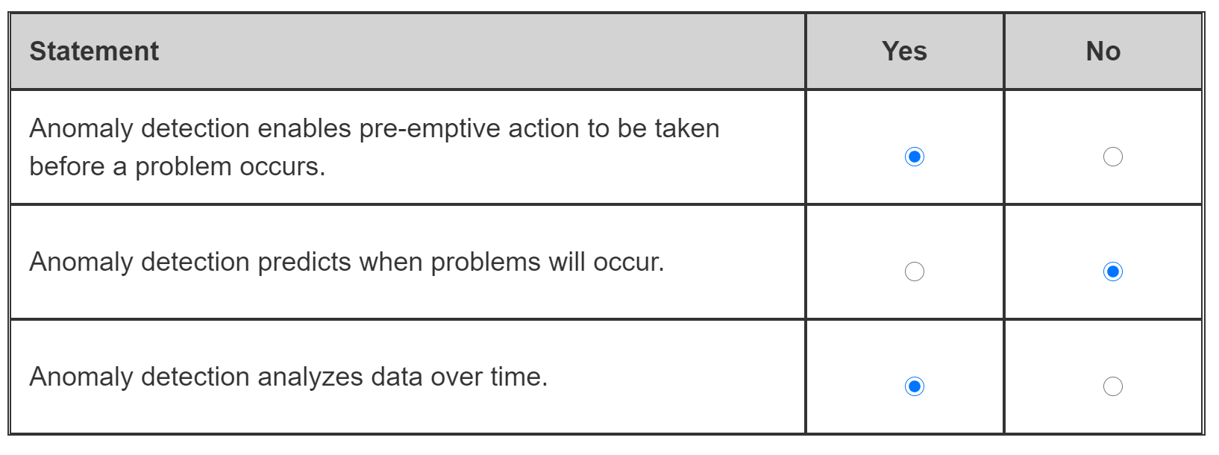

Anomaly detection detects unusual patterns or events, enabling pre-emptive action to be taken before a problem occurs. Anomaly detection monitors streams of data from devices and systems, and it uses AI algorithms to identify unusual events, patterns, or changes to trends that could indicate a problem or future failure. By flagging these issues, action can be taken to resolve the potential problem before it adversely affects the operation.  
  
Anomaly detection does not predict when a problem will occur. Anomaly detection uses data to identify potential issues that should be investigated, but does not predict if or when the issue will cause a problem.  
  
Anomaly detection analyzes data over time and identifies unusual changes by applying a set of algorithms to the time series data.  
  
**References**  
  
[Anomaly detector](https://azure.microsoft.com/services/cognitive-services/anomaly-detector/)  
  
[Introducing Azure Anomaly Detector API](https://techcommunity.microsoft.com/t5/ai-customer-engineering-team/introducing-azure-anomaly-detector-api/ba-p/490162)  
  
[What is the Anomaly Detector API?](https://docs.microsoft.com/azure/cognitive-services/anomaly-detector/overview)  
  
[What is Azure Machine Learning?](https://docs.microsoft.com/azure/machine-learning/overview-what-is-azure-ml)

### Question 9: Common

Match the AI workload to the scenario. To answer, drag the appropriate workload to each scenario. A workload may be used once, more than once, or not at all.

Drag and drop the answers





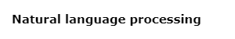











**Explanation**

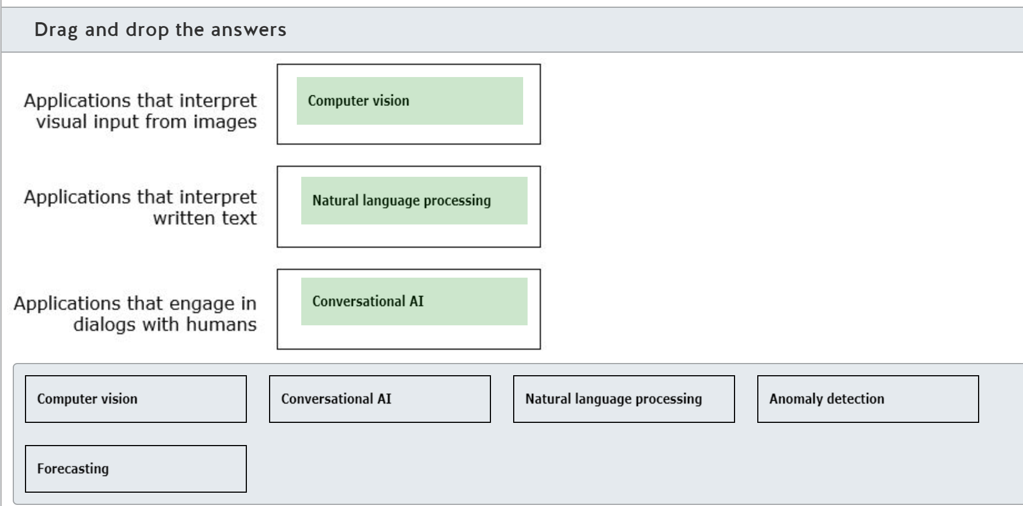

Computer vision can interpret the contents of the image to classify the image, detect objects in the image, and analyze and describe the image.  
  
Natural language processing can interpret written text. Natural language processing can analyze the text to determine the language used and the sentiment expressed, extract key phrases, and identify key entities and actions.  
  
Conversational AI is used to create applications in which AI agents engage with humans in conversations (dialogs). Humans commonly experience conversational AI through website chat bots.  
  
Anomaly detection detects unusual patterns or events in a stream of data.  
  
Forecasting uses a machine learning model that contains historical data to predict or forecast an outcome based on the data input into the model.  
  
**References**  
  
[Understand computer vision](https://docs.microsoft.com/learn/modules/get-started-ai-fundamentals/4-understand-computer-vision)  
  
[Understand natural language processing](https://docs.microsoft.com/learn/modules/get-started-ai-fundamentals/5-understand-natural-language-process)  
  
[Understand conversational AI](https://docs.microsoft.com/learn/modules/get-started-ai-fundamentals/6-understand-conversational-ai)  
  
[Understand anomaly detection](https://docs.microsoft.com/learn/modules/get-started-ai-fundamentals/3-understand-anomaly-detection)  
  
[Understand machine learning](https://docs.microsoft.com/learn/modules/get-started-ai-fundamentals/2-understand-machine-learn)

### Question 10: Computer Vision

For which scenario should you use Computer Vision?

Choose the correct answer

Finding relevant information to answer a specific customer question

Translating commands into actions

Detecting abnormalities in health scans

Discovering financial system fraud

**Explanation**

Computer Vision interprets and classifies images. The Custom Vision service can be used to train a model with images of scans, some of which have abnormalities and some of which do not. Computer Vision can then classify new images with a score between 0 and 1 according to the probability of having abnormalities, where 1 indicates the highest probability.  
  
You cannot discover financial system fraud with Computer Vision. Financial fraud can be discovered by analyzing data and looking for patterns that might indicate fraud. You would use Anomaly detection to discover financial system fraud.  
  
You cannot translate commands into actions with Computer Vision. Translating commands into actions is performed using natural language processing that extracts key phrases, intents, and actions from written and spoken text.  
  
You cannot find relevant information to answer a specific customer question with Computer Vision. Finding relevant information to answer a specific customer question is performed by a combination of conversational AI and natural language processing.  
  
**References**  
  
[What is Computer Vision?](https://docs.microsoft.com/azure/cognitive-services/computer-vision/home)  
  
[Understand computer vision](https://docs.microsoft.com/learn/modules/get-started-ai-fundamentals/4-understand-computer-vision)  
  
[Understand anomaly detection](https://docs.microsoft.com/learn/modules/get-started-ai-fundamentals/3-understand-anomaly-detection)  
  
[Understand natural language processing](https://docs.microsoft.com/learn/modules/get-started-ai-fundamentals/5-understand-natural-language-process)  
  
[Understand conversational AI](https://docs.microsoft.com/learn/modules/get-started-ai-fundamentals/6-understand-conversational-ai)

### Question 11: Knowledge mining

To complete the following sentence, select the appropriate option from the drop-down menu.

Choose the correct options

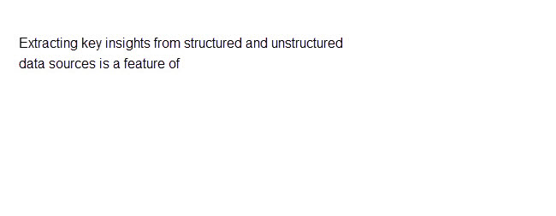



Knowledge mining

**Explanation**

Knowledge Mining uses a combination of AI services to extract meaning and relationships from large amounts of information. This information can be held in structured and unstructured data sources, documents, and databases. Knowledge Mining uncovers hidden insights in your data.  
  
Anomaly detection detects unusual patterns or events in a stream of data. Anomaly detection does not extract insights from the data but instead alerts when something out of the ordinary occurs.  
  
Conversational AI is used to create applications in which AI agents take part in conversations with humans. Humans commonly experience conversational AI through chat bots on websites and other systems.  
  
The prediction model uses a machine learning model that contains historical data to predict or forecast an outcome based on the data that is input into the model. The prediction model does not discover insights from structured and unstructured data.  
  
**References**  
  
[What is knowledge mining?](https://azure.microsoft.com/solutions/knowledge-mining/)  
  
[Implement knowledge mining with Azure Cognitive Search](https://docs.microsoft.com/learn/paths/implement-knowledge-mining-azure-cognitive-search/)  
  
[Understand anomaly detection](https://docs.microsoft.com/learn/modules/get-started-ai-fundamentals/3-understand-anomaly-detection)  
  
[Understand conversational AI](https://docs.microsoft.com/learn/modules/get-started-ai-fundamentals/6-understand-conversational-ai)  
  
[Overview of the prediction model](https://docs.microsoft.com/ai-builder/prediction-overview)

### Question 12: Conversational AI

For which two of these scenarios should you use Conversational AI? Each correct answer presents a complete solution.

Choose the correct answers

Translating speech from one language to another.

Making a travel reservation.

Detecting a change in hospital infection rates.

Detecting spam in emails.

Answering frequently asked questions.

**Explanation**

AI agents (bots) engage in conversations (dialogs) with human users. Bots use natural language processing (NLP) to make sense of human input and identify the actions a human wants to perform. It also identifies the object that the action is to be performed on. Bots can also prompt the human for the information required to complete a transaction. A common use for bots is to make travel reservations.  
  
Another use for conversational AI is responding to human questions with answers from a knowledge base of questions. Conversational AI, with NLP, can find the most appropriate answers from question and answer pairs, and provide the answer back to the human.  
  
Conversational AI cannot detect a change in hospital infection rates. This is a feature of anomaly detection that detects unusual patterns from time-series data.  
  
Conversational AI cannot detect spam in emails. This is a feature of NLP that can analyze the text in an email and determine if the email contains a spam message.  
  
Conversational AI cannot translate speech from one language to another. This is a feature of NLP, in particular, the speech services. Although conversational AI has some natural language processing capabilities, these are restricted to extracting the key words from human input.  
  
**References**  
  
[Understand conversational AI](https://docs.microsoft.com/learn/modules/get-started-ai-fundamentals/6-understand-conversational-ai)  
  
[Understand anomaly detection](https://docs.microsoft.com/learn/modules/get-started-ai-fundamentals/3-understand-anomaly-detection)  
  
[Understand natural language processing](https://docs.microsoft.com/learn/modules/get-started-ai-fundamentals/5-understand-natural-language-process)

## Identify guiding principles for responsible AI

### Question 13: Which two guiding principles are part of Microsoft’s responsible AI approach? Each correct answer presents a complete solution.

Choose the correct answers

Simplified Identity Governance

Secure Adaptive Access

Seamless User Experiences

Reliability & Safety

Inclusiveness

**Explanation**

Reliability & Safety and Inclusiveness are part of Microsoft’s responsible AI approach, which consists of six guiding principles. The remaining four are: Fairness, Privacy & Security, Transparency, and Accountability.  
  
Secure Adaptive Access, Seamless User Experiences, and Simplified Identity Governance are the guiding principles of Microsoft’s identity strategy, not responsible AI.  
  
**References**  
  
[Responsible AI resources](https://www.microsoft.com/en-gb/ai/responsible-ai-resources?rtc=1&activetab=pivot1%3aprimaryr4)  
  
[Responsible AI](https://www.microsoft.com/en-us/ai/responsible-ai?activetab=pivot1%3aprimaryr6)  
  
[Guiding principles of our identity strategy: staying ahead of evolving customer needs](https://www.microsoft.com/security/blog/2020/07/27/guiding-principles-identity-products/)

### Question 14: A company gives clear explanations of how the banking AI system works and what factors it considers in approving mortgage applications. Which responsible AI principle is this an example of?

Choose the correct answer

Inclusiveness

Accountability

Fairness

Transparency

**Explanation**

This is an example of Transparency. Transparency is a guiding principle of responsible AI that requires the system to be understandable. System users should understand how it operates, what data it uses, and the system’s capabilities and limitations.  
  
Fairness is focused on treating all people fairly. As a guiding principle, fairness requires a responsible AI solution to operate without any bias regarding the person’s gender, origin, or any other factor that might provide any group of people an unfair advantage or disadvantage.  
  
Inclusiveness is focused on empowering everyone and engaging people. AI should bring benefits to all members of society, regardless of their gender, physical or mental abilities, sexual orientation, or other factors.  
  
Accountability requires AI solution designers and developers to apply governance and organizational policies to meet clearly defined ethical and legal standards.  
  
**References**  
  
[Responsible AI resources](https://www.microsoft.com/en-gb/ai/responsible-ai-resources?rtc=1&activetab=pivot1%3aprimaryr4)  
  
[Responsible AI](https://www.microsoft.com/en-us/ai/responsible-ai?activetab=pivot1%3aprimaryr6)

### Question 15: A company carries out rigorous testing and deployment management of the AI system that powers a driverless taxi solution. This is an example of applying which responsible AI principle?

Choose the correct answer

Inclusiveness

Transparency

Reliability and safety

Accountability

**Explanation**

This is an example of Reliability and safety. This guiding principle of responsible AI requires AI systems to perform reliably and safely without any substantial risk to human life.  
  
Transparency requires a responsible AI solution to be understandable, so that the system users understand how it operates, what data it utilizes, and the system’s capabilities and limitations.  
  
Inclusiveness is focused on empowering everyone and engaging people. AI should bring benefits to all members of society, regardless of their gender, physical or mental abilities, sexual orientation, or other factors.  
  
Accountability requires AI solution designers and developers to apply governance and organizational policies to meet clearly defined ethical and legal standards.  
  
**References**  
  
[Responsible AI resources](https://www.microsoft.com/en-gb/ai/responsible-ai-resources?rtc=1&activetab=pivot1%3aprimaryr4)  
  
[Responsible AI](https://www.microsoft.com/en-us/ai/responsible-ai?activetab=pivot1%3aprimaryr6)

### Question 16: An HR AI system screens job candidates without taking into account personal factors such as age, gender, ethnicity, or physical abilities. This is an example of applying which responsible AI principle?

Choose the correct answer

Inclusiveness

Accountability

Fairness

Transparency

**Explanation**

This is an example of Fairness. Fairness is the guiding principle of responsible AI that indicates that AI systems should treat all people fairly. In this example, an HR AI system screens potential job candidates without any bias based on their age, gender, ethnicity, or physical abilities to avoid unfair advantage or disadvantage to any specific groups of job applicants.  
  
Inclusiveness is focused on empowering everyone and engaging people. AI should bring benefits to all members of society, regardless of their gender, physical or mental abilities, sexual orientation and other factors.  
  
Accountability requires AI solution designers and developers to apply governance and organizational policies to meet clearly defined ethical and legal standards.  
  
Transparency requires a responsible AI solution to be understandable, so that the users understand how it operates, what data it uses, and what the system’s capabilities and limitations are.  
  
**References**  
  
[Responsible AI resources](https://www.microsoft.com/en-gb/ai/responsible-ai-resources?rtc=1&activetab=pivot1%3aprimaryr4)  
  
[Responsible AI](https://www.microsoft.com/en-us/ai/responsible-ai?activetab=pivot1%3aprimaryr6)

### Question 17: For each of the following statements, select Yes if the statement is true. Otherwise, select No.

|  |  |  |
| --- | --- | --- |
| **Statement** | **Yes** | **No** |
| According to the Transparency principle, AI systems should treat all people fairly. |  |  |
| According to the Reliability & Safety principle, AI systems should be secure and respect privacy. |  |  |
| According to the Accountability principle, people should be accountable for AI systems. |  |  |

**Explanation**

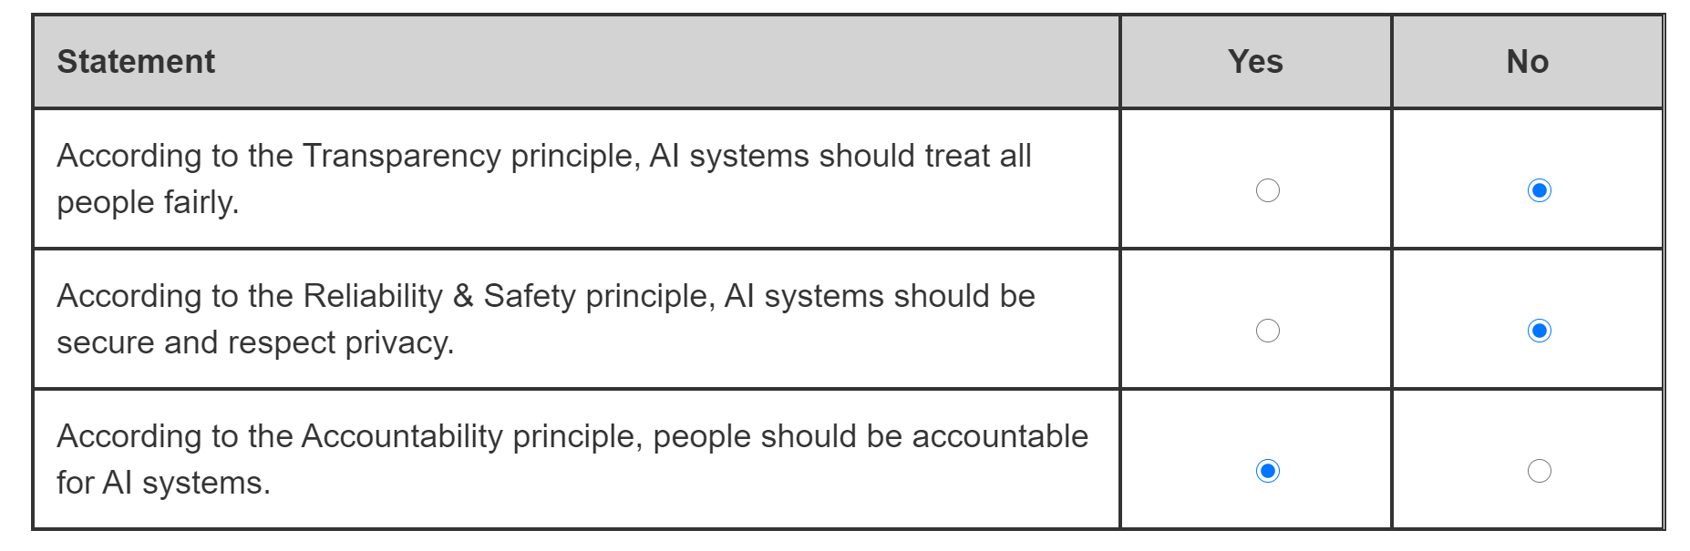

The Transparency principle does not deal with fairness. It indicates that AI systems should be understandable. System users should have a clear understanding of how an AI system operates, what data it utilizes, what the system’s capabilities and limitations are, and so on. The guiding principle concerned with AI systems treating all people fairly is Fairness.  
  
The Reliability & Safety principle indicates that AI systems should perform reliably and safely. This requires proper testing and verification of an AI system’s functionality to ensure that it works as expected and to eliminate potential risk to human life. The guiding principle concerned with AI systems being secure and respecting privacy is Privacy & Security.  
  
People should be accountable for AI systems according to the Accountability principle. AI systems are built by people (designers and developers) and they should be responsible for what AI systems do. It requires people to follow governance and organizational policies to ensure that the solution meets clearly defined ethical and legal standards.  
  
**References**  
  
[Responsible AI resources](https://www.microsoft.com/en-gb/ai/responsible-ai-resources?rtc=1&activetab=pivot1%3aprimaryr4)  
  
[Responsible AI](https://www.microsoft.com/en-us/ai/responsible-ai?activetab=pivot1%3aprimaryr6)

### Question 18: To complete the sentence, select the appropriate option from the drop-down menu.

Choose the correct options

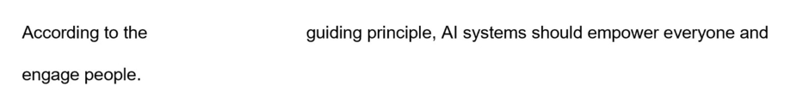



inclusiveness

**Explanation**

Inclusiveness is the guiding principle of Microsoft’s responsible AI approach that indicates that AI systems should empower everyone and engage people. According to this principle, AI should bring benefits to all parts of society, regardless of gender, origin, physical or mental abilities, sexual orientation, or any other factors.  
  
The Fairness principle says that AI systems should treat all people fairly, and the focus should be on eliminating any bias that would result in an unfair advantage or disadvantage to any specific groups of people.  
  
Transparency is the guiding principle that indicates that AI systems should be understandable. People using the system should understand how it works, as well as its capabilities and limitations.  
  
**References**  
  
[Responsible AI resources](https://www.microsoft.com/en-gb/ai/responsible-ai-resources?rtc=1&activetab=pivot1%3aprimaryr4)  
  
[Responsible AI](https://www.microsoft.com/en-us/ai/responsible-ai?activetab=pivot1%3aprimaryr6)

### Question 19: Which of the responsible AI principles is concerned with the mitigation of bias in a machine learning model?

Choose the correct answer

Inclusiveness

Accountability

Fairness

Transparency

**Explanation**

Fairness is the principle that is concerned with treating all people equally and reducing unfairness. A responsible AI-based solution must operate without giving any unfair advantage to, withholding information from, or allocating resources to a specific group of people. There should be no bias regarding the person’s gender, or any other characteristic. An AI model should be interpreted to quantify the extent of how data influences a model's prediction to help eliminate bias.  
  
Accountability is a principle that requires that the people involved in designing and developing AI-based systems operate within a governance framework and follow defined ethical policies and legal standards.  
  
Inclusiveness is the principle that AI-based solutions should empower everyone. AI should provide benefits to all parts of society, regardless of gender, physical ability, ethnicity, sexual orientation, or any other factor.  
  
Transparency is the principle that AI-based solutions should be understandable. Users should be aware of the purpose of the AI-based system, how it operates, its scope, and limitations.  
  
**References**  
  
[Responsible AI](https://www.microsoft.com/ai/responsible-ai)  
  
[Understand responsible AI](https://docs.microsoft.com/learn/modules/get-started-ai-fundamentals/7-understand-responsible-ai)

### Question 20: To complete the sentence, select the appropriate option from the drop-down menu.

Choose the correct options

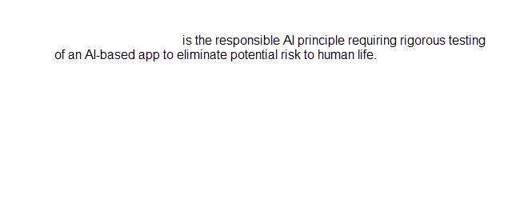



Reliability and safety

**Explanation**

Reliability & Safety requires the rigorous testing of an AI-based system's functionality and deployment to ensure that it works as expected, and that potential risk to human life is eliminated.  
  
Privacy & Security requires that the AI-based system should respect privacy and be secure. AI-based systems typically operate on high volumes of data, including personal data, that should not be disclosed. The data used in training the model and new data used for predictions, is subject to privacy rules.  
  
Accountability requires that the people involved in designing and developing AI-based systems operate within a governance framework and follow defined ethical policies and legal standards.  
  
**References**  
  
[Responsible AI](https://www.microsoft.com/en-us/ai/responsible-ai?rtc=1&activetab=pivot1%3aprimaryr6)  
  
[Understand responsible AI](https://docs.microsoft.com/learn/modules/get-started-ai-fundamentals/7-understand-responsible-ai)

### Question 21: Match the Responsible AI principles to the objective. To answer, drag the appropriate principle to each objective. A principle may be used once, more than once, or not at all.

Drag and drop the answers



















**Explanation**

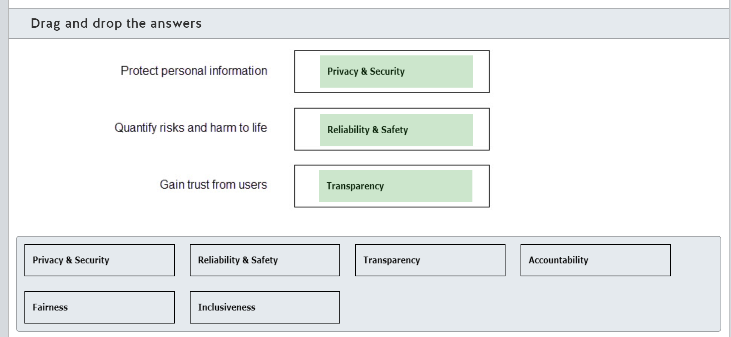

Privacy & security is concerned with keeping AI-based solutions secure and preventing personal data from being disclosed.  
  
Reliability & safety is concerned with ensuring an AI-based solution operates as expected and does not cause harm, including harm to life.  
  
Transparency is the interpretability and intelligibility of an AI-based solution. Transparency enables users to be able to trust an AI-based solution by informing them of the scope and purpose of the solution, as well as informing them how the data is used and the limitations of AI processing.  
  
Accountability requires that the people involved in designing and developing AI-based solutions operate within a governance framework and follow defined ethical policies and legal standards.  
  
Inclusiveness requires that AI-based solutions empower everyone and provide benefits to all parts of society, regardless of gender, physical ability, ethnicity, sexual orientation, or any other factor.  
  
Fairness requires that an AI-based solution treats all people fairly and reduces bias.  
  
**References**  
  
[Responsible AI](https://www.microsoft.com/ai/responsible-ai)  
  
[Understand responsible AI](https://docs.microsoft.com/learn/modules/get-started-ai-fundamentals/7-understand-responsible-ai)

### Question 22: For each of the following statements about inclusiveness, select Yes if the statement is true. Otherwise, select No.

|  |  |  |
| --- | --- | --- |
| **Statement** | **Yes** | **No** |
| Inclusiveness brings the benefits of an AI-based solution to all members of society. |  |  |
| Inclusiveness makes users aware of the purpose and limitations of an AI-based solution. |  |  |
| Inclusiveness is an AI-based solution that empowers and engages all communities in the world. |  |  |

**Explanation**

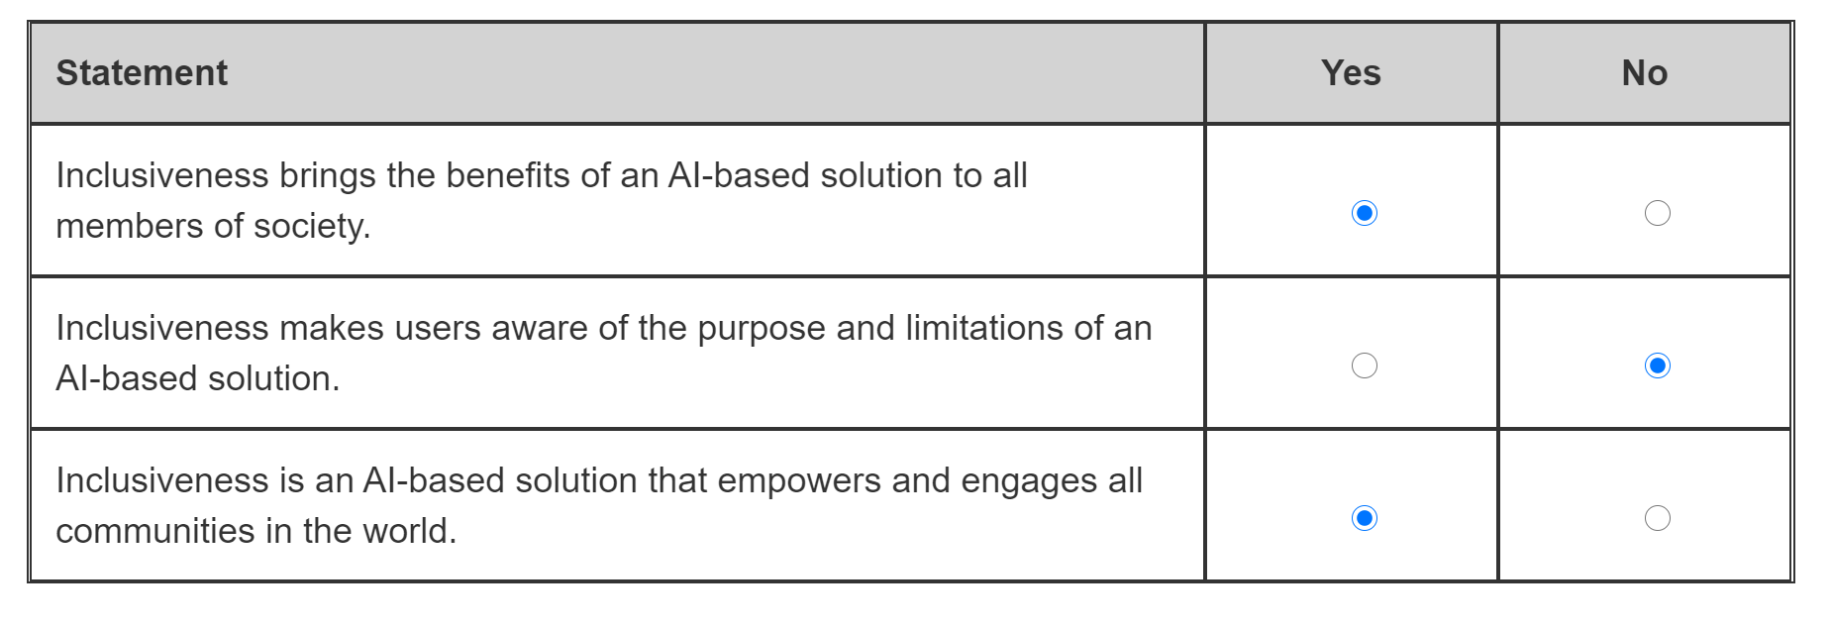

AI-based solutions that follow the inclusiveness principle empower everyone and bring benefits to all parts of society, regardless of gender, physical ability, ethnicity, sexual orientation, or any other factor.  
  
Transparency makes users aware of the scope and purpose of the solution, as well as how it uses data and the limitations of AI in the solution.  
  
AI-based solutions that follow the inclusiveness principle are designed with minorities in mind. They engage everyone in all communities worldwide.  
  
**References**  
  
[Responsible AI](https://www.microsoft.com/ai/responsible-ai)  
  
[Understand responsible AI](https://docs.microsoft.com/learn/modules/get-started-ai-fundamentals/7-understand-responsible-ai)

### Question 23: Which responsible AI principle is concerned with making users aware of the limitations of an AI-based system?

Choose the correct answer

Fairness

Transparency

Accountability

Inclusiveness

**Explanation**

Transparency is the principle that dictates that AI-based solutions should be understandable. Users should be aware of the purpose of the AI-based system, how it operates, its scope and limitations.  
  
Accountability requires that the people involved in designing and developing AI-based solutions operate within a governance framework and follow defined ethical policies and legal standards.  
  
Fairness is the principle that dictates that AI-based solutions should treat all people fairly. Fairness requires an AI-based solution to not give any unfair advantage to, withhold information from, or allocate resources to a specific group of people.  
  
Inclusiveness is the principle that dictates that AI-based solutions should empower everyone. AI should provide benefits to all parts of society, regardless of gender, physical ability, ethnicity, sexual orientation, or any other factors.  
  
**References**  
  
[Responsible AI](https://www.microsoft.com/ai/responsible-ai)  
  
[Understand responsible AI](https://docs.microsoft.com/learn/modules/get-started-ai-fundamentals/7-understand-responsible-ai)

### Question 24: Which two of these scenarios does the accountability responsible AI principle apply to? Each correct answer presents a complete solution.

Choose the correct answers

Keeping personal details private

Following a governance framework

Operating as expected

Meeting ethical standards

Treating people fairly

**Explanation**

Accountability requires that the people involved in designing and developing AI-based solutions operate within a clear governance framework.  
  
Accountability also requires that the people involved in designing and developing AI-based solutions follow clearly defined ethical policies and legal standards.  
  
Privacy & security is concerned with keeping AI-based solutions secure and preventing personal data from being disclosed.  
  
Reliability & safety is concerned with ensuring an AI-based solution operates as expected and does not cause harm, including harm to life.  
  
Fairness requires that an AI-based solution treats all people fairly without bias towards a person’s gender, or any other characteristic.  
  
**References**  
  
[Responsible AI](https://www.microsoft.com/ai/responsible-ai)  
  
[Understand responsible AI](https://docs.microsoft.com/learn/modules/get-started-ai-fundamentals/7-understand-responsible-ai)

# Describe fundamental principles of machine learning on Azure

## Identify common machine learning types

### Question 25: Predicting the online sales volume for the next financial quarter is an example of what machine learning scenario?

Choose the correct answer

Regression

Clustering

Classification

**Explanation**

This is an example of Regression. In a regression machine learning scenario, you predict a numeric value, typically in a continuous form. In this example, you can use machine learning to predict the online sales volume for the next financial quarter by using historical sales volume data and various factors such as holidays seasons, confirmed sales orders, and so on.  
  
Classification is used to make predictions in a non-continuous form. Classification involves learning from labeled data to classify new observations, for example, to check whether newly arrived email messages are spam or not spam.  
  
Clustering analyzes data to find similarities in data points and group them together using unlabeled data, for example, to learn about purchasing habits of ecommerce clients.  
  
**References**  
  
[Regression modules](https://docs.microsoft.com/en-us/azure/machine-learning/studio-module-reference/machine-learning-initialize-model-regression)  
  
[Classification modules](https://docs.microsoft.com/en-us/azure/machine-learning/studio-module-reference/machine-learning-initialize-model-classification)  
  
[Clustering modules](https://docs.microsoft.com/en-us/azure/machine-learning/studio-module-reference/machine-learning-initialize-model-clustering)  
  
[Machine Learning Algorithm Cheat Sheet for Azure Machine Learning designer](https://docs.microsoft.com/en-us/azure/machine-learning/algorithm-cheat-sheet)  
  
[How to select algorithms for Azure Machine Learning](https://docs.microsoft.com/en-us/azure/machine-learning/how-to-select-algorithms)

### Question 26: Analyzing X-ray images to detect whether a person has pneumonia is an example of what machine learning scenario?

Choose the correct answer

Classification

Regression

Clustering

**Explanation**

This is an example of classification. A classification machine learning scenario helps you predict a value, typically in a non-continuous form. A model trained on the labeled sets of X-ray images of various patients can analyze new images and classify in a binary way whether a person does or does not have pneumonia.  
  
Regression is used to make predictions in a continuous form, learning from labeled historical data to predict or forecast new values, for example, to predict house prices based on the location, number of rooms and other factors.  
  
Clustering analyzes data to find similarities in the data points and group them together using unlabeled data, for example, to learn about the purchasing habits of ecommerce clients.  
  
**References**  
  
[Classification modules](https://docs.microsoft.com/en-us/azure/machine-learning/studio-module-reference/machine-learning-initialize-model-classification)  
  
[Regression modules](https://docs.microsoft.com/en-us/azure/machine-learning/studio-module-reference/machine-learning-initialize-model-regression)  
  
[Clustering modules](https://docs.microsoft.com/en-us/azure/machine-learning/studio-module-reference/machine-learning-initialize-model-clustering)  
  
[Machine Learning Algorithm Cheat Sheet for Azure Machine Learning designer](https://docs.microsoft.com/en-us/azure/machine-learning/algorithm-cheat-sheet)  
  
[How to select algorithms for Azure Machine Learning](https://docs.microsoft.com/en-us/azure/machine-learning/how-to-select-algorithms)

### Question 27: Grouping together online shoppers with similar traits for targeted marketing is an example of what machine learning scenario?

Choose the correct answer

Clustering

Classification

Regression

**Explanation**

This is an example of clustering. In a clustering machine learning scenario, the model iteratively groups cases in an unlabeled dataset into clusters that have similar characteristics. Therefore, in this example, data about the online behavior of shoppers can be analyzed to group the ones with the similar traits into specific clusters to target in future marketing campaigns.  
  
Classification is used to make predictions in a non-continuous form by learning from labeled data to classify new observations, for example, checking whether newly arrived email messages are spam or not spam.  
  
Regression is used to make predictions in a continuous form by learning from labeled historical data to predict or forecast new values, for example, to predict house price based on the location, number of rooms, and other factors.  
  
**References**  
  
[Clustering modules](https://docs.microsoft.com/en-us/azure/machine-learning/studio-module-reference/machine-learning-initialize-model-clustering)  
  
[Classification modules](https://docs.microsoft.com/en-us/azure/machine-learning/studio-module-reference/machine-learning-initialize-model-classification)  
  
[Regression modules](https://docs.microsoft.com/en-us/azure/machine-learning/studio-module-reference/machine-learning-initialize-model-regression)  
  
[Machine Learning Algorithm Cheat Sheet for Azure Machine Learning designer](https://docs.microsoft.com/en-us/azure/machine-learning/algorithm-cheat-sheet)  
  
[How to select algorithms for Azure Machine Learning](https://docs.microsoft.com/en-us/azure/machine-learning/how-to-select-algorithms)

### Question 28: To complete the sentence, select the appropriate option from the drop-down menu.

Choose the correct options





clustering

**Explanation**

Clustering is a machine learning method where you use relevant clustering algorithms, such as K-means, to analyze the input data and set parameters such as the distance metric or expected number of clusters. A model then runs iteratively to group together the data points that contain similar characteristics. Clustering can help to explore the data and discover unexpected correlations. It can be used to analyze customers' purchasing behavior.  
  
Classification does not group data points with similar characteristics. Instead, it is used to determine the category or class of those data points, such as whether an object in the image is a hotdog.  
  
Regression is a machine learning method that evaluates relationships between the variables in the input dataset to predict a numeric outcome when the values of those variables change. It can be used to predict the price of a house based on its location and type.  
  
**References**  
  
[Clustering modules](https://docs.microsoft.com/en-us/azure/machine-learning/studio-module-reference/machine-learning-initialize-model-clustering)  
  
[Classification modules](https://docs.microsoft.com/en-us/azure/machine-learning/studio-module-reference/machine-learning-initialize-model-classification)  
  
[Regression modules](https://docs.microsoft.com/en-us/azure/machine-learning/studio-module-reference/machine-learning-initialize-model-regression)

### Question 29: To complete the sentence, select the appropriate option from the drop-down menu.

Choose the correct options

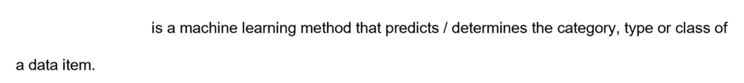



classification

**Explanation**

Classification is a supervised learning method in which the model learns from labeled data to predict the class or category of the label for new, unlabeled input data. Classification algorithms may be binary (whether it is an A or B, or whether an email message is spam or not) or multiclass (identifying various bird types in the video stream from a garden webcam).  
  
Clustering is a method in which a machine learning model groups data points with similar characteristics into clusters to get a better insight into the dataset and uncover hidden correlations and relationships. In text analysis, clustering can help to group documents with similar topics or sentiment.  
  
Regression is a machine learning method that evaluates the relationship between the variables in the input dataset to predict a numeric outcome when the values of those variables change, for example, to predict whether a patient needs to be admitted to hospital based on previous health records and recent medical test results.  
  
**References**  
  
[Clustering modules](https://docs.microsoft.com/en-us/azure/machine-learning/studio-module-reference/machine-learning-initialize-model-clustering)  
  
[Classification modules](https://docs.microsoft.com/en-us/azure/machine-learning/studio-module-reference/machine-learning-initialize-model-classification)  
  
[Regression modules](https://docs.microsoft.com/en-us/azure/machine-learning/studio-module-reference/machine-learning-initialize-model-regression)

### Question 30: Forecasting stock market index values based on macro economic changes is an example of what machine learning scenario?

Choose the correct answer

Classification

Clustering

Regression

**Explanation**

This is an example of regression. In a regression machine learning scenario, you predict a numeric value, typically in a continuous form. In this example, you can use machine learning to forecast (predict) stock market index values based on historical records of index fluctuations and their relationship with various macro economic factors.  
  
Classification is used to make predictions in a non-continuous form. Classification involves learning from labeled data to classify new observations, for example, to check whether newly arrived email messages are spam.  
  
Clustering analyzes the data to find similarities in data points and group them together using unlabeled data, for example, to learn about purchasing habits of ecommerce clients.  
  
**References**  
  
[Regression modules](https://docs.microsoft.com/en-us/azure/machine-learning/studio-module-reference/machine-learning-initialize-model-regression)  
  
[Classification modules](https://docs.microsoft.com/en-us/azure/machine-learning/studio-module-reference/machine-learning-initialize-model-classification)  
  
[Clustering modules](https://docs.microsoft.com/en-us/azure/machine-learning/studio-module-reference/machine-learning-initialize-model-clustering)  
  
[Machine Learning Algorithm Cheat Sheet for Azure Machine Learning designer](https://docs.microsoft.com/en-us/azure/machine-learning/algorithm-cheat-sheet)  
  
[How to select algorithms for Azure Machine Learning](https://docs.microsoft.com/en-us/azure/machine-learning/how-to-select-algorithms)

### Question 31: Processing new tweets to categorize them as positive or negative is an example of what machine learning scenario?

Choose the correct answer

Clustering

Classification

Regression

**Explanation**

This is an example of classification. A classification machine learning scenario helps you predict a value, typically in a non-continuous form. A model trained to analyze textual context and label it as positive or negative can process new tweets to classify opinions and emotions.  
  
Regression is used to make predictions in a continuous form, learning from labeled historical data to predict or forecast new values, for example, to predict house prices based on the location, number of rooms, and other factors.  
  
Clustering analyzes data to find similarities in the data points and group them together using unlabeled data, for example, to learn about the purchasing habits of ecommerce clients.  
  
**References**  
  
[Classification modules](https://docs.microsoft.com/en-us/azure/machine-learning/studio-module-reference/machine-learning-initialize-model-classification)  
  
[Regression modules](https://docs.microsoft.com/en-us/azure/machine-learning/studio-module-reference/machine-learning-initialize-model-regression)  
  
[Clustering modules](https://docs.microsoft.com/en-us/azure/machine-learning/studio-module-reference/machine-learning-initialize-model-clustering)  
  
[Machine Learning Algorithm Cheat Sheet for Azure Machine Learning designer](https://docs.microsoft.com/en-us/azure/machine-learning/algorithm-cheat-sheet)  
  
[How to select algorithms for Azure Machine Learning](https://docs.microsoft.com/en-us/azure/machine-learning/how-to-select-algorithms)

### Question 32: Which machine learning type should you use to predict ice cream sales based on the weather forecast?

Choose the correct answer

Clustering

Classification

Regression

**Explanation**

The regression machine learning model predicts a numeric value by using a formula that is derived from historic data. Regression predicts continuous values. You use the history of sales versus temperature to create the model. You input a new temperature and the model forecasts the sales based on this temperature. Regression is an example of supervised learning.  
  
Classification is used to make predictions where you do not have continuous values but distinct categories. Classification involves learning using labels to classify data. Classification predicts a discrete number of values, and it is an example of supervised learning.  
  
Clustering analyzes the data to find similarities in data points and uses unlabeled data to group the similarities into clusters. Clustering is an example of unsupervised learning.  
  
**References**  
  
[Machine learning algorithms](https://azure.microsoft.com/overview/machine-learning-algorithms/)  
  
[How to select algorithms for Azure Machine Learning](https://docs.microsoft.com/azure/machine-learning/how-to-select-algorithms)

### Question 33: Which machine learning type should you use to determine the amount of credit to give to a customer?

Choose the correct answer

Classification

Clustering

Regression

**Explanation**

The regression machine learning model predicts a numeric value using a formula that is derived from historic data. Regression predicts continuous values. You will use the customer details and history of repayments to create the model. You can input a new customer's details and the model will calculate the credit limit based on these details.  
  
Classification is used to make predictions that do not require continuous values but distinct categories, such as Yes or No. Classification can be used to approve or reject a customer for credit but not to forecast the numeric amount of credit.  
  
Clustering analyzes unlabeled data to find similarities in data points and groups them together into clusters. Clustering can be used to segment customers into similar groups. Clustering cannot calculate the amount of credit to give to the customer.  
  
**References**  
  
[Introduction](https://docs.microsoft.com/learn/modules/train-evaluate-regression-models/1-introduction)  
  
[Machine learning algorithms](https://azure.microsoft.com/overview/machine-learning-algorithms/)  
  
[How to select algorithms for Azure Machine Learning](https://docs.microsoft.com/azure/machine-learning/how-to-select-algorithms)

### Question 34: Which machine learning type should you use to determine if a social media post has positive or negative sentiment?

Choose the correct answer

Classification

Clustering

Regression

**Explanation**

The classification machine learning model is used to predict mutually exclusive categories. Classification involves learning using labels to classify data. Two-class classification algorithms can provide an either/or answer, such as a social media post that has positive or negative sentiment.  
  
Regression is used to predict a numeric value using a formula that is derived from historic data. Regression predicts continuous values. A regression algorithm can be used to predict the number of likes on a social media post.  
  
Clustering analyzes unlabeled data to find similarities in data points and groups them together into clusters. A clustering algorithm could be used to group social media posts into multiple groups based on similarities in the posts.  
  
**References**  
  
[Introduction](https://docs.microsoft.com/learn/modules/train-evaluate-classification-models/1-introduction)  
  
[Machine learning algorithms](https://azure.microsoft.com/overview/machine-learning-algorithms/)  
  
[How to select algorithms for Azure Machine Learning](https://docs.microsoft.com/azure/machine-learning/how-to-select-algorithms)

### Question 35: Which machine learning type should you use to approve or reject a customer's application for credit?

Choose the correct answer

Clustering

Classification

Regression

**Explanation**

The classification machine learning model is used to predict mutually exclusive categories. Classification involves learning using labels to classify data. Two-class classification algorithms can provide a Yes/No answer such as the reply to an application for credit.  
  
Regression is used to predict a numeric value using a formula that is derived from historic data. Regression predicts continuous values. A regression algorithm can be used to predict the amount of credit to give to the customer. Regression does not provide mutually exclusive approve or reject answers.  
  
Clustering analyzes unlabeled data to find similarities in data points and groups them together into clusters. A clustering algorithm could be used to segment customers into multiple groups based on similarities in the customers details and history.  
  
**References**  
  
[Introduction](https://docs.microsoft.com/learn/modules/train-evaluate-classification-models/1-introduction)  
  
[Machine learning algorithms](https://azure.microsoft.com/overview/machine-learning-algorithms/)  
  
[How to select algorithms for Azure Machine Learning](https://docs.microsoft.com/azure/machine-learning/how-to-select-algorithms)

### Question 36: To complete the following sentence, select the appropriate option from the drop-down menu.

Choose the correct options

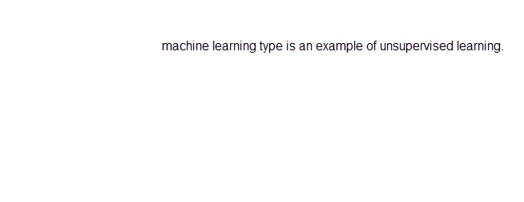



clustering

**Explanation**

Clustering machine learning is an example of unsupervised learning. In unsupervised learning, the data is not labeled. An unsupervised learning algorithm aims to determine the structure of the data.  
  
Classification and Regression are examples of supervised machine learning. In supervised learning, each data point is either labeled or associated with a category. A supervised learning algorithm aims to predict values or categories for other data points.  
  
**References**  
  
[Machine Learning Algorithm Cheat Sheet for Azure Machine Learning designer](https://docs.microsoft.com/en-us/azure/machine-learning/algorithm-cheat-sheet)

### Question 37: To complete the following sentence, select the appropriate option from the drop-down menu.

Choose the correct options

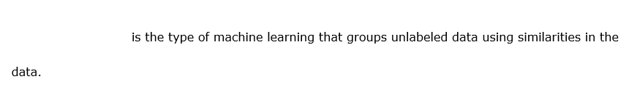



clustering

**Explanation**

The clustering machine learning model analyzes unlabeled data to find similarities in data points and groups them together into clusters. The clustering algorithm segments data into multiple groups based on similarities in the data.  
  
Classification is used to make predictions that do not require continuous values but need distinct categories such as Yes or No. Classification involves learning using labels to classify data.  
  
Regression is used to predict a numeric value using a formula that is derived from historic data. Regression predicts continuous values. Regression involves learning using labeled data. Regression does not group data based on categories or similarities.  
  
**References**  
  
[Introduction](https://docs.microsoft.com/learn/modules/train-evaluate-cluster-models/1-introduction)  
  
[Machine learning algorithms](https://azure.microsoft.com/overview/machine-learning-algorithms/)  
  
[How to select algorithms for Azure Machine Learning](https://docs.microsoft.com/azure/machine-learning/how-to-select-algorithms)

## Describe core machine learning concepts

### Question 38 metric/classification

Question 38: Which two metrics can you use to evaluate classification machine learning models? Each correct answer presents a complete solution.

Choose the correct answers

Mean Absolute Error (MAE)

Precision

Recall

Average Distance to Cluster Center

**Explanation**

You can use Precision and Recall. Both are used to evaluate classification models. Precision is the proportion of true results over all positive results. Recall is the fraction of all correct results returned by the model.  
  
You should not use MAE to evaluate classification machine learning models. MAE is used to evaluate regression methods. MAE measures how close the predictions of the regression model are to the actual outcomes. The lower the score, the better.  
  
You should not use Average Distance to Cluster Center to evaluate classification machine learning models. This metric is used in the evaluation of clustering models, representing the closeness of all points in a cluster to the center of that cluster.  
  
**References**  
  
[Machine Learning - Evaluate](https://docs.microsoft.com/en-us/azure/machine-learning/studio-module-reference/machine-learning-evaluate)  
  
[Evaluate Model](https://docs.microsoft.com/en-us/azure/machine-learning/studio-module-reference/evaluate-model)

 Previous

### Question 39 metrics/regression

Question 39: Which two metrics can you use to evaluate regression machine learning models? Each correct answer presents a complete solution.

Choose the correct answers

Number of Points

Coefficient of Determination

F-score

Root Mean Squared Error (RMSE)

**Explanation**

You can use RMSE and Coefficient of Determination to evaluate regression machine learning models. Metrics used to evaluate regression methods are generally focused on estimating the amount of error, where a small difference between observed and predicted values is an indicator of a better fit model. By squaring the difference, **RMSE** as a metric helps to disregard the difference between over-prediction and under-prediction. **Coefficient of determination** (R2) represents the predictive power of the regression model. Its value varies between 0 and 1, where 1 typically indicates a perfectly fit model, while 0 indicates a random one. However, in some cases low and high values of R2 may not reflect the actual level of the model’s accuracy.  
  
You should not use F-score to evaluate regression machine learning models. F-score is a metric that is used to evaluate classification models. F-score is computed as the weighted average of precision (the proportion of true results over all positive results) and recall (the fraction of all correct results returned by the model) between 0 and 1. The higher the value of F-score, the better, with 1 being the ideal value.  
  
You should not use Number of Points to evaluate regression machine learning models. Number of Points is a metric used to evaluate clustering models, showing how many data points are assigned to each cluster, along with the total overall number of data points in any cluster.  
  
**References**  
  
[Machine Learning - Evaluate](https://docs.microsoft.com/en-us/azure/machine-learning/studio-module-reference/machine-learning-evaluate)  
  
[Evaluate Model](https://docs.microsoft.com/en-us/azure/machine-learning/studio-module-reference/evaluate-model)

### Question 40 – features and label

Question 40: You train a machine learning model on the flowers dataset to predict the type of the iris species. Sample records from the dataset are shown in the exhibit.  
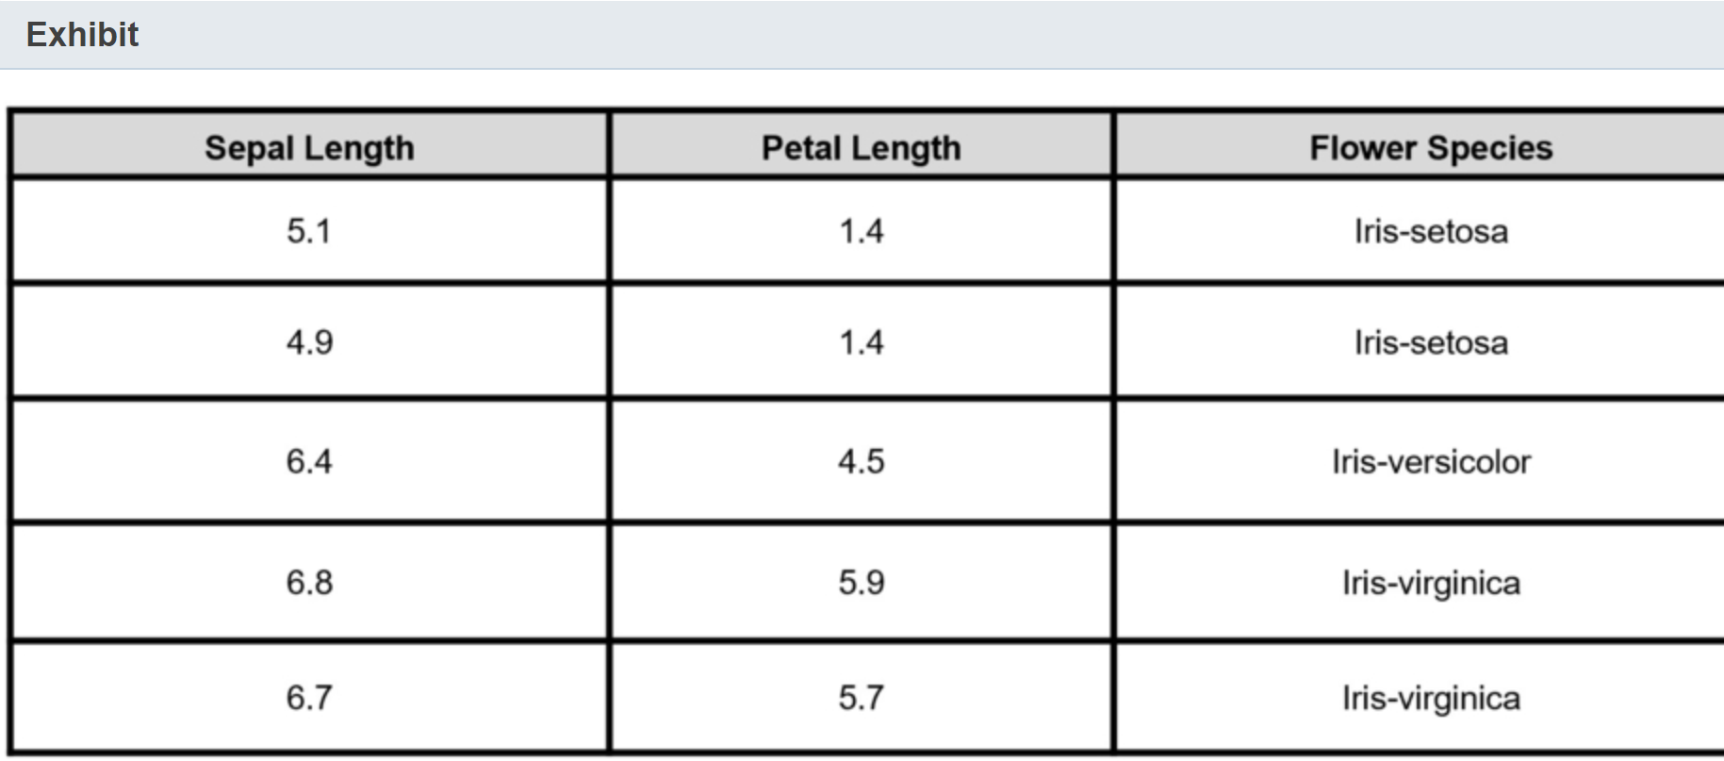  
What do Sepal Length and Flower Species represent in the dataset? To answer, select the appropriate options from the drop-down menus.

Choose the correct options







**Explanation**



The Sepal Length column is a feature column. In machine learning, features are the descriptive attributes used to train classification models like this to predict a class or category of the outcome, such as the type of the iris species.  
  
The Flower Species column is a label column. In machine learning, labels are the outcomes that the model needs to predict or forecast. In this example model is trained to predict the iris species, so it uses values from the Flower Species column to verify and adjust its logic.  
  
There are no algorithm columns. An algorithm is set of commands or instructions that a computer typically executes in a sequence. In machine learning particularly, algorithms operate on the provided dataset to produce relevant classification, regression, or clustering. They are not part of the input dataset.  
  
**References**  
  
[Prepare data for building a model](https://docs.microsoft.com/en-us/dotnet/machine-learning/how-to-guides/prepare-data-ml-net)  
  
[Feature Selection modules](https://docs.microsoft.com/en-us/azure/machine-learning/studio-module-reference/feature-selection-modules)  
  
[How to choose an ML.NET algorithm](https://docs.microsoft.com/en-us/dotnet/machine-learning/how-to-choose-an-ml-net-algorithm)

### Question 41 – validation/testing dataset

Question 41: You need to hold back a dataset from model training so it can be used to estimate a model's prediction error while tuning its hyperparameters.  
  
Which dataset should you use?

Choose the correct answer

Training dataset

Testing dataset

Raw data

Validation dataset

**Explanation**

You should use the validation dataset. The validation dataset is a sample of data held back from the training of machine learning model. It helps to get an unbiased evaluation of the model while tuning its hyperparameters. You use it after the training but before the final testing of the model.  
  
You should not use the training dataset. The training dataset is not held back, but it is instead actively used to train the model.  
  
You should not use the testing dataset. Like the validation dataset, the testing dataset is held back from model training to provide an unbiased evaluation of the model. However, the testing dataset is used in the testing of the final model fit on the training dataset, while the validation dataset is used while tuning the model’s hyperparameters.  
  
You should not use raw data. Raw date is often noisy and unreliable, and thus it requires further preprocessing and cleaning before it can be split into subsets for the model’s training, validation, or testing.  
  
**References**  
  
[Cross Validate Model](https://docs.microsoft.com/en-us/azure/machine-learning/algorithm-module-reference/cross-validate-model)  
  
[The ML.NET CLI command reference](https://docs.microsoft.com/en-us/dotnet/machine-learning/reference/ml-net-cli-reference)  
  
[Tune Model Hyperparameters](https://docs.microsoft.com/en-us/azure/machine-learning/studio-module-reference/tune-model-hyperparameters)  
  
[Load and classify your own datasets](https://docs.microsoft.com/en-us/quantum/user-guide/libraries/machine-learning/load?tabs=tabid-python)  
  
[Tasks to prepare data for enhanced machine learning](https://docs.microsoft.com/en-us/azure/machine-learning/team-data-science-process/prepare-data)

 Previous

### Question 42 Epoch

Question 42: You train a new machine learning model using a classification algorithm.  
  
You need to ensure that your model iterates over the whole dataset during the training process only a certain number of times.  
  
Which setting should you adjust?

Choose the correct answer

Epoch

Learning rate

Random seed

Batch size

**Explanation**

You should adjust the Epoch setting. This setting indicates how many epochs (iterations through the whole dataset) the machine learning model should be trained on.  
  
You should not adjust the Batch size setting. This setting indicates the number of training examples used in one iteration. The smaller is the batch size, the higher the number of parameter updates per epoch.  
  
You should not adjust the Learning rate setting. This is a tuning setting for an optimization algorithm that controls how much you need to change the model in response to the estimated error each time the model's weights are updated.  
  
You should not update the Random seed setting. This an integer value that helps to ensure reproducibility of the experiment across multiple runs in the same pipeline.  
  
**References**  
  
[Algorithm & module reference for Azure Machine Learning designer (preview)](https://docs.microsoft.com/en-us/azure/machine-learning/algorithm-module-reference/module-reference)  
  
[Train Pytorch Model](https://docs.microsoft.com/en-us/azure/machine-learning/algorithm-module-reference/train-pytorch-model)

 Previous

### Question 43 metrics/classification

Question 43: In the evaluation of the classification model you get a value of 0.4 for the area under the curve (AUC) metrics. What does it mean?

Choose the correct answer

40 percent of data is allocated to training and 60 percent to testing.

60 percent of data is allocated to training and 40 percent to testing.

The model is performing worse than a random guess.

The model is performing better than a random guess.

**Explanation**

AUC value of 0.4 means that the model is performing worse than a random guess. AUC values range between 0 and 1. The higher the value, the better the performance of the classification model. A value of 0.5 indicates a prediction that is close to random guessing.  
  
Splitting dataset into training and testing subsets is not related to AUC metric. You split data as part of the data transformation process, where certain part of data is allocated to train machine learning model and another part to test it.  
  
**References**  
  
[Evaluate your ML.NET model with metrics](https://docs.microsoft.com/en-us/dotnet/machine-learning/resources/metrics)  
  
[Evaluate model performance in Azure Machine Learning Studio (classic)](https://docs.microsoft.com/en-us/azure/machine-learning/studio/evaluate-model-performance)  
  
[Evaluate Model module](https://docs.microsoft.com/en-us/azure/machine-learning/algorithm-module-reference/evaluate-model)

### Question 44 – features/label

Question 44:

You are building a machine learning model to predict a person's income based on their height and age.   
  
The exhibit shows a sample from an income dataset.

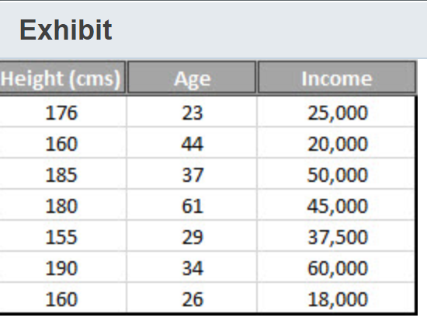  
  
What do the following columns in the dataset represent? To answer, select the appropriate options from the drop-down menus.

Choose the correct options

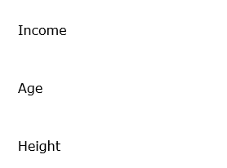







**Explanation**

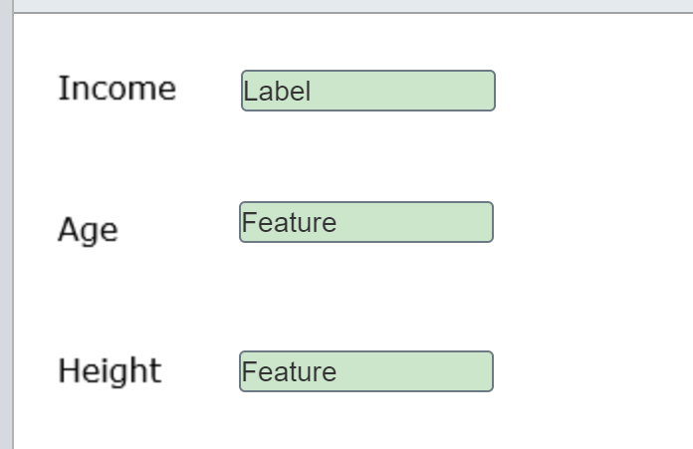

The Income column is a label. Labels are the outputs that the model predicts. This model needs to predict the amount of income for a person based on their characteristics (features).  
  
The Age and Height columns are features. A feature is a column in your dataset. You use features to train the model to predict the outcome. The age is one of those inputs.  
  
A learning model learns the relationship between the features and the label. You can use the model to predict the label based on its features. You provide the model with new input containing the features (age and height) and the model will return the predicted label (income) for that person.  
  
A hyperparameter is used to tune the machine learning model. For example, the number of runs or the sampling method. The columns in the dataset are not hyperparameters.  
  
**References**  
  
[Edit Metadata module](https://docs.microsoft.com/azure/machine-learning/algorithm-module-reference/edit-metadata)  
  
[Explore data](https://docs.microsoft.com/learn/modules/create-regression-model-azure-machine-learning-designer/explore-data)  
  
[Tune hyperparameters for your model with Azure Machine Learning](https://docs.microsoft.com/azure/machine-learning/how-to-tune-hyperparameters)

### Question 45 training/validation

Question 45: Which two datasets do you use to build a machine learning model? Each correct answer presents part of the solution.

Choose the correct answers

Training dataset

Azure Open Dataset

Validation dataset

Testing dataset

**Explanation**

The training dataset is the sample of data used to train the model. It is the largest sample of data used when creating a machine learning model.  
  
The validation dataset is a second sample of data used to provide an evaluation of the model to see if the model can correctly predict, or classify, using data not seen before. The validation dataset is used to tune the model.  
  
A testing dataset is a set of data used to provide a final unbiased evaluation of the model. A test dataset is an independent sample of data and is used once a model has been completely trained with the training and validation datasets.  
  
Azure Open Datasets are curated datasets made available on Azure that you can import into your machine learning model.  
  
**References**  
  
[What is AI Training Data?](https://lionbridge.ai/articles/what-is-ai-training-data/)  
  
[Configure data splits and cross-validation in automated machine learning](https://docs.microsoft.com/en-us/azure/machine-learning/how-to-configure-cross-validation-data-splits)  
  
[About Train, Validation and Test Sets in Machine Learning](https://towardsdatascience.com/train-validation-and-test-sets-72cb40cba9e7)  
  
[Azure Open Datasets](https://azure.microsoft.com/services/open-datasets/)

### Question 46 – very basic - pattern

Question 46: To complete the following sentence, select the appropriate option from the drop-down menu.

Choose the correct options





pattern

**Explanation**

A ML algorithm finds patterns in the training data that map the input data features to the label that you want to predict. The algorithm outputs an ML model that captures these patterns.   
  
You use the ML model to generate predictions on new data after you have trained the model. Predictions are not used when training a model.  
  
Depending on the algorithm, each prediction has a confidence score (probability) that indicates the degree of confidence the model has in its prediction. Many Azure Cognitive services return a confidence score between 0 and 1, where 1 is the most confident. Probabilities are not used when training the model.   
  
**References**  
  
[Machine learning algorithms](https://azure.microsoft.com/overview/machine-learning-algorithms)  
  
[Make predictions with a trained model](https://docs.microsoft.com/dotnet/machine-learning/how-to-guides/machine-learning-model-predictions-ml-net)  
  
[Prediction scores indicate prediction accuracy for intent and entities](https://docs.microsoft.com/azure/cognitive-services/LUIS/luis-concept-prediction-score)

 Previous

### Question 47 metrics/classification

Question 47: Which two metrics can you use to evaluate a classification machine learning model? Each correct answer presents a complete solution.

Choose the correct answers

Coefficient of determination

Maximal Distance to Cluster Center

F-score

Root mean squared error (RMSE)

Precision

**Explanation**

You can use precision and F1 score. These are two of the metrics that can be used to evaluate classification models.  
  
Precision is a measure of the correct positive results. Precision is the number of true positives divided by the sum of the number of true positives and false positives. Precision is scored between 0 and 1. Values closer to 1 are better.  
  
F1 score is a measure combining precision and recall. F1 score is the weighted average of precision and recall (the number of true positives divided by the sum of true positives and false negatives). F-score is scored between 0 and 1. Values closer to 1 are better.  
  
You should not use Maximal Distance to Cluster Center. This metric is used when evaluating clustering models. Maximal Distance to Cluster Center is a measure of how dispersed the clusters are.  
  
You should not use coefficient of determination, also known as R2 or R-squared. This metric is used when evaluating regression models. Coefficient of determination is a measure of the variance from the mean in its predictions. The closer the coefficient of determination is to 1, the better the model is performing.  
  
You should not use root mean squared error (RMSE) to evaluate classification machine learning models. This metric is used to evaluate regression models. RMSE is a measure of the difference between predictions and actual values. The closer RMSE is to 0, the better the model is performing.  
  
**References**  
  
[Evaluate a classification model](https://docs.microsoft.com/learn/modules/create-classification-model-azure-machine-learning-designer/evaluate-model)  
  
[Understand automated machine learning results](https://docs.microsoft.com/azure/machine-learning/how-to-understand-automated-ml)  
  
[Evaluate Model module](https://docs.microsoft.com/azure/machine-learning/algorithm-module-reference/evaluate-model)

### Question 48 – metrics – regression

Question 48: Which two metrics can you use to evaluate a regression machine learning model? Each correct answer presents a complete solution.

Choose the correct answers

Average Distance to Cluster Center

Relative absolute error (RAE)

Area under the curve (AUC)

Precision

Coefficient of determination

**Explanation**

You can use RAE and Coefficient of determination. These are two of the metrics that can be used to evaluate regression models.  
  
Coefficient of determination, also known as R2 or R-squared, is a measure of the variance from the mean in its predictions. The closer the Coefficient of determination is to 1, the better the model is performing.  
  
RAE is a measure of the difference between predictions and actual values. The closer RAE is to 0, the better the model is performing.  
  
You should not use AUC. This metric is used when evaluating classification models. AUC measures the area under a curve that represents true positive rate over true negative rate. AUC ranges between 0 and 1. Values closer to 1 indicate that the model is performing better.  
  
You should not use Average Distance to Cluster Center. This metric is used when evaluating clustering models. Average Distance to Cluster Center is a measure of how focused the clusters are. The lower, the better.  
  
You should not use Precision. This metric is used when evaluating classification models. Precision is the number of true positives divided by the sum of true positives and false positives. Precision is scored between 0 and 1. Values closer to 1 are better.  
  
**References**  
  
[Evaluate a regression model](https://docs.microsoft.com/learn/modules/create-regression-model-azure-machine-learning-designer/evaluate-model)  
  
[Understand automated machine learning results](https://docs.microsoft.com/azure/machine-learning/how-to-understand-automated-ml)  
  
[Evaluate Model module](https://docs.microsoft.com/azure/machine-learning/algorithm-module-reference/evaluate-model)

 Previous

### Question 49 – metric/classification

Question 49: You evaluate a machine learning model and it generates the matrix shown in the exhibit.

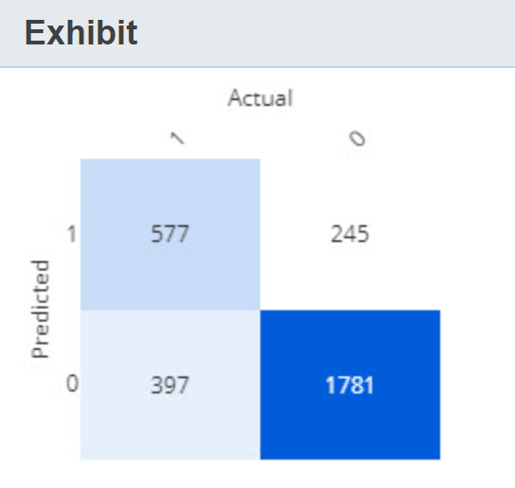  
  
For each of the following statements, select Yes if the statement is true. Otherwise, select No.

|  |  |  |
| --- | --- | --- |
| **Statement** | **Yes** | **No** |
| The machine learning model is a classification model. |  |  |
| There are 397 false positives. |  |  |
| There are 1781 true negatives. |  |  |

**Explanation**

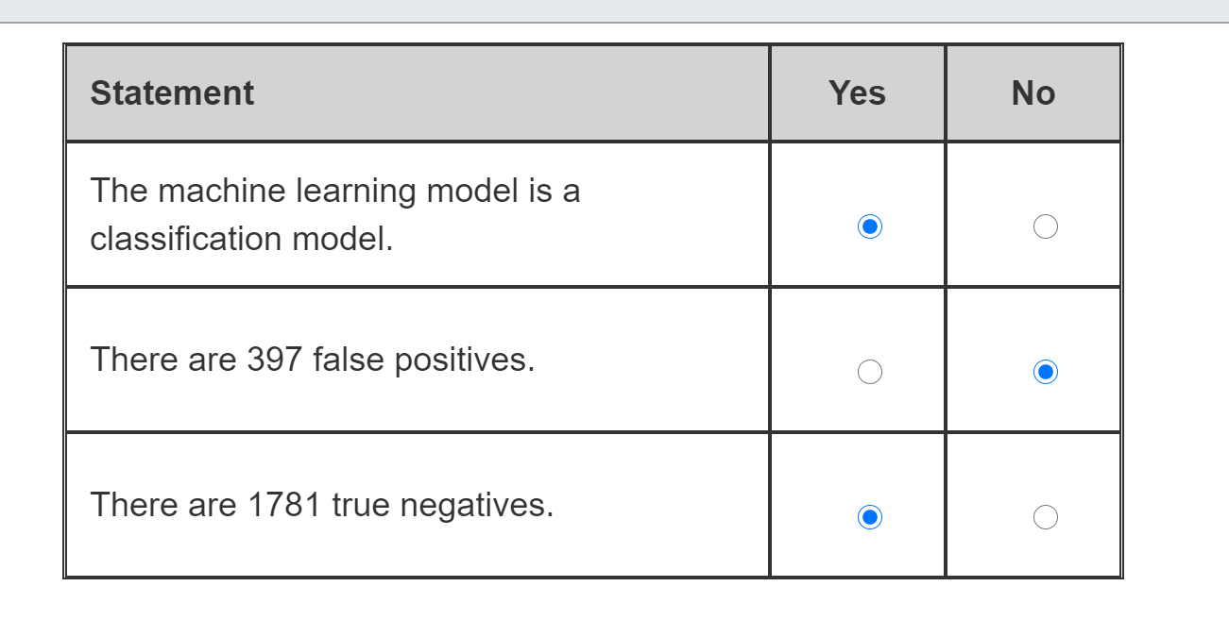

The exhibit shows the confusion matrix for the model. A confusion matrix is generated for a classification model and shows the number of true and false results for each class. In this exhibit, the classes are 0 and 1. In a binary classification model, a 2x2 grid is created with the number of true positive, false positives, false negatives, and true negatives.  
  
The number of false positives is 245, not 397. There are 397 false negatives, because the model did not identify them correctly (prediction was class 0) but there were actual true results (actual was class 1). 245 is the number of false positives (prediction was 1, actual was 0).  
  
The number of true negatives is 1781 as shown in the bottom right of the grid (actual and prediction was 0).  
  
**References**  
  
[Evaluate a classification model](https://docs.microsoft.com/learn/modules/create-classification-model-azure-machine-learning-designer/evaluate-model)  
  
[Understand automated machine learning results](https://docs.microsoft.com/azure/machine-learning/how-to-understand-automated-ml)

### Question 50 – very basic supervised/unsupervised

Question 50: Which technique does each of these family of algorithms use when training a model? To answer, select the appropriate options from the drop-down menus.

Choose the correct options

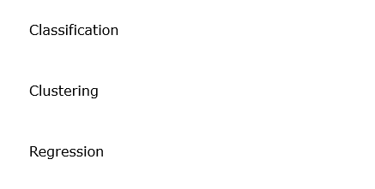







**Explanation**

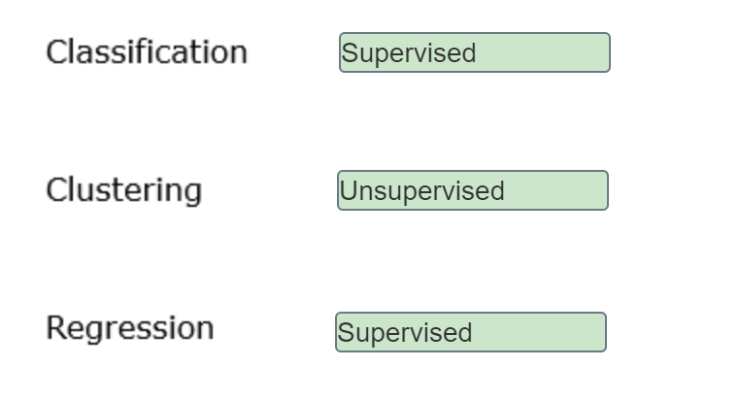

Classification and Regression both involve learning using features and labeled data. This is a supervised learning technique. The data acts as a teacher and trains the model.  
  
Clustering machine models learn by discovering similarities, patterns, and relationships in the data without the data being labeled. This is an unsupervised learning technique.  
  
Reinforcement learning is an approach to machine learning that learns behaviors by getting feedback from its use from an agent, usually computer program, that provides feedback.  
  
**References**  
  
[Machine learning algorithms](https://azure.microsoft.com/overview/machine-learning-algorithms)  
  
[Introduction-Classification](https://docs.microsoft.com/learn/modules/train-evaluate-classification-models/1-introduction)  
  
[Introduction-Clustering](https://docs.microsoft.com/learn/modules/train-evaluate-cluster-models/1-introduction)  
  
[Introduction-Regression](https://docs.microsoft.com/learn/modules/train-evaluate-regression-models/1-introduction)

Bottom of Form

## Identify core tasks in creating a machine learning solution

### Question 51 – Evaluate

Question 51: What should you do to measure the accuracy of the predictions and assess model fit?

Choose the correct answer

Evaluate the model.

Detect languages.

Score the model.

Evaluate the probability function.

**Explanation**

You should evaluate the model. Once the model is trained and scored, you can evaluate the scores to measure the accuracy (performance) of a trained model. The metrics used in the evaluation process vary depending on the machine learning type. For example, you can use precision and recall with classification models, root mean squared error (RMSE) with regression models, and average distance to cluster center with clustering models.  
  
You should not score the model. By scoring, you generate values based on a trained model, given some new input data. A model is scored before it is evaluated, but scoring on its own cannot measure the accuracy of the predictions or assess model fit.  
  
You should not evaluate the probability function. You can use this module to evaluate the distribution of data within the dataset columns to understand which model might fit the data best. However, it cannot be used to measure the accuracy of the trained model.  
  
You should not detect languages. You can use machine learning algorithms to analyze the input text and identify the language associated with each record in the input dataset. However, it cannot help to measure the accuracy of the predictions and assess model fit.  
  
**References**  
  
[Machine Learning - Evaluate](https://docs.microsoft.com/en-us/azure/machine-learning/studio-module-reference/machine-learning-evaluate)  
  
[Score Model](https://docs.microsoft.com/en-us/azure/machine-learning/algorithm-module-reference/score-model)  
  
[Evaluate Probability Function](https://docs.microsoft.com/en-us/azure/machine-learning/studio-module-reference/evaluate-probability-function)  
  
[Detect Languages](https://docs.microsoft.com/en-us/azure/machine-learning/studio-module-reference/detect-languages)

 Previous

### Question 52 – feature/label

Question 52: To complete the sentence, select the appropriate option from the drop-down menu.

Choose the correct options

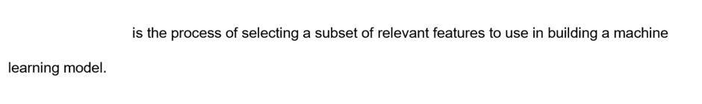



Feature selection

**Explanation**

Feature selection is a process of selecting relevant features (also known as variables or predictors) to use in building a target machine learning model. For example, house location and the number of bedrooms are the features that are more relevant (and thus, more likely to be selected) in the training of a regression model to predict the selling price of a house.  
  
Cross-validation is a technique that is used to assess both the variability of a dataset and the reliability of any model trained using that data.  
  
Evaluation is a process of measuring accuracy (performance) of a trained model.  
  
**References**  
  
[Feature Selection modules](https://docs.microsoft.com/en-us/azure/machine-learning/studio-module-reference/feature-selection-modules)  
  
[Cross-Validate Model](https://docs.microsoft.com/en-us/azure/machine-learning/studio-module-reference/cross-validate-model)  
  
[Evaluate Model](https://docs.microsoft.com/en-us/azure/machine-learning/studio-module-reference/evaluate-model)

### Question 53 – split data training/validation

Question 53: For each of the following statements about data splitting in machine learning, select Yes if the statement is true. Otherwise, select No.

|  |  |  |
| --- | --- | --- |
| **Statement** | **Yes** | **No** |
| You can divide a dataset using regular expression. |  |  |
| You can split a dataset for training/testing by rows. |  |  |
| You can split a dataset for training/testing by columns. |  |  |

**Explanation**

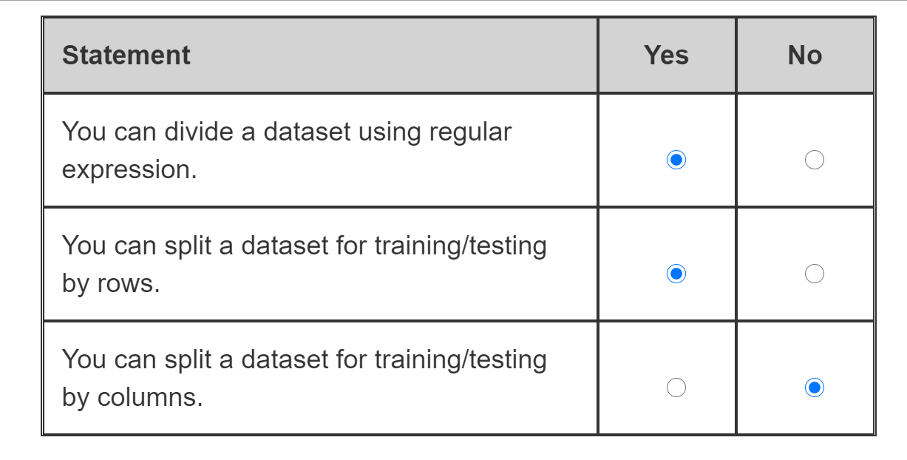

With data splitting you can divide your original dataset using regular expression. One set will contain the rows with values that match the regular expression and another set will contain all remaining rows.  
  
You can split a dataset for machine learning training/testing by rows. It can be done randomly or using some criteria, such as regular expressions.  
  
You cannot split a dataset for machine learning training/testing by columns. Data splitting should be done by rows so that each dataset retains relevant columns with features and labels, which are then used in training and testing processes. Splitting a dataset by columns will break the structure of the records, affect the model’s ability to learn about correlation between the features, and make it impossible to test the model fit with the second data set.  
  
**References**  
[Split Data module](https://docs.microsoft.com/en-us/azure/machine-learning/algorithm-module-reference/split-data)  
  
[Data Transformation - Sample and Split](https://docs.microsoft.com/en-us/azure/machine-learning/studio-module-reference/data-transformation-sample-and-split)  
  
[Split Data using Split Rows](https://docs.microsoft.com/en-us/azure/machine-learning/studio-module-reference/split-data-using-split-rows)

### Question 54 - sampling

Question 54: Which data transformation method is used in machine learning to create a smaller dataset representative of the original massive dataset?

Choose the correct answer

Sampling

Normalization

Feature hashing

Splitting

**Explanation**

Sampling is a technique used in machine learning to reduce the size of the dataset, but still maintaining the same ratio of values. Sampling helps to ensure that there is a fair distribution of classes in the generated smaller dataset, calculating and applying proportions from the original massive dataset.  
  
Splitting is a method that is useful for dividing dataset into training and testing subsets to feed the model during training process and then test its fit. While you can specify the proportion of split, splitting is not intended for the creation of smaller datasets that are representative of the original massive dataset.  
  
Normalization is a technique used in the data preparation. With normalization you transform the values of numeric columns to use a common scale, for example between 0 and 1, without impacting on the differences in the value ranges or losing information itself.  
  
Feature hashing is used to transform text data into a set of features represented as integers. Numerical data can be used then to train text analysis models.  
  
**References**  
  
[Data Transformation - Sample and Split](https://docs.microsoft.com/en-us/azure/machine-learning/studio-module-reference/data-transformation-sample-and-split)  
  
[Partition and Sample module](https://docs.microsoft.com/en-us/azure/machine-learning/algorithm-module-reference/partition-and-sample)  
  
[Split Data module](https://docs.microsoft.com/en-us/azure/machine-learning/algorithm-module-reference/split-data)  
  
[Feature Hashing](https://docs.microsoft.com/en-us/azure/machine-learning/studio-module-reference/feature-hashing)

### Question 55 – data ingestion

Question 55: To complete the following sentence, select the appropriate option from the drop-down menu.

Choose the correct options

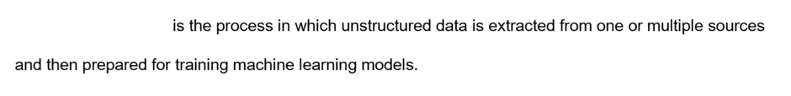



Data ingestion

**Explanation**

Data ingestion is the process in which unstructured data is extracted from one or multiple sources and then prepared for training machine learning models. Raw data may come in different formats, so extracting and converting it into supported format is a critical preparation task in machine learning model’s training process.  
  
Value clipping is the process of detecting outliers (data values which are above or below a specified threshold) to remove or replace them with a mean, constant or other substitute values.  
  
Data export is the process of saving machine learning results, intermediate data or working data into the local or cloud storage destinations. With the data export you move data out, which is the opposite to the data ingestion where you bring data in.  
  
**References**  
  
[Data ingestion options for Azure Machine Learning workflows](https://docs.microsoft.com/en-us/azure/machine-learning/concept-data-ingestion)  
  
[Clip Values](https://docs.microsoft.com/en-us/azure/machine-learning/algorithm-module-reference/clip-values)  
  
[Export Data module](https://docs.microsoft.com/en-us/azure/machine-learning/algorithm-module-reference/export-data)

 Previous

### Question 56 two training model

Question 56: Which two are types of distributed machine learning model training? Each correct answer presents a complete solution.

Choose the correct answers

Model parallelism

Data normalization

Data parallelism

Model evaluation

Model interpretability

**Explanation**

Data parallelism and model parallelism are the two main types of distributed training. With data parallelism you divide data into partitions, where the number of partitions is equal to the number of compute nodes, which are used to train a machine learning model. The model is copied to each compute node to operate on an allocated subset of data. With model parallelism the model is segmented into different parts to run concurrently on different compute nodes, each operating on the same data.  
  
Model interpretability is not a type of distributed model training. It is a principle which ensures that the machine learning model is explainable and compliant with the relevant corporate policies, industry standards and government regulations.  
  
Data normalization is not a type of distributed training. It is a technique where you change the value of numeric columns in the dataset to use a common scale, for example to range from 0 to 1, without affecting differences in the value ranges or losing information.  
  
Model evaluation is focused on the measurement of the trained model’s accuracy (performance). It is not a type of distributed training either.  
  
**References**  
  
[Distributed training with Azure Machine Learning](https://docs.microsoft.com/en-us/azure/machine-learning/concept-distributed-training)  
  
[Model interpretability in Azure Machine Learning (preview)](https://docs.microsoft.com/en-us/azure/machine-learning/how-to-machine-learning-interpretability)  
  
[Normalize Data module](https://docs.microsoft.com/en-us/azure/machine-learning/algorithm-module-reference/normalize-data)  
  
[Evaluate Model module](https://docs.microsoft.com/en-us/azure/machine-learning/algorithm-module-reference/evaluate-model)

 Previous

### Question 57 ACI and AKS

Question 57: To which two compute targets can you deploy a machine learning model as a web service? Each correct answer presents a complete solution.

Choose the correct answers

Azure Service Bus

Azure Container Instances (ACI)

Azure Kubernetes Service (AKS)

Azure IoT Hub

Azure Event Hub

**Explanation**

You can deploy a machine learning model as a web service to ACI and AKS. Both are supported as the compute targets for the containerized model deployments. ACI offers the fastest and simplest way to run isolated containers, while AKS provides full container orchestration, including autoscaling, coordinated application upgrades and service discovery across multiple containers.  
  
You cannot deploy a model as a web service to Azure Event Hub, Azure IoT Hub or Azure Service Bus. Event Hub is a service for events processing and ingestion, IoT Hub enables management of IoT devices and bi-directional communication between those devices and relevant IoT applications. Service Bus is a message broker that enables reliable and secure asynchronous transfer of data and state.  
  
**References**  
  
[Deploy models with Azure Machine Learning](https://docs.microsoft.com/en-us/azure/machine-learning/how-to-deploy-and-where?tabs=azcli)  
  
[Deploy a model to Azure Container Instances](https://docs.microsoft.com/en-us/azure/machine-learning/how-to-deploy-azure-container-instance)  
  
[What is Azure Container Instances?](https://docs.microsoft.com/en-us/azure/container-instances/container-instances-overview)  
  
[Azure Kubernetes Service (AKS)](https://docs.microsoft.com/en-us/azure/aks/intro-kubernetes)  
  
[Azure Event Hubs — A big data streaming platform and event ingestion service](https://docs.microsoft.com/en-us/azure/event-hubs/event-hubs-about)  
  
[What is Azure IoT Hub?](https://docs.microsoft.com/en-us/azure/iot-hub/about-iot-hub)  
  
[What is Azure Service Bus?](https://docs.microsoft.com/en-us/azure/service-bus-messaging/service-bus-messaging-overview)

 Previous

AKS

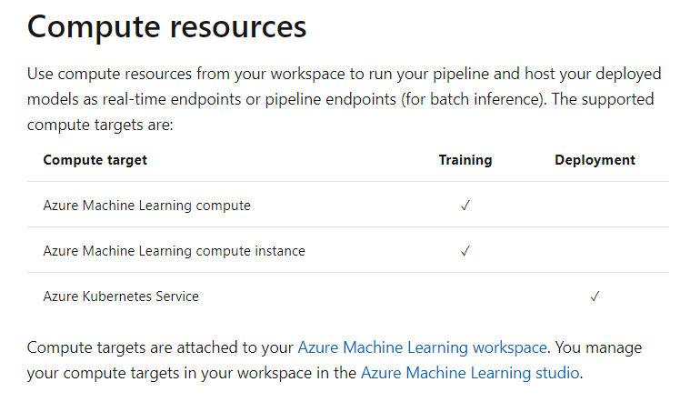

https://docs.microsoft.com/en-us/azure/machine-learning/concept-designer#deploy

You want to deploy a real-time inference pipeline as a service for others to consume. Which of the following must you deploy the model to for this requirement?

* ​

A local web service

* ​

Azure Container Instances

* ​

Azure Kubernetes Services

**(Correct)**

* ​

Azure Machine Learning compute

Explanation

The Inference pipeline can be deployed onto an Azure Kubernetes cluster

### Question 58 feature engineering

Question 58: To complete the following sentence, select the appropriate option from the drop-down menu.

Choose the correct options

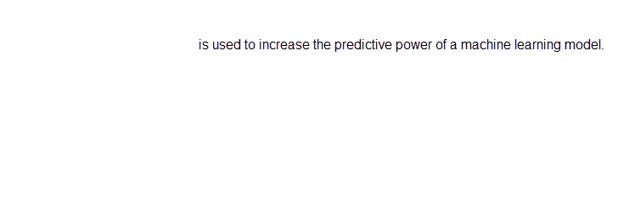



Feature engineering

**Explanation**

Feature engineering is the process of creating new features from raw data to increase the predictive power of the machine learning model. Engineered features capture additional information that is not available in the original feature set. Examples of feature engineering are aggregating data, calculating a moving average, and calculating the difference over time.  
  
Feature selection is the process of selecting a subset of relevant features to use when building and training the model. Feature selection restricts the data to the most valuable inputs, reducing noise and improving training performance.  
  
Evaluation is the process of measuring the accuracy of a trained model. A set of metrics are used to measure how accurate the predictions of the model are.  
  
**References**  
  
[Feature engineering in data science](https://docs.microsoft.com/azure/machine-learning/team-data-science-process/create-features)  
  
[Feature selection in the Team Data Science Process (TDSP)](https://docs.microsoft.com/azure/machine-learning/team-data-science-process/select-features)  
  
[Evaluate Model module](https://docs.microsoft.com/azure/machine-learning/algorithm-module-reference/evaluate-model)

### Question 59 - inference

Question 59: What should you do after training your model and prior to deploying it as a web service?

Choose the correct answer

Clone the training pipeline.

Create a compute cluster.

Evaluate the model.

Create an inference pipeline from the training pipeline.

**Explanation**

After training your model, you need to create another pipeline that performs the same steps for new data input, not the sample data used in training. This new pipeline is an inference pipeline that will be used for predictions. You will publish the inference pipeline as a web service.  
  
Cloning the training pipeline just makes a copy of the pipeline steps in a new experiment. The cloned pipeline is in draft.  
  
Compute clusters are used to train your model. You need to create an Inference cluster to deploy your model.  
  
Evaluation is the process of measuring the accuracy of a trained model. A set of metrics are used to measure how accurate the predictions of the model are. Evaluation is part of the training of your model. You normally remove the evaluate model module from the inference pipeline.  
  
**References**  
  
[Create an inference pipeline](https://docs.microsoft.com/learn/modules/create-regression-model-azure-machine-learning-designer/inference-pipeline)  
  
[What is Azure Machine Learning designer (preview)?](https://docs.microsoft.com/azure/machine-learning/concept-designer)  
  
[Create compute targets for model training and deployment with Python SDK](https://docs.microsoft.com/azure/machine-learning/how-to-create-attach-compute-sdk)  
  
[Evaluate Model module](https://docs.microsoft.com/azure/machine-learning/algorithm-module-reference/evaluate-model)

### Question 60

Question 60: You train a machine learning model. The model evaluation had low training error and high accuracy. You deploy the model and you see a high error rate when predicting new values.  
  
What should you do to improve predictions?

Choose the correct answer

Cross validate the model.

Normalize the data.

Add features.

Split the training data.

**Explanation**

Having low training error and high testing error is known as overfitting. Overfitting means that the model does not generalize well from training data to unseen data, especially for that data that is different from the training data. Common causes are bias in the training data or too many features, meaning that the model cannot distinguish between the signal and the noise.  
  
You should perform cross-validation. In cross-validation, a dataset can be repeatedly split into a training dataset and a validation dataset. Each split is used to train and test the model. Cross-validation evaluates both the dataset and the model, and it provides an idea of how representative the dataset is and how sensitive the model is to variations in input data.  
  
You should not add features. Having too many features can be a cause of overfitting. You should consider removing features instead.  
  
You should not normalize the data. Features with data using different scales can bias the model towards that feature. However, in this scenario the evaluation of the model was successful, so the data does not seem biased. Normalizing the data will not solve the problem.  
  
You should not split the data. You have evaluated the model with test data and the evaluation was successful. Testing with the same data or data you have already used to train the model will cause over training which is a potential cause of overfitting.  
  
**References**  
  
[Cross Validate Model](https://docs.microsoft.com/azure/machine-learning/algorithm-module-reference/cross-validate-model)  
  
[Configure data splits and cross-validation in automated machine learning](https://docs.microsoft.com/azure/machine-learning/how-to-configure-cross-validation-data-splits)  
  
[Train a machine learning model using cross validation](https://docs.microsoft.com/en-us/dotnet/machine-learning/how-to-guides/train-machine-learning-model-cross-validation-ml-net)  
  
[Understanding Cross Validation](https://towardsdatascience.com/understanding-cross-validation-419dbd47e9bd)

### Question 61 – normalization

Question 61: A dataset contains attributes that have values in different units with different ranges of values.  
  
Which data preprocessing method is used to transform the values into a common scale?

Choose the correct answer

Normalization

Binning

Substitution

Sampling

**Explanation**

Normalization is the method that adjusts the values in numeric columns so that all numeric values are on a common scale, normally between 0 and 1. A dataset that has values using different scales can bias the model towards that feature.  
  
Binning is a method used to segment data into groups of the same size. Binning is used when the distribution of values in the data is skewed and transforms continuous numeric features into discrete features (categories).  
  
Sampling is a method used for reducing the size of data while retaining the same ratio of values.  
  
Substitution is a method used for replacing missing values in a dataset.  
  
**References**  
  
[Tasks to prepare data for enhanced machine learning](https://docs.microsoft.com/azure/machine-learning/team-data-science-process/prepare-data)  
  
[Normalize Data module](https://docs.microsoft.com/azure/machine-learning/algorithm-module-reference/normalize-data)

 Previous

### Question 62 - score

Question 62: What should you do to measure the accuracy of a trained machine learning model?

Choose the correct answer

Score the model.

Summarize the data.

Normalize the data.

Create features.

**Explanation**

You should score the model. After a model has been trained, the model should be evaluated using a different set of data. Scoring applies new data to the trained model to generate predictions that can be evaluated using metrics that measure how accurate the predictions of the model are.  
  
You should not create features. Feature engineering creates new features to enhance the training dataset and increase the predictive power of the machine learning model. Features are selected and created before a model is trained and do not assist in the measurement of a model's accuracy.  
  
You should not summarize the data. Summarization generates a set of standard statistical measures that describe each column in the dataset. Summarizing a dataset does not assist in the measurement of a model's accuracy.  
  
You should not normalize the data. Normalization adjusts the range of values in the dataset to prevent the model being biased towards a feature. Normalization is performed before a model is trained and does not assist in the measurement of a model's accuracy.  
  
**References**  
  
[Score Model](https://docs.microsoft.com/azure/machine-learning/algorithm-module-reference/score-model)  
  
[Feature engineering in data science](https://docs.microsoft.com/azure/machine-learning/team-data-science-process/create-features)  
  
[Normalize Data module](https://docs.microsoft.com/azure/machine-learning/algorithm-module-reference/normalize-data)  
  
[Summarize Data](https://docs.microsoft.com/azure/machine-learning/algorithm-module-reference/summarize-data)

### Question 63 – compute instance

Question 63: Which compute target should you use for the development of machine learning models?

Choose the correct answer

Azure Container Instances (ACI)

Compute cluster

Azure Kubernetes Service (AKS)

Compute instance

**Explanation**

A compute instance is a configured development environment for machine learning. A compute instance is used as a compute target for authoring and training models for development and testing purposes.  
  
ACI is used to run a prediction model as a web service in testing and debugging scenarios.  
  
AKS cluster is used to run highly scalable real-time interferencea as a web service.  
  
A compute cluster is used to train models with Azure ML designer and for running batch interference on large amounts of data.  
  
**References**  
  
[What are compute targets in Azure Machine Learning?](https://docs.microsoft.com/azure/machine-learning/concept-compute-target)  
  
[Azure Machine Learning tools and interfaces](https://docs.microsoft.com/learn/modules/intro-to-azure-machine-learning-service/3-azure-ml-tools)  
  
[What is an Azure Machine Learning compute instance?](https://docs.microsoft.com/azure/machine-learning/concept-compute-instance)  
  
[Deploy a model to Azure Container Instances](https://docs.microsoft.com/azure/machine-learning/how-to-deploy-azure-container-instance)  
  
[Deploy a model to an Azure Kubernetes Service cluster](https://docs.microsoft.com/azure/machine-learning/how-to-deploy-azure-kubernetes-service)  
  
[Run batch inference on large amounts of data by using Azure Machine Learning](https://docs.microsoft.com/azure/machine-learning/how-to-use-parallel-run-step)

## Describe capabilities of no-code machine learning with Azure Machine Learning:

### Question 64 – portal

Question 64: You build a new pipeline in Azure Machine Learning Designer to predict potential flight delays. 70 percent of the flight delays data is to be allocated to training, and the remaining 30 percent to testing.  
  
Which modules should you use to complete the pipeline configuration? To answer, drag the appropriate module name to the relevant slots. A module name may be used once, more than once, or not at all.

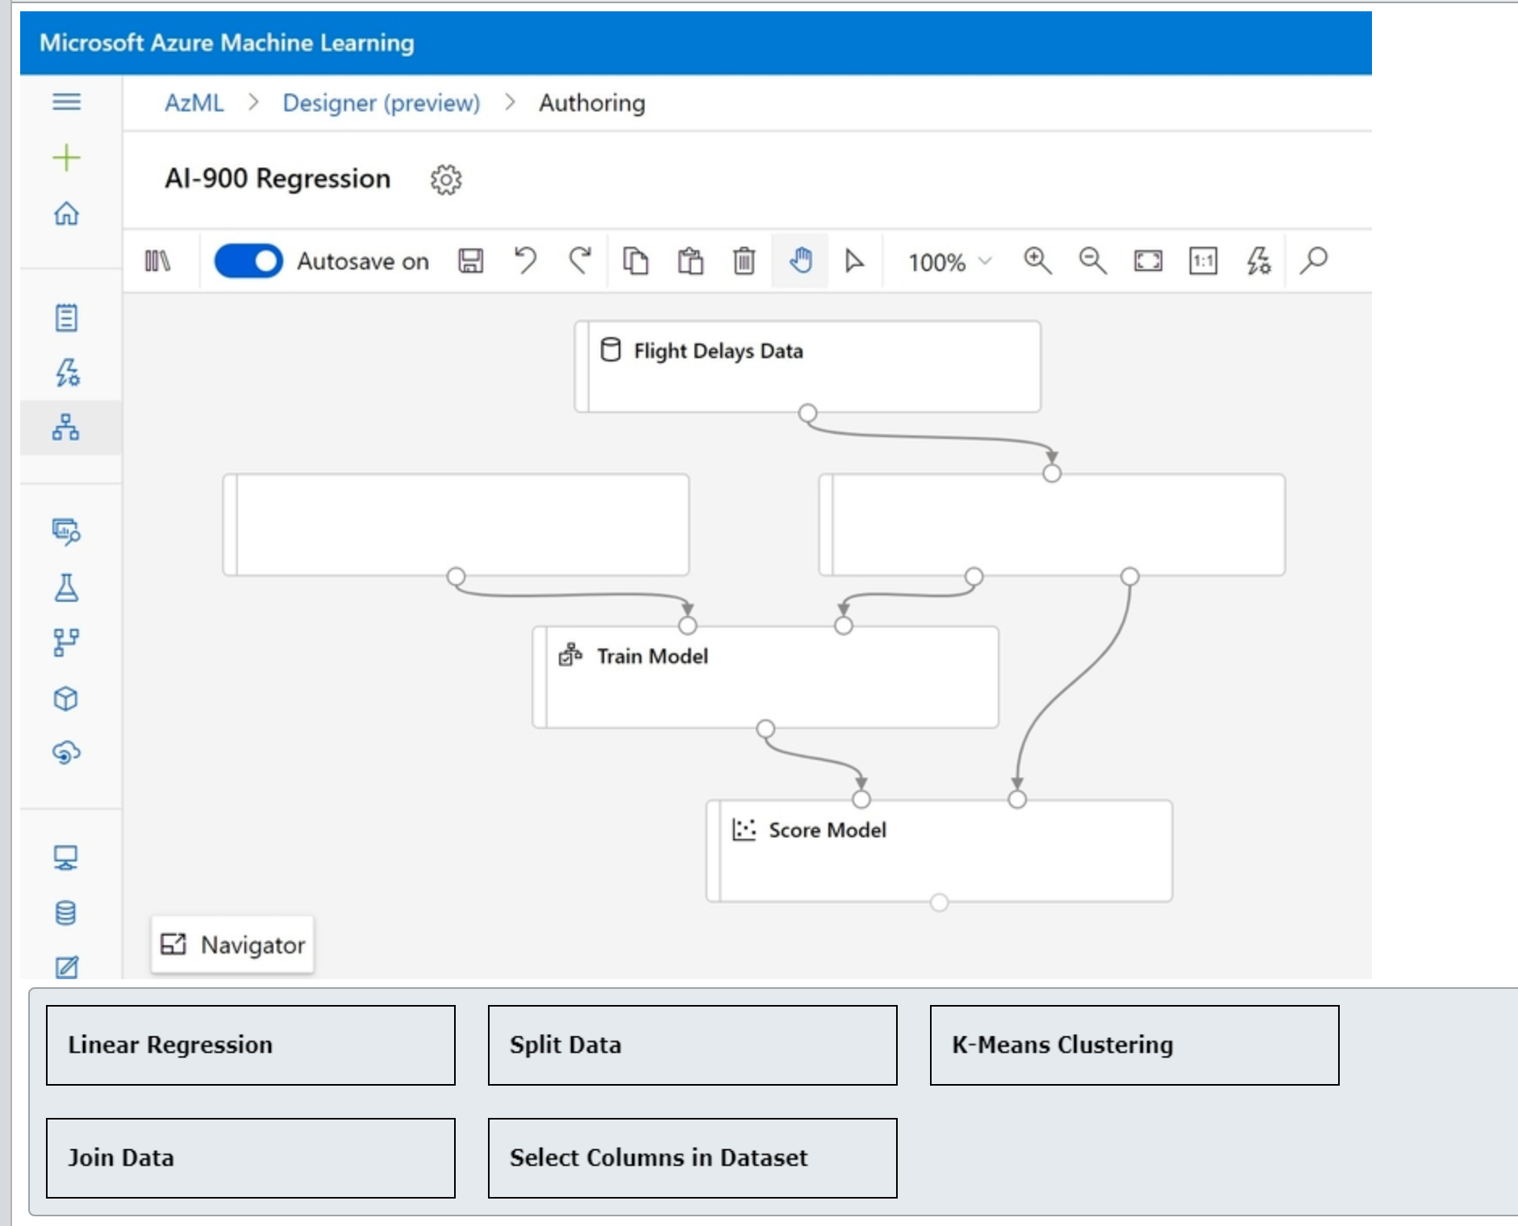

Drag and drop the answers















**Explanation**

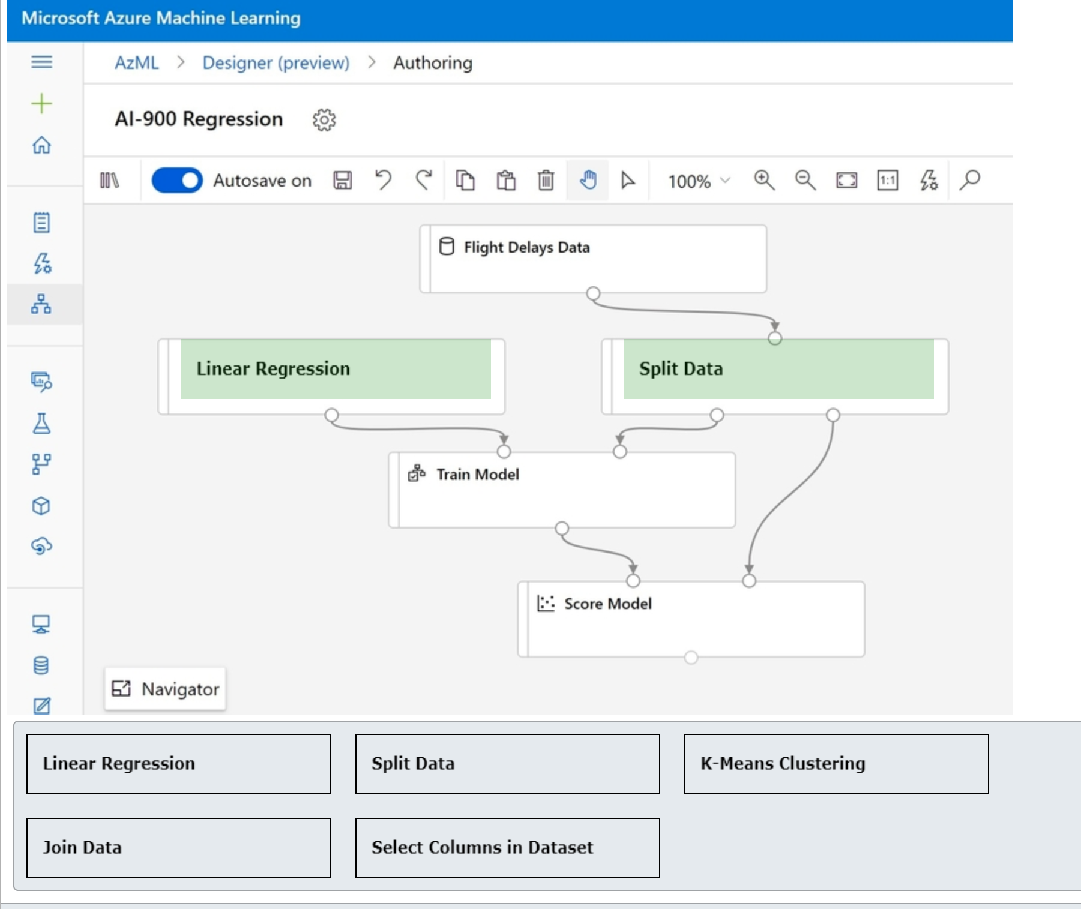

You should use Linear Regression module for the pipeline configuration. You should link its output port to the left input port of Train Model module. Linear regression is a type of regression algorithm that you can use in this scenario to train a model on the labeled flight delay dataset and predict potential delays.  
  
You should use Split Data module for the pipeline configuration where Flight Delays dataset is used as an input. Split Data module will divide dataset into training and testing subsets in a 30/70 ratio, and then feed them respectively to the right input ports of Train Model and Score Model modules.  
  
You should not use K-Means Clustering module. This is a clustering algorithm module and cannot be used to train regression models for flight delay predictions.  
  
You should not use Join Data module. This can be used to merge two datasets using joint operation. However, it cannot be used to split the original dataset into training and testing subsets as required in this scenario.  
  
You should not use Select Columns in Dataset. With this module you can select a subset of columns. However, it cannot be used to split dataset as required in this scenario.  
  
**References**  
  
[Tutorial: Predict automobile price with the designer (preview)](https://docs.microsoft.com/en-us/azure/machine-learning/tutorial-designer-automobile-price-train-score)  
  
[Split Data module](https://docs.microsoft.com/en-us/azure/machine-learning/algorithm-module-reference/split-data)  
  
[Linear Regression module](https://docs.microsoft.com/en-us/azure/machine-learning/algorithm-module-reference/linear-regression)  
  
[Select Columns in Dataset module](https://docs.microsoft.com/en-us/azure/machine-learning/algorithm-module-reference/select-columns-in-dataset)  
  
[Join Data](https://docs.microsoft.com/en-us/azure/machine-learning/algorithm-module-reference/join-data)  
  
[Module: K-Means Clustering](https://docs.microsoft.com/en-us/azure/machine-learning/algorithm-module-reference/k-means-clustering)

### Question 65 - portal

Question 65: You build a new pipeline in Azure Machine Learning Designer to predict from the census data whether a person will earn more or less than $50,000 per year.  
  
You need to populate the records with the empty numeric fields with the column’s mean values.  
  
What modules should you use to complete the pipeline configuration? To answer, drag the appropriate module names to the relevant slots. A module name may be used once, more than once, or not at all.

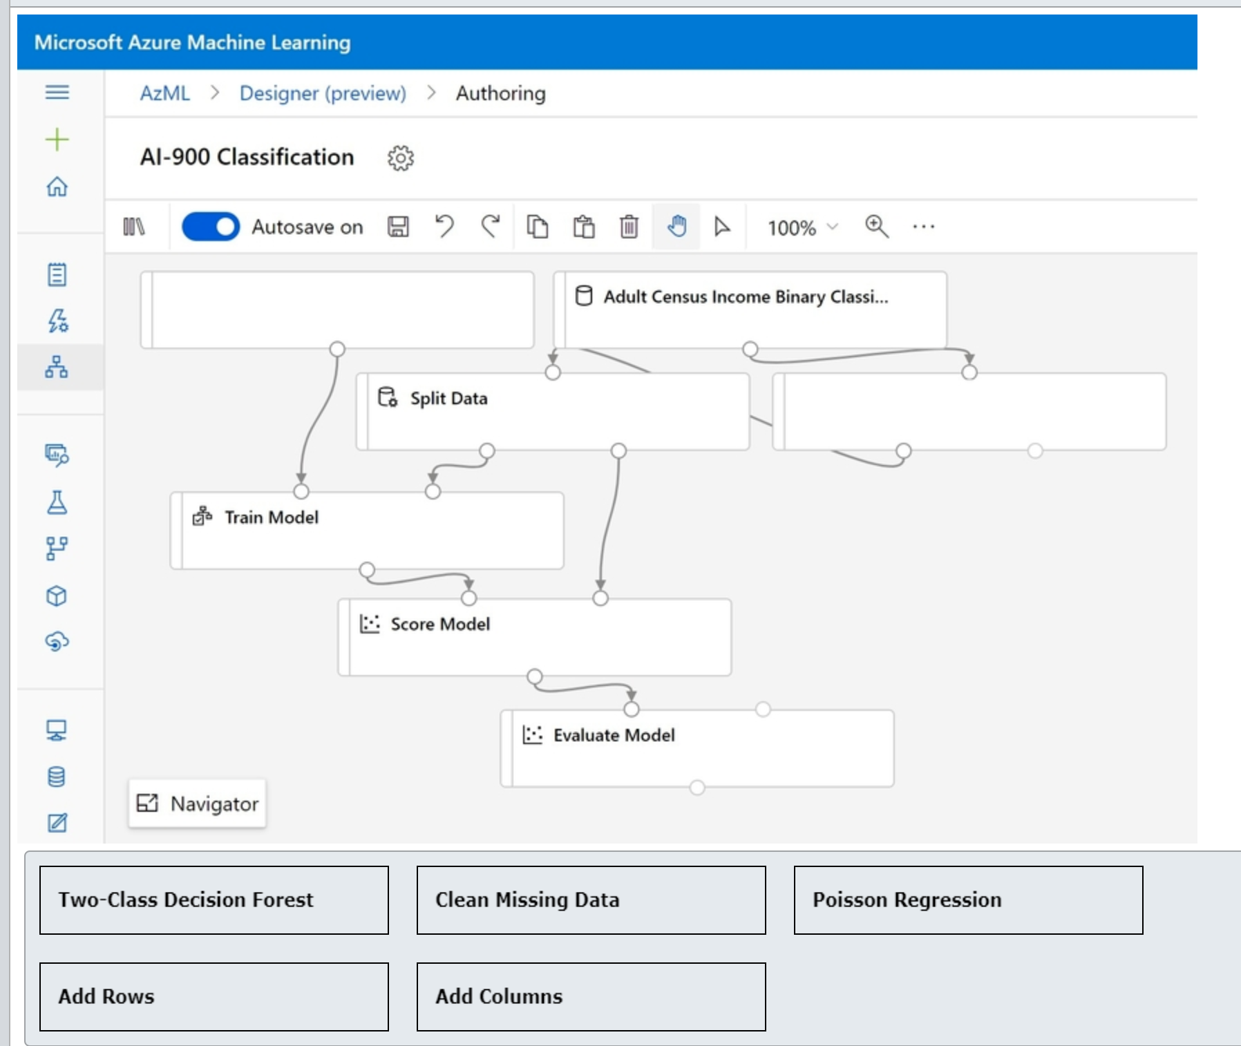

Drag and drop the answers















**Explanation**

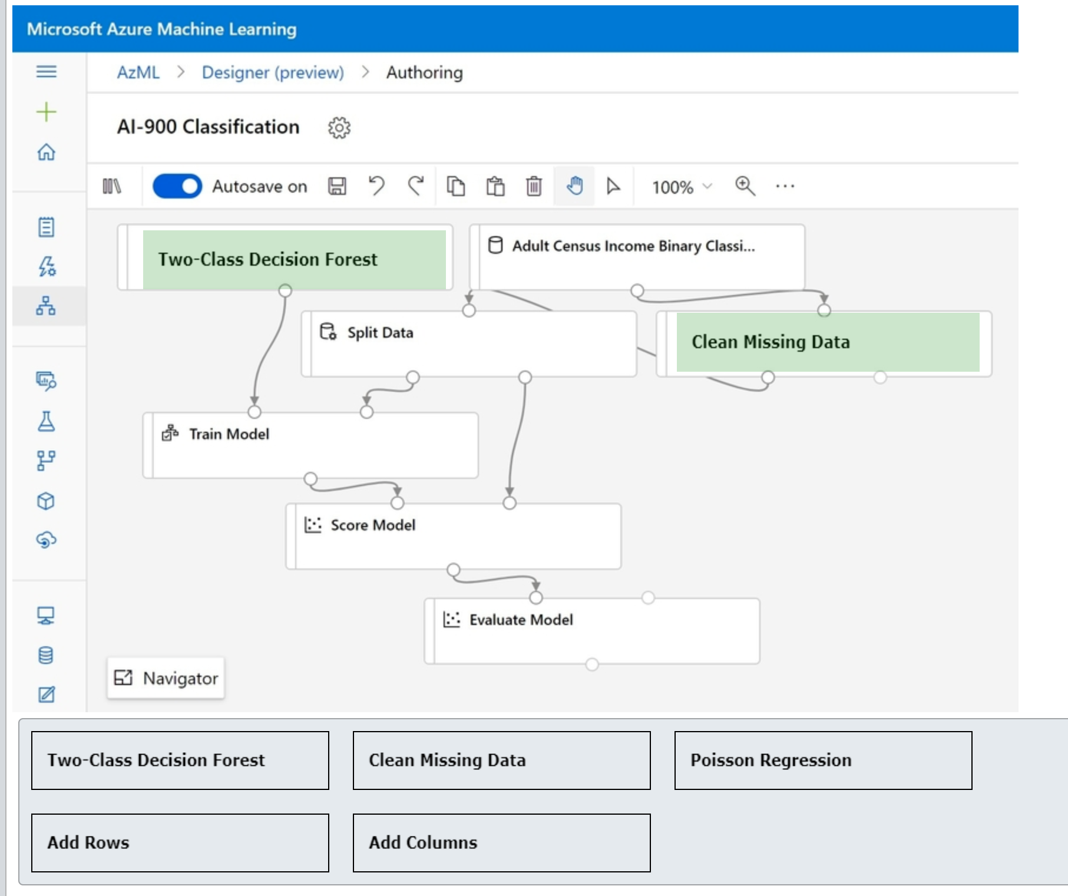

You should use the Two-Class Decision Forest module for the pipeline configuration and link its output port to the left input port of the Train Model module. It is a classification algorithm that predicts a binary outcome, which meets our case requirements as the model should predict whether a person will earn more or less than $50,000 per year.  
  
You should also use the Clean Missing Data module for the pipeline configuration. You should link its input port to the census dataset output port, while this module’s own output port should feed the Split Data module. This will ensure that the module finds and populates all the empty fields before the pipeline splits them into training and testing subsets.  
  
You should not use the Poisson Regression module. As its name describes, this is a regression type algorithm that predicts numeric values, typically counts. However, in this scenario we require a classification algorithm module to predict the probability of a person being in either a lower or a higher income earner category.  
  
You should not use the Add Rows or the Add Columns modules. They are intended to merge two datasets by combining their rows or columns. However, these modules cannot be used to find and populate empty cells in a single dataset with the columns’ mean values as required in this scenario.  
  
**References**  
  
[Tutorial: Predict automobile price with the designer (preview)](https://docs.microsoft.com/en-us/azure/machine-learning/tutorial-designer-automobile-price-train-score)  
  
[Two-Class Decision Forest module](https://docs.microsoft.com/en-us/azure/machine-learning/algorithm-module-reference/two-class-decision-forest)  
  
[Poisson Regression](https://docs.microsoft.com/en-us/azure/machine-learning/algorithm-module-reference/poisson-regression)  
  
[Clean Missing Data module](https://docs.microsoft.com/en-us/azure/machine-learning/algorithm-module-reference/clean-missing-data)  
  
[Add Columns module](https://docs.microsoft.com/en-us/azure/machine-learning/algorithm-module-reference/add-columns)  
  
[Add Rows module](https://docs.microsoft.com/en-us/azure/machine-learning/algorithm-module-reference/add-rows)

 Previous

### Question 66 Designer

Question 66: For each of the following statements about Azure Machine Learning (Azure ML) designer, select Yes if the statement is true. Otherwise, select No.

|  |  |  |
| --- | --- | --- |
| **Statement** | **Yes** | **No** |
| You can connect datasets directly to each other. |  |  |
| You can connect modules directly to each other. |  |  |
| Pipeline endpoint can be used to send and receive data in real time. |  |  |

**Explanation**

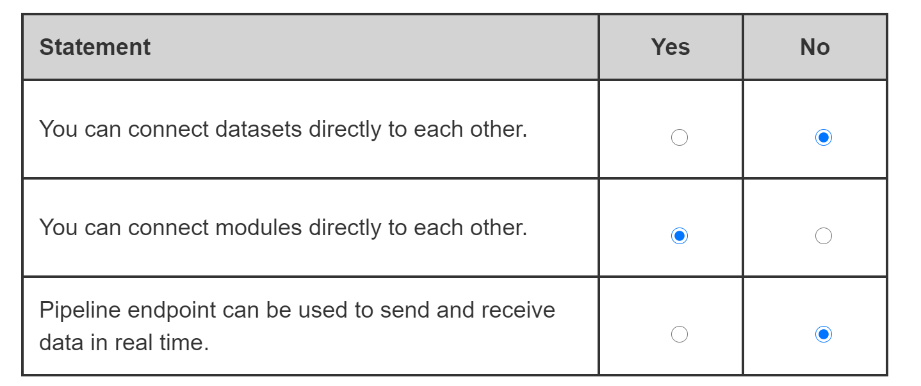

You cannot connect datasets in Azure ML designer directly to each other. Like the data sources, datasets have only output ports and thus can only connect to modules, but not to other datasets. However, modules can be used to combine the data from various datasets.  
  
You can connect modules in AzureML designer directly to each other. Modules have both input and output ports and can connect to either datasets or other modules.  
  
Pipelines in AzureML designer published to a pipeline endpoint can be used to train models, process new data, etc. However, data cannot be sent or received from a pipeline endpoint in real time, but it is actioned asynchronously instead. For the real time interaction, such as to receive model’s prediction results, a pipeline should be deployed as a real-time endpoint.  
  
**References**  
  
[What is Azure Machine Learning designer (preview)?](https://docs.microsoft.com/en-us/azure/machine-learning/concept-designer)

 Previous

### Question 67 best model option

Question 67: What should you configure in Automated Machine Learning (AutoML) settings to ensure that it follows the Transparency principle of Responsible AI?

Choose the correct answer

Enable Explain best model option.

Set Primary metric to Accuracy.

Set Validation type to Auto.

Select RandomForest in Blocked algorithms list.

**Explanation**

You should enable Explain best model option. According to the Responsible AI’s Transparency principle, AI systems should be understandable. Enabling this configuration setting ensures that explainability is automatically shown for the recommended best model created by AutoML.  
  
You should not select RandomForest in Blocked algorithms list. This configuration setting lets you specify algorithms that AutoML will not use during model training. It does not make AI system explainable to end users.  
  
You should not set Primary metric to Accuracy. This configuration setting can help you select main metrics for scoring your model. However, it does not make AI system’s functionality transparent to end users.  
  
You should not set Validation type to Auto. With this configuration setting some data guardrails are enabled, but it does not explain specifics of the model’s functionality as required by Transparency principle of Responsible AI.  
  
**References**  
  
[Responsible AI](https://www.microsoft.com/en-us/ai/responsible-ai?activetab=pivot1:primaryr6)  
  
[Create, review, and deploy automated machine learning models with Azure Machine Learning](https://docs.microsoft.com/en-us/azure/machine-learning/how-to-use-automated-ml-for-ml-models)

 Previous

### Question 68 only File/Tabular dataset supported in Auto ml

Question 68: Which two data source types are supported in Azure Automated Machine Learning (AutoML)? Each correct answer presents a complete solution.

Choose the correct answers

File Dataset

Tabular Dataset

Azure Cosmos DB

Azure Cache for Redis

Azure Database for MySQL

**Explanation**

Tabular and File datasets are the data source types supported in Azure AutoML. Tabular dataset represents data in tabular format, which was generated by parsing CSV, TSV, Parquet JSON Lines or SQL query result files. File dataset can represent files in any format, such as image or sound files, which can be downloaded from your datastores or public URLs and used along with the relevant labels to train a model.  
  
Azure Cache for Redis, Azure Cosmos DB and Azure Database for MySQL are not supported as data sources in Azure AutoML. These are managed in-memory data store, NoSQL and SQL databases, which provide access to the data via API endpoints, while Azure AutoML requires direct access to source files to parse them for Tabular dataset, or download/mount them for File dataset registration.  
  
**References**  
  
[Create Azure Machine Learning datasets](https://docs.microsoft.com/en-us/azure/machine-learning/how-to-create-register-datasets)  
  
[Welcome to Azure Cosmos DB](https://docs.microsoft.com/en-us/azure/cosmos-db/introduction)  
  
[Azure Cache for Redis](https://docs.microsoft.com/en-gb/azure/azure-cache-for-redis/cache-overview)  
  
[What is Azure Database for MySQL?](https://docs.microsoft.com/en-gb/azure/mysql/overview)

### Question 69 auto ml def

Question 69: To complete the following sentence, select the appropriate option from the drop-down menu.

Choose the correct options





**Explanation**

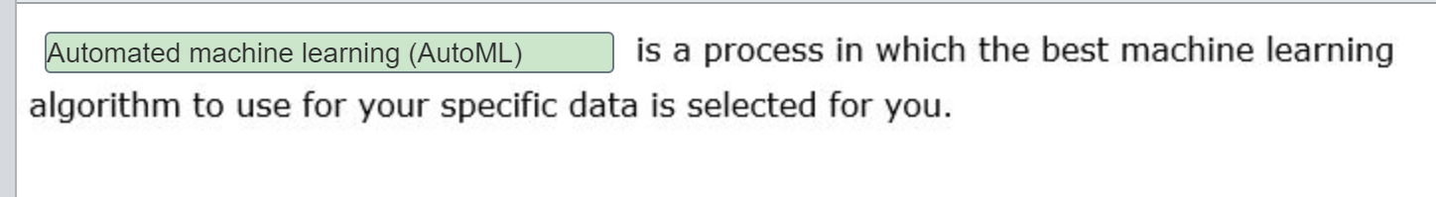

AutoML is a process in which the best machine learning algorithm to use for your specific data is selected for you. AutoML tries different algorithms and tuning parameters in parallel while training a model and stops once it reaches predefined exit criteria. Generated output provides the list of used algorithms along with recommendations on the best ones to use.  
  
Normalization is a technique used to change the values in numeric columns to bring them up to the common scale; to the values ranging between 0 and 1, without loss of information or differences in the value ranges.  
  
Feature engineering is a process of creating new features from within provided input dataset, which can help to better represent relationships and correlations between the input data and expected outcome. Feature engineering improves the quality and performance of the trained model and increases its predictive power.  
  
**References**  
  
[Create, review, and deploy automated machine learning models with Azure Machine Learning](https://docs.microsoft.com/en-us/azure/machine-learning/how-to-use-automated-ml-for-ml-models)  
  
[Normalize Data module](https://docs.microsoft.com/en-us/azure/machine-learning/algorithm-module-reference/normalize-data)  
  
[Feature engineering in data science](https://docs.microsoft.com/en-us/azure/machine-learning/team-data-science-process/create-features)

### Question 70 only File/Tabular dataset supported in Auto ml

Question 70: Which two types of dataset can you register and use to train your Automatic Machine Learning (AutoML) model? Each correct answer presents a complete solution.

Choose the correct answers

SQL Query

Folder

Azure Blob Container

File

Tabular

**Explanation**

Both File and Tabular datasets can be used in Azure Machine Learning training workflows. A file dataset references single or multiple files. A tabular dataset represents data in a tabular format by parsing the provided file(s). You can create a tabular dataset from CSV, TSV, Parquet, JSON files, and from the output of SQL queries.  
  
You can create a dataset from files in an Azure Blob Container but not from an Azure Blob Container itself. An Azure Blob Container is a valid data store for Azure Machine Learning.  
  
You can create a dataset from files in a folder but not from a folder itself. An Azure File Share is a valid data store for Azure Machine Learning.  
  
You can create a dataset from the output of a SQL query but not from a SQL query itself. An Azure SQL Database is a valid data store for Azure Machine Learning.  
  
**References**  
  
[Secure data access in Azure Machine Learning](https://docs.microsoft.com/azure/machine-learning/concept-data)  
  
[Create Azure Machine Learning datasets](https://docs.microsoft.com/azure/machine-learning/how-to-create-register-datasets)

 Previous

### Question 71 normalize

**MinMax**: The min-max normalizer linearly rescales every feature to the [0,1] interval.

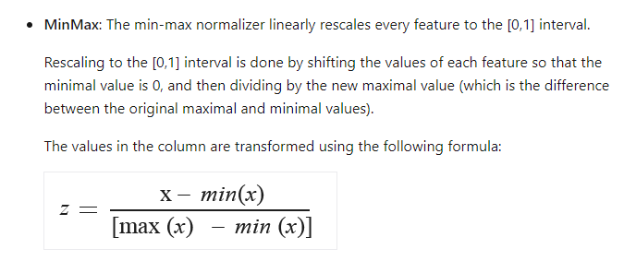

Question 71: Your dataset has multiple numeric features whose values are on different scales.  
  
Which module should you add to the training pipeline in the Azure Machine Leraning (ML) designer to mitigate bias?

Choose the correct answer

Normalize Data

Clip Values

Clean Missing Data

Select Columns in Dataset

**Explanation**

The Normalize Data module adjusts the values in the numeric columns so that all numeric columns are on a similar scale, between 0 and 1. A dataset that has features in different scales can bias the model towards that feature. To mitigate the bias in the model, you transform the numeric features to use the same scale.  
  
The Clean Missing Data module removes, replaces, or infers missing values in the dataset. Clean Missing Data can also remove empty rows from the data set. Missing data can limit the accuracy and effectiveness of predictions. Clean Missing Data does not adjust the scale of the data.  
  
The Clip Values module replaces data values that are above or below a specified threshold with a substitute value. Clip Values is usually used to remove anomalies or outliers in the data. Clip Values does not adjust the scale of the data.  
  
The Select Columns in Dataset module removes columns from the dataset and creates a smaller dataset. Select Columns in Dataset does not change the data values.  
  
**References**  
  
[Normalize Data module](https://docs.microsoft.com/azure/machine-learning/algorithm-module-reference/normalize-data)  
  
[Clean Missing Data module](https://docs.microsoft.com/azure/machine-learning/algorithm-module-reference/clean-missing-data)  
  
[Clip Values](https://docs.microsoft.com/azure/machine-learning/algorithm-module-reference/clip-values)  
  
[Select Columns in Dataset module](https://docs.microsoft.com/azure/machine-learning/algorithm-module-reference/select-columns-in-dataset)

 Previous

### Question 72 not valid question

Question 72: You plan to use Azure Machine Learning designer to create a classification machine learning model. Which Azure Machine Learning workspace edition should you use?

Choose the correct answer

Enterprise

Production

Basic

Dev-test

**Explanation**

The Enterprise edition has all the features of the Basic edition plus the use of the Machine Learning designer to create and publish models with no code.  
  
The Basic edition can create, run, and publish models, but only by using the SDK. The Basic edition does not allow the use of the Machine Learning designer. The Basic edition is a code first experience.  
  
Production and dev-test are the available cluster purposes when creating an inference cluster to run a prediction model.  
  
**References**  
  
[Azure Machine Learning pricing](https://azure.microsoft.com/pricing/details/machine-learning/)  
  
[Enterprise (preview) and Basic Editions of Azure Machine Learning](https://docs.microsoft.com/azure/machine-learning/concept-editions)  
  
[Deploy models with Azure Machine Learning](https://docs.microsoft.com/azure/machine-learning/how-to-deploy-and-where)  
  
[Deploy a model to an Azure Kubernetes Service cluster](https://docs.microsoft.com/azure/machine-learning/how-to-deploy-azure-kubernetes-service)

 Previous

### Question 73 – Not valid question

Question 73: You use Automated machine learning (ML) to find the best model for your data.  
  
Which option should you use to interpret and provide transparency for the model selected?

Choose the correct answer

Target column

Forecast horizon

Enable deep learning

Explain best model

**Explanation**

Explain best model generates an explanation for the model that was identified as the best model. The explanation allows you to understand why the model was selected and how the model works. It enables you to meet regulatory requirements and provides transparency to users.  
  
Deep learning uses neural networks to increase classification accuracy. It does not enable you to explain the model.  
  
The forecast horizon is the number of time periods in the future you want to forecast. This option is available for time-series data.  
  
The target column is the label you want to predict. It does not enable you to explain how the model works.  
  
**References**  
  
[Model interpretability in Azure Machine Learning (preview)](https://docs.microsoft.com/azure/machine-learning/how-to-machine-learning-interpretability)  
  
[Create, review, and deploy automated machine learning models with Azure Machine Learning](https://docs.microsoft.com/azure/machine-learning/how-to-use-automated-ml-for-ml-models)  
  
[Tutorial: Forecast demand with automated machine learning](https://docs.microsoft.com/en-gb/azure/machine-learning/tutorial-automated-ml-forecast)  
  
[Deep neural network concepts](https://docs.microsoft.com/learn/modules/train-evaluate-deep-learn-models/2-deep-neural-network-concepts)  
  
[Auto-train a time-series forecast model](https://docs.microsoft.com/azure/machine-learning/how-to-auto-train-forecast#configure-and-run-experiment)

### Question 74 designer

Question 74: For each of the following statements, select Yes if the statement is true. Otherwise, select No.

|  |  |  |
| --- | --- | --- |
| **Statement** | **Yes** | **No** |
| The Azure Machine Learning studio supports both no-code and code-first experiences. |  |  |
| The Azure Machine Learning studio can create and run Jupyter notebooks. |  |  |
| The Azure Machine Learning studio can create models using C# and .NET. |  |  |

**Explanation**

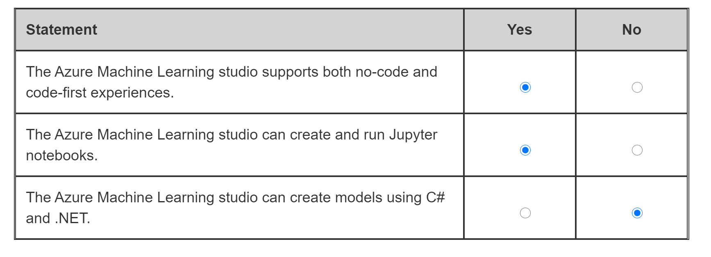

Azure Machine Learning studio supports both no-code and code-first experiences. You can build, train, and run machine learning models with Automated Machine Learning, Notebooks, and a Visual drag-and-drop designer.  
  
The Azure Machine Learning studio supports the use of Jupyter notebooks that use the Python SDK to create and run machine learning models.  
  
The Azure Machine Learning studio does not support the use of C# or .NET. You can use Visual Studio or Visual Studio Code to create a model in C# using the ML.NET SDK.  
  
**References**  
  
[What is Azure Machine Learning studio?](https://docs.microsoft.com/azure/machine-learning/overview-what-is-machine-learning-studio)  
  
[Tutorial: Get started creating your first ML experiment with the Python SDK](https://docs.microsoft.com/azure/machine-learning/tutorial-1st-experiment-sdk-setup)  
  
[Compare the machine learning products and technologies from Microsoft](https://docs.microsoft.com/azure/architecture/data-guide/technology-choices/data-science-and-machine-learning)  
  
[What is ML.NET and how does it work?](https://docs.microsoft.com/dotnet/machine-learning/how-does-mldotnet-work)

### Question 75 auto ml only possible classification/regression

Question 75: For each of the following statements, select Yes if the statement is true. Otherwise, select No.

|  |  |  |
| --- | --- | --- |
| **Statement** | **Yes** | **No** |
| Automated machine learning (AutoML) can train and tune a classification model. |  |  |
| Automated machine learning (AutoML) can train and tune a clustering model. |  |  |
| Automated machine learning (AutoML) can train and tune a regression model. |  |  |

**Explanation**

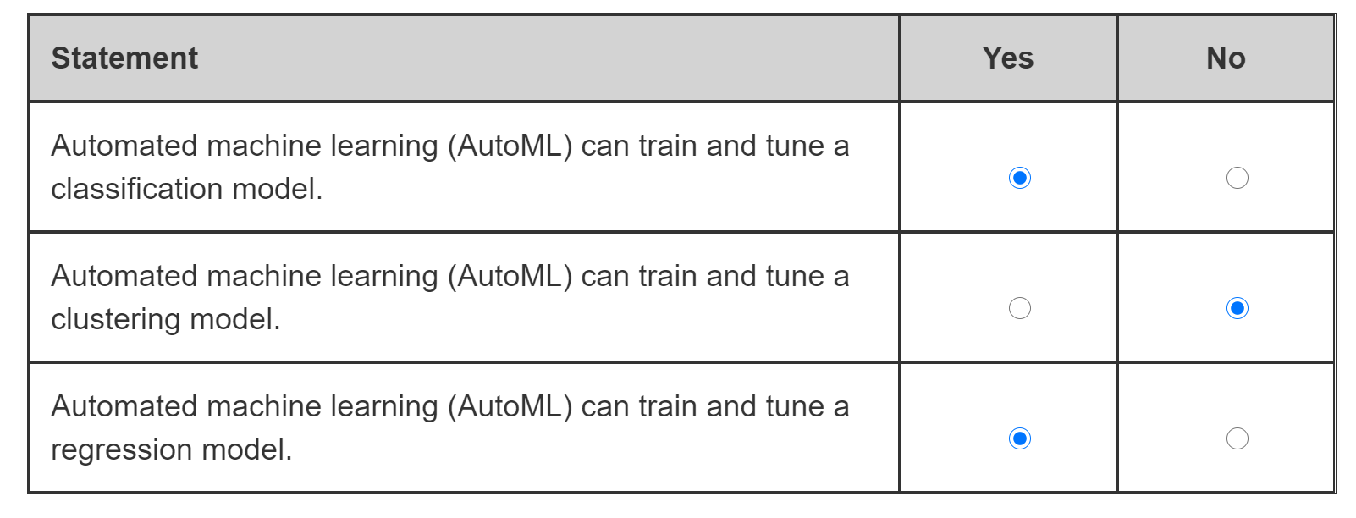

Automated machine learning (AutoML) finds the best algorithm for the dataset and task you choose. You can choose from classification, regression, and time-series forecasting. A number of iterations are run evaluating different algorithms and features. The results are analyzed and ranked, and an explanation produced that interprets the best model for the data, parameters, and task.  
  
AutoML can train and tune a classification model. Classification is one of the model types you can choose when using AutoML. AutoML will discover which of the classification algorithms produces the best model for the dataset.  
  
AutoML cannot train and tune a clustering model. There is only one clustering algorithm available in Azure Machine Learning, K-Means Clustering. AutoML has no purpose for clustering because there is only the single model.  
  
AutoML can train and tune a regression model. Regression is one of the model types you can choose when using AutoML. AutoML will discover which of the regression algorithms produces the best model for the dataset.  
  
**References**  
  
[What is automated machine learning (AutoML)?](https://docs.microsoft.com/azure/machine-learning/concept-automated-ml)  
  
[Module: K-Means Clustering](https://docs.microsoft.com/azure/machine-learning/algorithm-module-reference/k-means-clustering)

### Question 76 designer

Question 76: You create a training pipeline in Azure Machine Learning designer. You need to complete the pipeline.  
  
Which modules should you use to complete the pipeline? To answer, drag the appropriate module to the relevant slots. A module may be used once, more than once, or not at all.

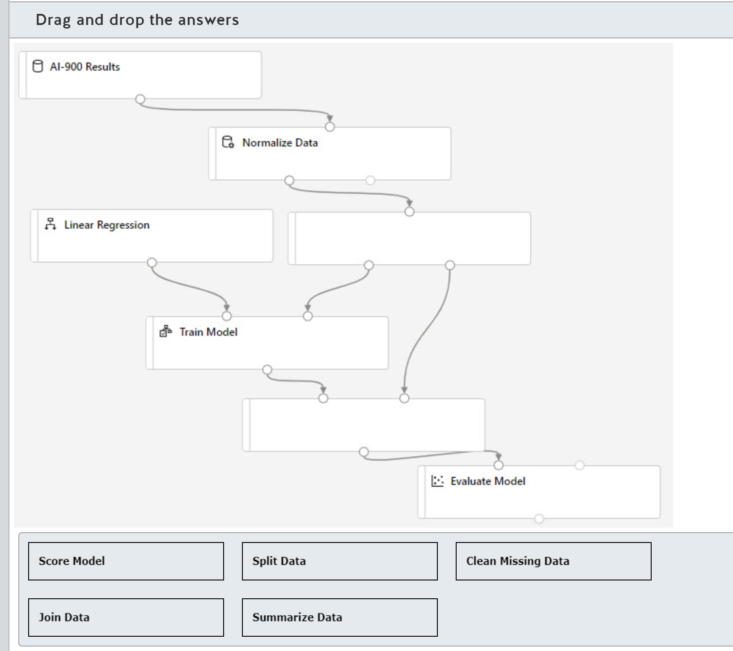

Drag and drop the answers















**Explanation**

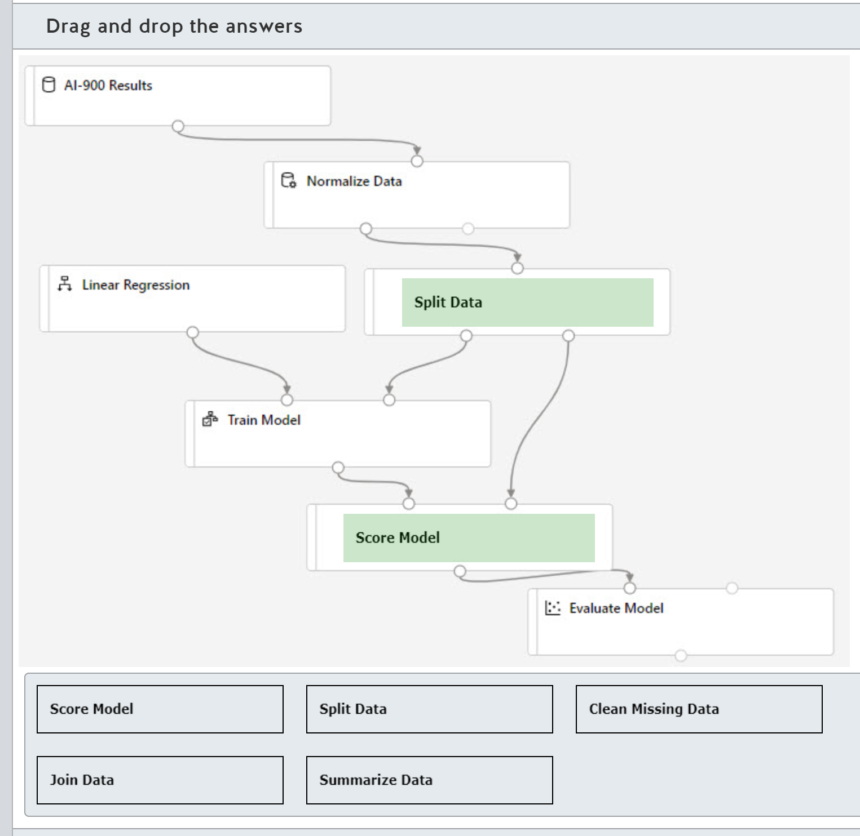

The Split Data module is required to create two datasets, one to train the model and the other to score the model. Split Data has two outputs, one to the Train Model step and the other to the Score Model step.  
  
The Score Model module is required before you can evaluate the model. The Score Model module is added between the Train Model and Evaluate Model steps in the pipeline. Score Model generates predictions using the trained model. Score Model has two inputs, one from Train Model and the other from Split Data.  
  
The Clean Missing Data module removes and replaces missing values and removes rows. Clean Missing Data should be added before any Normalize Data step in the pipeline to make sure the normalization is correctly performed. Clean Missing Data has two outputs, the second is the rejected data and is not usually connected to any other step.  
  
The Join Data module joins two datasets together using a key column.  
  
The Summarize Data module creates a set of statistical measures to describe each column in the data set.  
  
**References**  
  
[What is Azure Machine Learning designer (preview)?](https://docs.microsoft.com/azure/machine-learning/concept-designer)  
  
[Split Data module](https://docs.microsoft.com/azure/machine-learning/algorithm-module-reference/split-data)  
  
[Score Model](https://docs.microsoft.com/azure/machine-learning/algorithm-module-reference/score-model)  
  
[Clean Missing Data module](https://docs.microsoft.com/azure/machine-learning/algorithm-module-reference/clean-missing-data)  
  
[Join Data](https://docs.microsoft.com/azure/machine-learning/algorithm-module-reference/join-data)  
  
[Summarize Data](https://docs.microsoft.com/azure/machine-learning/algorithm-module-reference/summarize-data)

### Question 77 - designer

Question 77: You create a real-time inference pipeline from a training pipeline in Azure Machine Learning designer. You need to complete the inference pipeline.  
  
Which modules should you use to complete the pipeline? To answer, drag the appropriate module to the relevant slots. A module may be used once, more than once, or not at all.

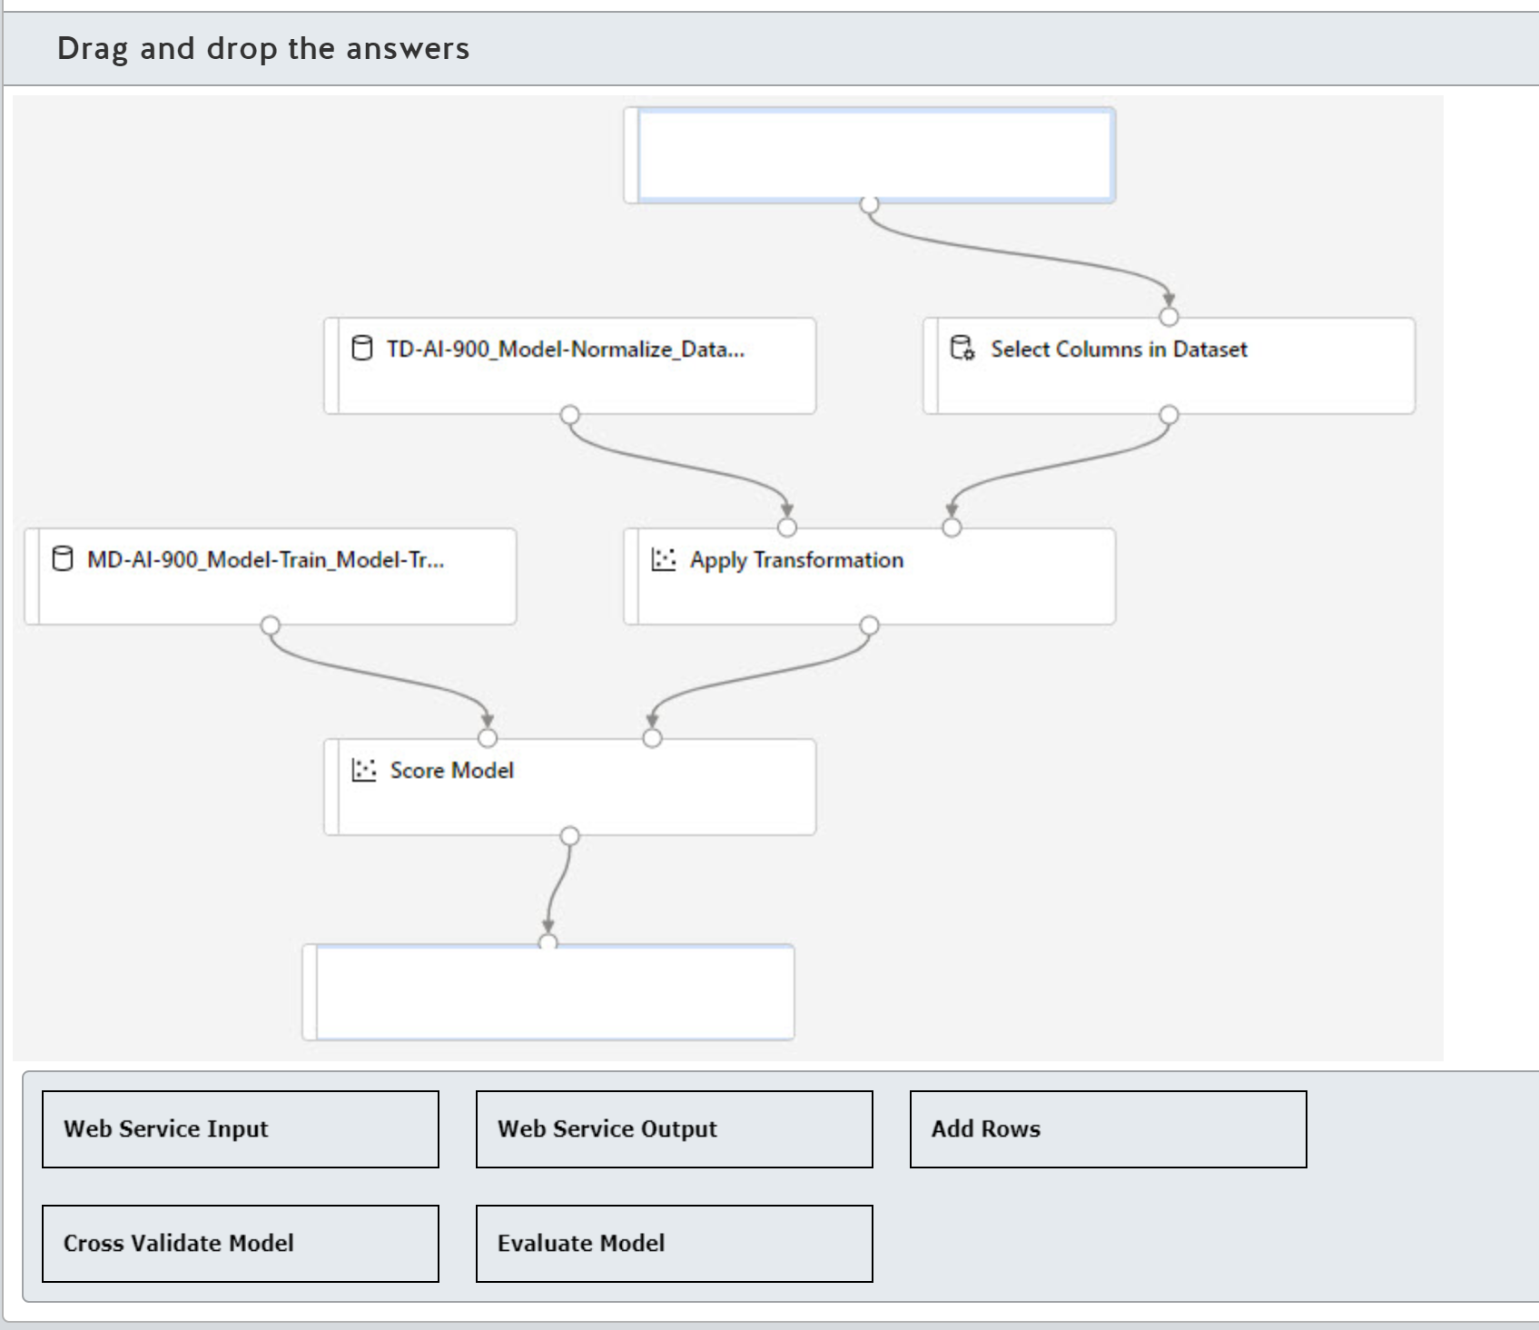

Drag and drop the answers















**Explanation**

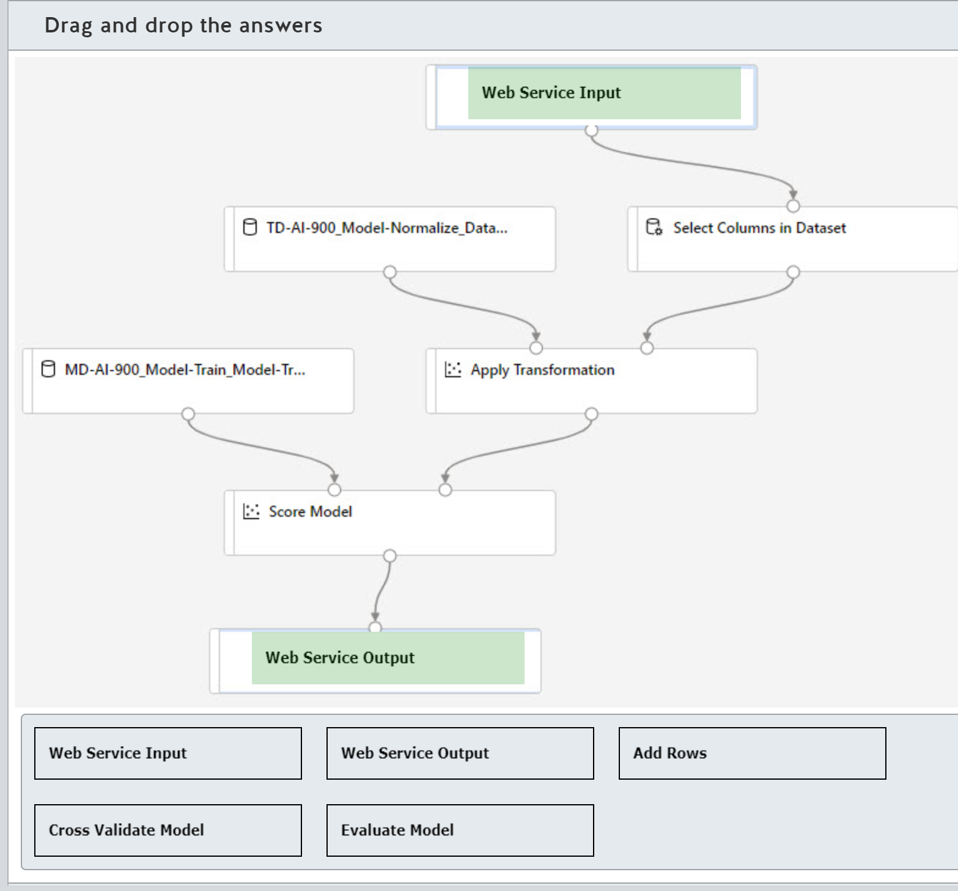

A real-time inference pipeline must have at least one Web Service Input module and one Web Service Output module. The Web Service Input module is normally the first step in the pipeline and replaces the dataset in the training pipeline. The Web Service Output module is normally the final step in the pipeline.  
  
The Add Rows module combines two datasets together by appending the second dataset to the first dataset. You would use this module in a training pipeline.  
  
The Cross Validate Model module evaluates both the dataset and the model, and provides an idea of how representative the dataset is and how sensitive the model is to variations in input data. You would use this module in a training pipeline to prevent your model from being overfitted.  
  
The Evaluate Model module is not required for an inference pipeline and can be removed. Evaluate Model is used to measure the accuracy of a trained pipeline.  
  
**References**  
  
[What is Azure Machine Learning designer (preview)?](https://docs.microsoft.com/azure/machine-learning/concept-designer)  
  
[Web Service Input and Web Service Output modules](https://docs.microsoft.com/en-us/azure/machine-learning/algorithm-module-reference/web-service-input-output)  
  
[Add Rows module](https://docs.microsoft.com/en-us/azure/machine-learning/algorithm-module-reference/add-rows)  
  
[Cross Validate Model](https://docs.microsoft.com/en-us/azure/machine-learning/algorithm-module-reference/cross-validate-model)  
  
[Evaluate Model module](https://docs.microsoft.com/en-us/azure/machine-learning/algorithm-module-reference/evaluate-model)

### Auto ML questions

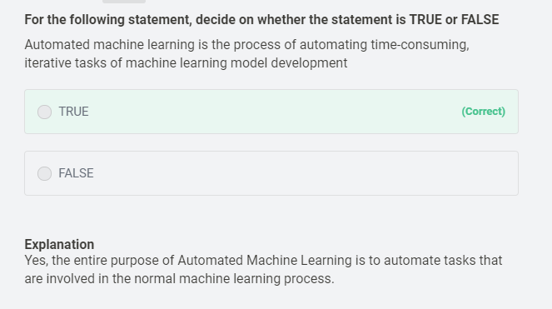

**For the following statement, decide on whether the statement is TRUE or FALSE**

Automated Machine Learning provides the ability to include custom Python scripts in a training pipeline?

* ​

TRUE

**(Correct)**

* ​

FALSE

#### Explanation

Yes, you can include custom Python scripts in your pipeline

**Select True or False**

Automated machine learning can automatically infer the training data from the use case provided

* ​

True

* ​

False

**(Correct)**

#### Explanation

We need to provide the training data to the Auto ML.

# Describe features of computer vision workloads on Azure

## Identify common types of computer vision solution:

### Question 78

Question 78: Match the Computer Vision solution to a scenario.  
  
To answer, drag the appropriate computer vision solution to each relevant scenario. A computer vision solution may be used once, more than once, or not at all.

Drag and drop the answers





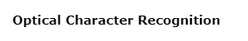









**Explanation**

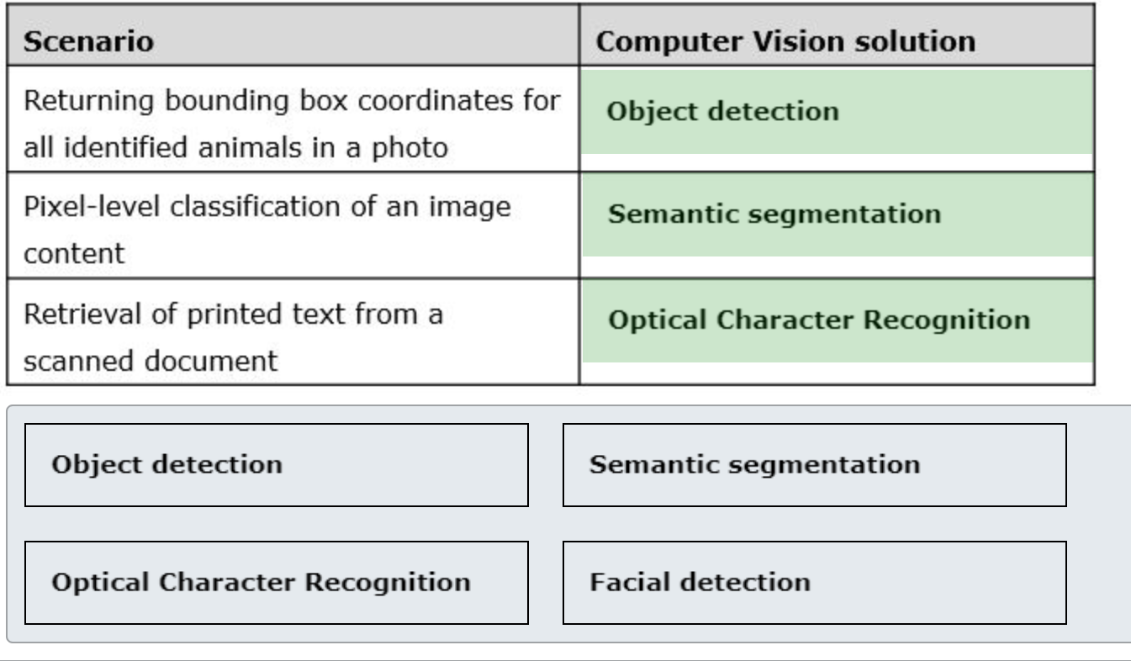

You should use object detection solution for returning bounding box coordinates for all identified animals on a photo. Object detection can process the image to identify various animals, such as cats and dogs, and return their coordinates.  
  
You should use semantic segmentation solution for pixel-level classification of an image content. As a part of the image processing, pixels which share specific characteristics, such as parts of tissue and bones on X-ray image, are assigned with the same labels to define the boundaries of the relevant body parts.  
  
You should use Optical Character Recognition (OCR) for retrieval of printed text from a scanned document. OCR is a process of extracting printed or handwritten text from the input images or PDF documents.  
  
Facial detection is not related to any of the provided scenarios. Facial detection can identify human faces on an image, generate a rectangle for each detected face, and provide additional details such as age or gender.  
  
**References**  
  
[What is Computer Vision?](https://docs.microsoft.com/en-us/azure/cognitive-services/computer-vision/home)  
  
[Detect common objects in images](https://docs.microsoft.com/en-us/azure/cognitive-services/computer-vision/concept-object-detection)  
  
[Semantic segmentation as image representation for scene recognition](https://www.microsoft.com/en-us/research/wp-content/uploads/2016/02/SemanticSegmentation_Final.pdf)  
  
[Optical Character Recognition (OCR)](https://docs.microsoft.com/en-us/azure/cognitive-services/computer-vision/concept-recognizing-text)  
  
[Face detection with Computer Vision](https://docs.microsoft.com/en-us/azure/cognitive-services/computer-vision/concept-detecting-faces)

 Previous

### Question 79

Question 79: To complete the following sentence, select the appropriate option from the drop-down menu.

Choose the correct options





**Explanation**

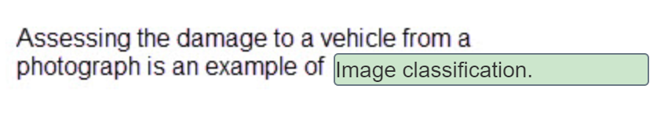

Image classification is a machine learning model that predicts the category (class) that the contents of an image belong to. A set of images is used to train the model. The model can then be used to categorize a new image. You train the model by uploading images of vehicles with differing levels of damage, and you label them with the class labels that you want to identify. The model will then be able to place any new image in one of the categories.  
  
Object detection identifies and tags individual objects in a model. Object detection will identify and tag the vehicle and may be able to identify the manufacturer and model, but it will not be able to assess the level of damage to the vehicle.  
  
Optical character recognition (OCR) extracts text from an image. You could use OCR to read the license plate of the vehicle, but it would not be able assess the level of damage to the vehicle.  
  
Semantic segmentation associates each pixel in an image with a tagged object. Semantic segmentation will not identify damage to a vehicle.  
  
**References**  
  
[Introduction](https://docs.microsoft.com/learn/modules/classify-images-custom-vision/1-introduction)  
  
[Get started with image classification on Azure](https://docs.microsoft.com/learn/modules/classify-images-custom-vision/2-azure-image-classification)  
  
[Get started with object detection on Azure](https://docs.microsoft.com/learn/modules/detect-objects-images-custom-vision/2-object-detection-azure)  
  
[Get started with OCR on Azure](https://docs.microsoft.com/learn/modules/read-text-computer-vision/2-ocr-azure)  
  
[An overview of semantic image segmentation](https://www.jeremyjordan.me/semantic-segmentation/)

 Previous

### Question 80

Question 80: For which two of these requirements should you use object detection? Each correct answer presents a complete solution.

Choose the correct answers

Detecting the color scheme

Identifying individual objects

Associating each pixel in the image with a label

Identifying the location of visual features

Identifying people

**Explanation**

Object detection identifies and tags individual visual features (objects) in a model. Object detection can recognize many different types of objects. Azure Computer vision is trained in more than 80 categories.  
  
Object detection will also return the coordinates for a box surrounding a tagged visual feature. Object detection is similar to image classification, but object detection also returns the location of a tagged object.  
  
Semantic segmentation associates each pixel in the image with a tagged object. Semantic segmentation is used when an AI solution needs to understand the context in which it operates, for example a robot.  
  
Detecting the color scheme in an image is an example of image classification. Colors are classified in an image as: the dominant foreground color, the dominant background color, and the accent color. The accent color is the most vibrant color in the image.  
  
Identifying people in an image is an example of facial detection and recognition. Facial detection and recognition can identify people in an image as well as extracting other characteristics from the face.  
  
**References**  
  
[Get started with object detection on Azure](https://docs.microsoft.com/learn/modules/detect-objects-images-custom-vision/2-object-detection-azure)  
  
[Computer Vision 86-category taxonomy](https://docs.microsoft.com/azure/cognitive-services/computer-vision/category-taxonomy)  
  
[Detect color schemes in images](https://docs.microsoft.com/azure/cognitive-services/computer-vision/concept-detecting-color-schemes)  
  
[Get started with Face analysis on Azure](https://docs.microsoft.com/learn/modules/detect-analyze-faces/2-face-analysis-azure)  
  
[An overview of semantic image segmentation](https://www.jeremyjordan.me/semantic-segmentation/)

 Previous

### Question 81

Question 81: In which of the following scenarios would you use semantic segmentation?

Choose the correct answer

Tagging famous people in an image gallery

Quality control on a manufacturing line

Driving autonomous vehicles

Recognizing customers in a retail store

**Explanation**

Semantic segmentation associates each pixel in an image with a tagged object. Semantic segmentation answers the question "which pixels belong to which object?". Semantic segmentation is used when an AI-based system needs to understand the context in which it operates, for example a self-driving car. Autonomous vehicles are an example of semantic segmentation, where the AI system must have the necessary perception of the environment so that the vehicle can safely integrate into existing traffic.  
  
Customer engagement in retail is an example of using facial recognition to identify customers when they walk into a retail store.  
  
Quality control on a manufacturing line is an example of image classification. Product labels and bottle caps can be verified to be correctly attached by using image classification against a set of trained images of correctly labeled and sealed products.  
  
Recognition of famous people is a feature of domain-specific content where thousands of images of well-known people have been added to the Computer Vision model. Images can be tagged with the names of celebrities.  
  
**References**  
  
[An overview of semantic image segmentation](https://www.jeremyjordan.me/semantic-segmentation)  
  
[Detect domain-specific content](https://docs.microsoft.com/azure/cognitive-services/Computer-vision/concept-detecting-domain-content)  
  
[Get started with image classification on Azure](https://docs.microsoft.com/learn/modules/classify-images-custom-vision/2-azure-image-classification)  
  
[Get started with Face analysis on Azure](https://docs.microsoft.com/learn/modules/detect-analyze-faces/2-face-analysis-azure)

 Previous

### Question 82 OCR

Question 82: Which of the following is a scenario where you would need to use an optical character recognition solution?

Choose the correct answer

Validating identity for access to business premises

Processing and validating invoices

Evaluating compliance with building safety regulations

Identifying products in a warehouse location

**Explanation**

Optical character recognition (OCR) extracts small amounts of printed or handwritten text from an image. OCR can recognize individual shapes as letters, numerals, punctuation, and other elements of text. By using OCR, you can extract details from invoices that have been sent electronically or scanned from paper. These details can then be validated against the expected details in your finance system.  
  
Evaluating compliance with building safety regulations is an example of object detection. Images of a building interior and exterior can be used to identify fire extinguishers, doors, as well as other access and emergency exits.  
  
Identifying products on a warehouse shelf is an example of image classification. The model will check for products against trained images that have been added to the model.  
  
Validating identity for access to business premises is an example of facial detection and recognition. Facial detection and recognition can identify a person in an image, and this can be used to permit access to a secure location.  
  
**References**  
  
[Get started with OCR on Azure](https://docs.microsoft.com/learn/modules/read-text-computer-vision/2-ocr-azure)  
  
[Get started with image classification on Azure](https://docs.microsoft.com/learn/modules/classify-images-custom-vision/2-azure-image-classification)  
  
[Get started with object detection on Azure](https://docs.microsoft.com/learn/modules/detect-objects-images-custom-vision/2-object-detection-azure)  
  
[Get started with Face analysis on Azure](https://docs.microsoft.com/learn/modules/detect-analyze-faces/2-face-analysis-azure)

 Previous

### Question 83 Facial

Question 83: For each of the following statements about facial detection, select Yes if the statement is true. Otherwise, select No.

|  |  |  |
| --- | --- | --- |
| **Statement** | **Yes** | **No** |
| Facial detection can determine whether a person is wearing glasses. |  |  |
| Facial detection requires a full-frontal image. |  |  |
| Facial detection can determine the emotion of a person. |  |  |

**Explanation**

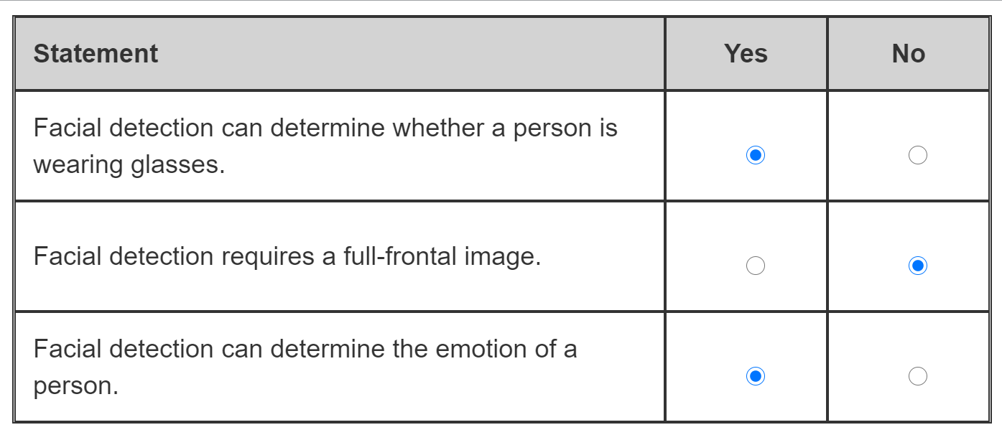

Facial detection can provide a series of attributes about a face it has detected, including whether the person is wearing glasses. Facial detection can also estimate the type of eye covering, including sunglasses and swimming goggles.  
  
Facial detection can extract facial characteristics from small, side-view and blurry faces. There are two models available when using facial detection. The second model is optimized for such situations.  
  
Facial detection can provide a series of attributes about a face that it has detected, including emotion. The emotions that can be detected include: happiness, sadness, neutral, anger, contempt, disgust, surprise, and fear.  
  
**References**  
  
[Face detection with Computer Vision](https://docs.microsoft.com/azure/cognitive-services/computer-vision/concept-detecting-faces)  
  
[Face detection and attributes](https://docs.microsoft.com/azure/cognitive-services/face/concepts/face-detection)  
  
[Get started with Face analysis on Azure](https://docs.microsoft.com/learn/modules/detect-analyze-faces/2-face-analysis-azure)  
  
[Specify a face detection model](https://docs.microsoft.com/azure/cognitive-services/face/face-api-how-to-topics/specify-detection-model)

 Previous

### Question 84

Question 84: Match the computer vision type to the scenario. To answer, drag the appropriate type to each scenario. A type may be used once, more than once, or not at all.

Drag and drop the answers













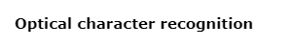

**Explanation**

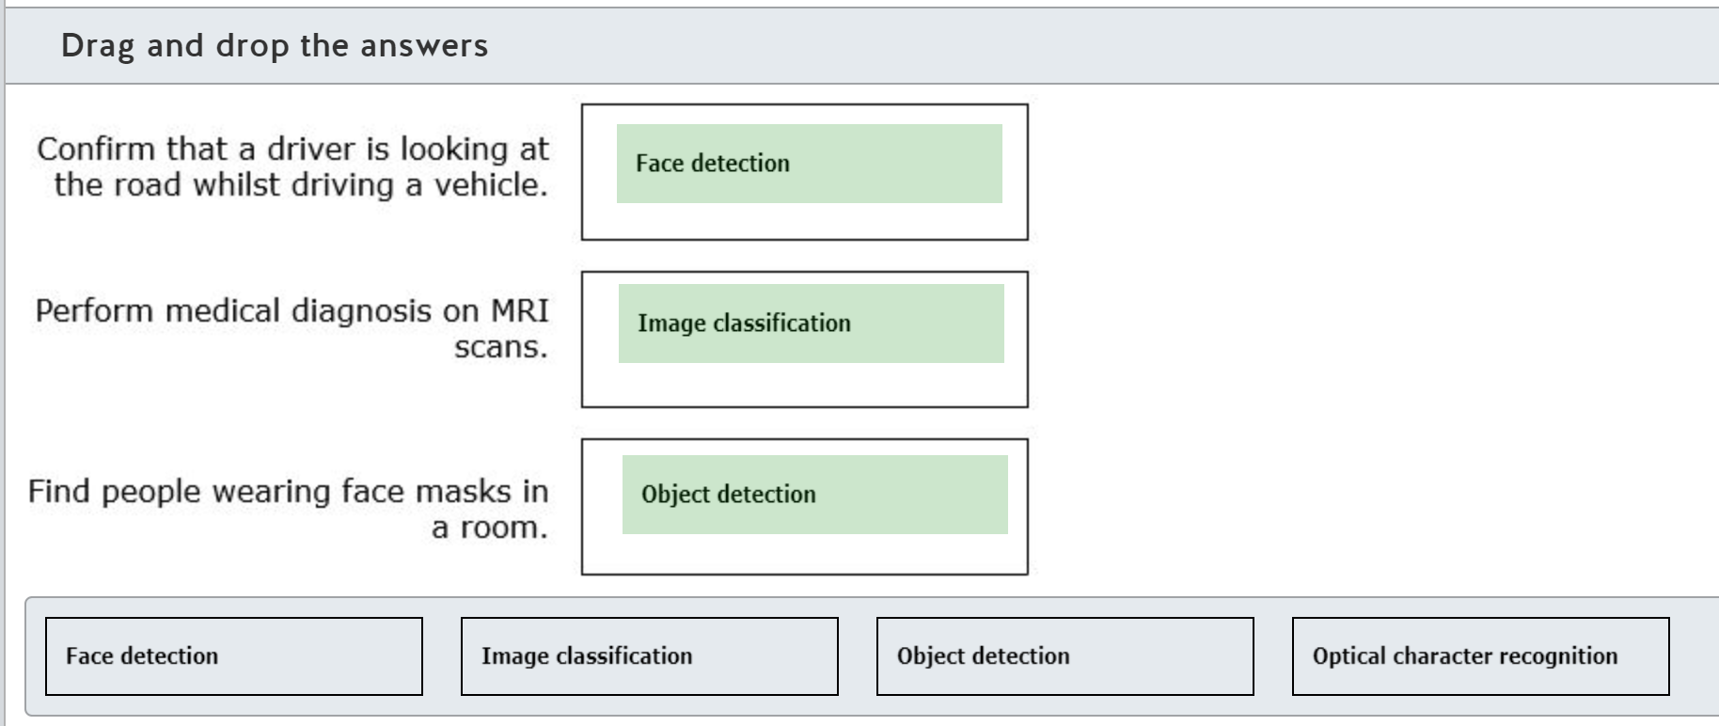

Face detection can be used to monitor a driver's face. The angle of the head can be determined and used to tell if the driver is looking at the road ahead, or looking down at a mobile device, or if the driver is showing signs of tiredness.  
  
Image classification can be used to evaluate scanned images from MRI machines to classify the images against trained images of known medical conditions.  
  
Object detection can be used to detect objects in an image. You can train Computer Vision to detect face masks. Face detection does not include the ability to recognize that a face is covered with a mask. Masks may actually prevent faces from being recognized.  
  
Optical character recognition (OCR) extracts text from an image. OCR can recognize individual shapes as letters, numerals, punctuation, and other elements of text.  
  
**References**  
  
[Get started with Face analysis on Azure](https://docs.microsoft.com/learn/modules/detect-analyze-faces/2-face-analysis-azure)  
  
[Get started with image classification on Azure](https://docs.microsoft.com/learn/modules/classify-images-custom-vision/2-azure-image-classification)  
  
[Get started with object detection on Azure](https://docs.microsoft.com/learn/modules/detect-objects-images-custom-vision/2-object-detection-azure)  
  
[Face mask detection with Azure Cognitive services Custom Vision](https://learnazureaiml.com/face-mask-detection-with-azure-cognitive-services-custom-vision/)  
  
[Get started with OCR on Azure](https://docs.microsoft.com/learn/modules/read-text-computer-vision/2-ocr-azure)

### Question 85

Question 85: Match the Computer Vision solution to a scenario.  
  
To answer, drag the appropriate computer vision solution to each relevant scenario. A computer vision solution may be used once, more than once, or not at all.

Drag and drop the answers















**Explanation**

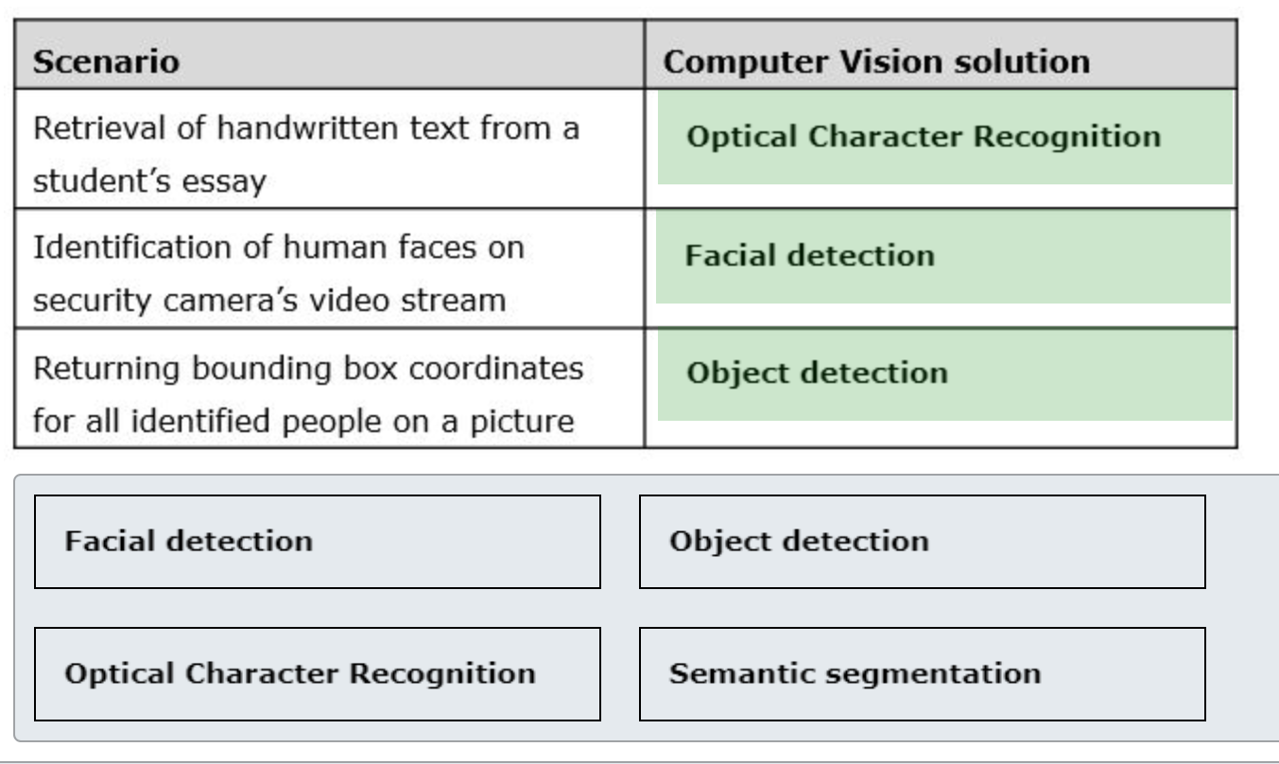

You should use optical character recognition (OCR) solution to retrieve handwritten text from a student's essay. OCR is a process of extracting printed or handwritten text from the input images or PDF documents.  
  
You should use facial detection solution to identify human faces on a security camera’s video stream. Facial detection can identify human faces on an image or a frame of a video stream, return the rectangle coordinates of their locations and provide additional details such as age or gender.  
  
You should use object detection solution for returning bounding box coordinates for all identified people on a picture. Object detection can process the image to identify various objects, including people, and return their coordinates.  
  
Semantic segmentation is not related to any of the provided scenarios. As a part of the image processing, pixels which share specific characteristics are assigned with the same labels to define boundaries of the relevant areas, such as road, people, or others cars in autonomous vehicle’s AI system that process visual information about surrounding objects.  
  
**References**  
  
[What is Computer Vision?](https://docs.microsoft.com/en-us/azure/cognitive-services/computer-vision/home)  
  
[Optical Character Recognition (OCR)](https://docs.microsoft.com/en-us/azure/cognitive-services/computer-vision/concept-recognizing-text)  
  
[What is the Azure Face service?](https://docs.microsoft.com/en-us/azure/cognitive-services/face/overview)  
  
[Detect common objects in images](https://docs.microsoft.com/en-us/azure/cognitive-services/computer-vision/concept-object-detection)  
  
[Semantic segmentation as image representation for scene recognition](https://www.microsoft.com/en-us/research/wp-content/uploads/2016/02/SemanticSegmentation_Final.pdf)

### Question 86

Question 86: To complete the following sentence, select the appropriate option from the drop-down menu.

Choose the correct options

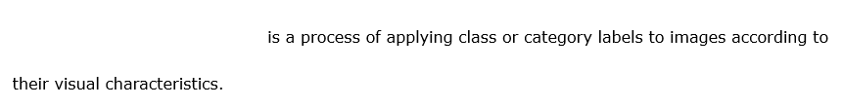



**Explanation**

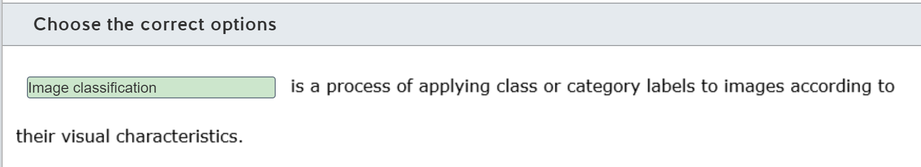

Image classification is a process of applying class or category labels to images according to their visual characteristics. You can use pretrained image classification AI services or train your own image classifier with a set of custom images.  
  
Object detection is the process of detecting objects, such as animals or humans, in an image and returning the bounding box coordinates for each detected object. Object detection is slightly more granular than image classification, as it identifies specific images within the images.  
  
NER is the ability to identify various entities in text and classify them into predetermined types or categories, such as people, products, locations, etc. NER cannot be applied to images because it is a text analytics AI solution.  
  
**References**  
  
[What is Custom Vision?](https://docs.microsoft.com/en-gb/azure/cognitive-services/custom-vision-service/home)  
  
[Detect common objects in images](https://docs.microsoft.com/en-us/azure/cognitive-services/computer-vision/concept-object-detection)  
  
[How to use Named Entity Recognition in Text Analytics](https://docs.microsoft.com/en-us/azure/cognitive-services/text-analytics/how-tos/text-analytics-how-to-entity-linking?tabs=version-3)

 Previous

### Question 87

Question 87: For each of the following statements about facial detection, select Yes if the statement is true. Otherwise, select No.

|  |  |  |
| --- | --- | --- |
| **Statement** | **Yes** | **No** |
| Photos taken at an extreme face angle can positively affect the facial detection process. |  |  |
| Wearing sunglasses can negatively affect the facial detection process. |  |  |
| A slower shutter speed of the video camera improves performance of the facial detection solution. |  |  |

**Explanation**

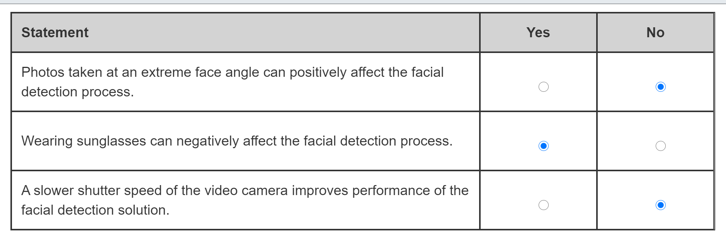

Photos taken at an extreme face angle do not positively affect the facial detection process. On the contrary, extreme face angle has negative effect on the performance of facial detection solutions. The best results with face detection are achieved when the photos feature frontal or near-frontal views of the face.  
  
Wearing sunglasses can negatively affect the facial detection process. Face occlusion with sunglasses or any objects that block part of the face is a technical challenge for AI model trained on the fully featured face landmarks. As a result of it, some faces of people wearing sunglasses might not be detected.  
  
Slower shutter speed of the video camera does not improve the performance of the facial detection solution. With the slower shutter speed, the amount of motion between the frames increases. To compensate it, some video cameras apply smoothing effects, making a blur between frames. To improve the performance of the facial detection process you may need to increase shutter speed, as it requires less of transitional adjustments and makes each frame clearer.  
  
**References**  
  
[Face detection and attributes](https://docs.microsoft.com/en-us/azure/cognitive-services/face/concepts/face-detection)  
  
[What is the Azure Face service?](https://docs.microsoft.com/en-us/azure/cognitive-services/face/overview)

 Previous

### Question 88

Question 88: Which scenario is an example of the use of Optical Character Recognition (OCR)?

Choose the correct answer

Detecting people and animals on a video feed of a security camera

Extracting handwritten text from the scanned copies of cheques

Recognizing speakers from audio recordings

Detecting abnormalities in a device telemetry

**Explanation**

Extracting handwritten text from the scanned copies of cheques is an example of the use of OCR. OCR solutions can extract printed or handwritten text from the images, such as scanned copies of cheques or PDF documents.  
  
Detecting abnormalities in the device telemetry is an example of the use of anomaly detection. With anomaly detection, it is possible to monitor time series data like device telemetry, determine boundaries of expected values and detect data points which deviate from the norm.  
  
Detecting people and animals on a video feed of a security camera is an example of the use of object detection. With object detection you can identify various objects, including people and animals on the static images or frames from the video stream. It is then possible to list those objects along with their coordinates.  
  
Recognizing speakers from audio recordings is an example of the use of speech recognition. Machine learning models can be trained on various audio samples to learn about unique voice features / signatures of speakers, and then recognize them in the new audio recordings.  
  
**References**  
  
[Optical Character Recognition (OCR)](https://docs.microsoft.com/en-us/azure/cognitive-services/computer-vision/concept-recognizing-text)  
  
[What is the Anomaly Detector API?](https://docs.microsoft.com/en-gb/azure/cognitive-services/anomaly-detector/overview)  
  
[Detect common objects in images](https://docs.microsoft.com/en-us/azure/cognitive-services/computer-vision/concept-object-detection)  
  
[What is the Azure Speaker Recognition service?](https://docs.microsoft.com/en-gb/azure/cognitive-services/speech-service/speaker-recognition-overview)

 Previous

### Question 89

Question 89: Which scenario is an example of the use of object detection?

Choose the correct answer

Finding answers on customer’s questions in a bot dialog screen

Tracking seasonal migration of animals from drone camera images

Verifying employees based on their voices

Extracting address details from scanned postal envelopes

**Explanation**

Tracking seasonal migration of animals from drone camera images is an example of the use of object detection. With object detection you can identify various objects, such as moving animals, on the static images or frames from the video cameras. AI solution can then list those objects along with their coordinates and establish relationships between them.  
  
Finding answers on customer’s questions in a bot dialog screen is an example of conversational AI. Chatbots can be integrated with the knowledge base to process requests from the customers, query the knowledge base for the possible answers and return the best search results back in a dialog screen.  
  
Extracting address details from scanned postal envelopes is an example Optical Character Recognition (OCR). OCR solutions can extract printed or handwritten text from the images, such as scanned postal envelopes, or multi-page PDF documents.  
  
Verifying employees based on their voices is an example of speech recognition. Voice-based verification system can enroll employees by taking audio samples of their voices. A machine learning model can be trained and learn about unique voice features of each employee to verify them in the future as a match to enrolled voice pattern.  
  
**References**  
  
[Detect common objects in images](https://docs.microsoft.com/en-us/azure/cognitive-services/computer-vision/concept-object-detection)  
  
[Query the knowledge base for answers](https://docs.microsoft.com/en-gb/azure/cognitive-services/QnAMaker/concepts/query-knowledge-base)  
  
[Optical Character Recognition (OCR)](https://docs.microsoft.com/en-us/azure/cognitive-services/computer-vision/concept-recognizing-text)  
  
[What is Speaker Recognition?](https://docs.microsoft.com/en-gb/azure/cognitive-services/speech-service/speaker-recognition-overview)

## Identify Azure tools and services for computer vision tasks

### Question 90 computer vision

Question 90: For each of the following statements about the Computer Vision service, select Yes if the statement is true. Otherwise, select No.

|  |  |  |
| --- | --- | --- |
| **Statement** | **Yes** | **No** |
| The Computer Vision service can moderate adult content. |  |  |
| The Computer Vision service can extract printed or handwritten text from images. |  |  |
| The Computer Vision service can translate text in an image. |  |  |

**Explanation**

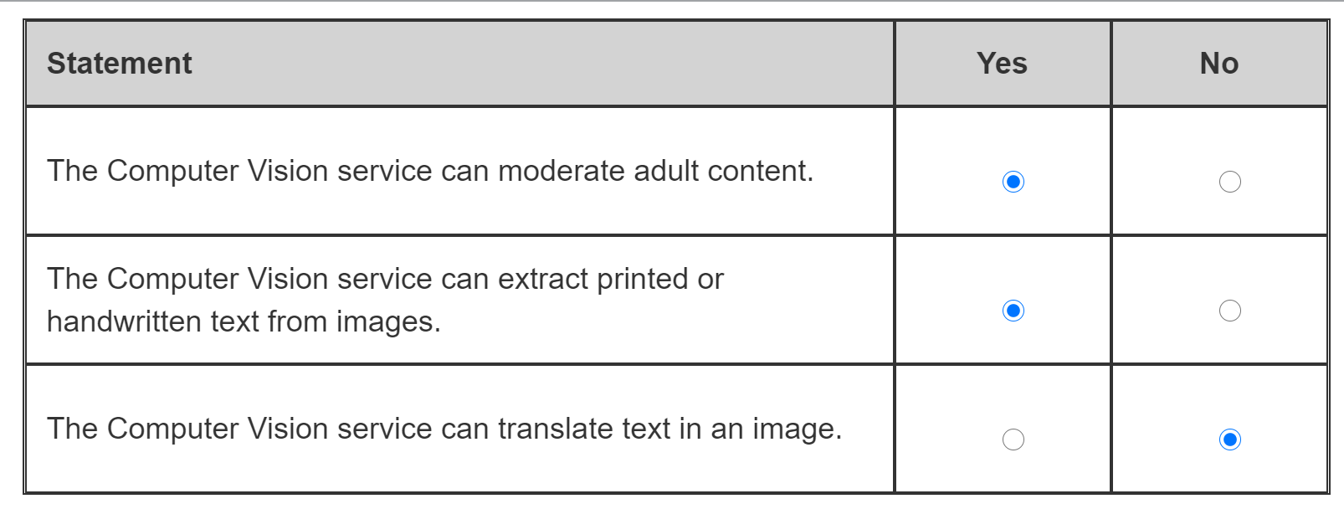

The Computer Vision service has a number of different APIs. The Analyze Image API can detect adult content, either sexual or gory. There is a separate Content Moderator service that provides additional moderation functionality and review processes.  
  
The Computer Vision service can extract printed or handwritten text from images. The Optical Character Recognition (OCR) API can find text in images and documents and extract the text.  
  
The Computer Vision service cannot translate text. It can extract the text. The text can then be translated into a different language with the Translator service.  
  
**References**  
  
[Detect adult content](https://docs.microsoft.com/azure/cognitive-services/computer-vision/concept-detecting-adult-content)  
  
[What is Computer Vision?](https://docs.microsoft.com/azure/cognitive-services/computer-vision/home)  
  
[Optical Character Recognition (OCR)](https://docs.microsoft.com/azure/cognitive-services/computer-vision/concept-recognizing-text)  
  
[What is Translator?](https://docs.microsoft.com/azure/cognitive-services/translator/translator-info-overview)

### Question 91 custom vision service

Question 91: Which two project types can you choose in the Custom Vision service? Each correct answer presents a complete solution.

Choose the correct answers

Semantic segmentation

Facial Recognition

Object Detection

Classification

K-Means Clustering

**Explanation**

The Custom Vision service supports two project types. One is classification, where you can specify labels to be applied to the image as tags. The other project type is object detection, which is similar to classification with tags, but it also returns boxed coordinates for objects found in the image.  
  
Custom Vision does not support facial recognition. To recognize faces, you need to add people and faces to the Face API.  
  
Custom Vision does not support K-Means Clustering. K-Means Clustering is the clustering algorithm that is used in Azure Machine Learning.  
  
Custom Vision does not support Semantic segmentation. Semantic segmentation associates each pixel in the image with a tagged object. Semantic Segmentation is not available in Azure Cognitive Services or Azure Machine Learning.  
  
**References**  
  
[What is Custom Vision?](https://docs.microsoft.com/azure/cognitive-services/custom-vision-service/home)  
  
[What is the Azure Face service?](https://docs.microsoft.com/azure/cognitive-services/face/overview)  
  
[Module: K-Means Clustering](https://docs.microsoft.com/azure/machine-learning/algorithm-module-reference/k-means-clustering)  
  
[An overview of semantic image segmentation](https://www.jeremyjordan.me/semantic-segmentation/)

 Previous

### Question 92 computer vision vs custom vs face

Question 92: Match the requirement to the service. To answer, drag the appropriate service to each scenario. A service may be used once, more than once, or not at all.

Drag and drop the answers















**Explanation**

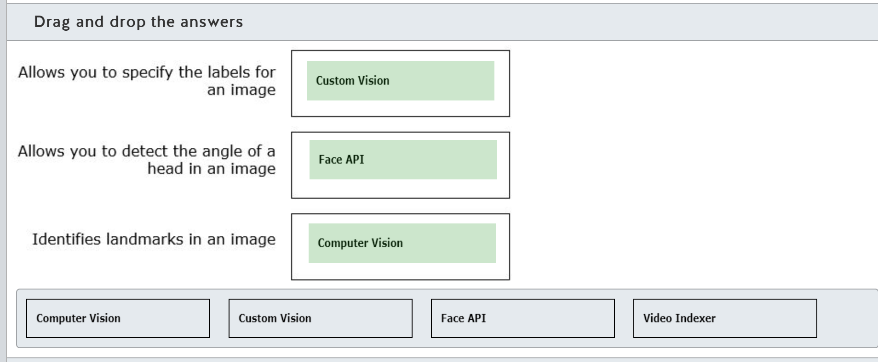

The Custom Vision service allows you to create your own labels and to tag images with these labels. You cannot add your own labels for any of the other services.  
  
The Face API can detect the angle a head is posed at. Computer Vision can detect faces, but it is not able to supply the angle of the head. Video Indexer can detect faces but does not return the attributes that the Face API can return.  
  
The Computer Vision Service is the only service that can identify landmarks from an image. The Custom Vision service does not have this capability. The Face API service is concerned with the details of faces. The Video Indexer service can detect and identify people and brands, but not landmarks.  
  
The Video Indexer service extracts insights from video images. Video Indexer can detect and identify people and brands, and it allows you to customize the people and brand models.  
  
**References**  
  
[What is Custom Vision?](https://docs.microsoft.com/azure/cognitive-services/custom-vision-service/home)  
  
[Face detection and attributes](https://docs.microsoft.com/azure/cognitive-services/face/concepts/face-detection)  
  
[What is Computer Vision?](https://docs.microsoft.com/azure/cognitive-services/computer-vision/home)  
  
[What is Azure Media Services Video Indexer?](https://docs.microsoft.com/azure/media-services/video-indexer/video-indexer-overview)

 Previous

### Question 93 Face api

Question 93: Match the requirement to the face recognition operation. To answer, drag the appropriate operation to each scenario. An operation may be used once, more than once, or not at all.

Drag and drop the answers















**Explanation**

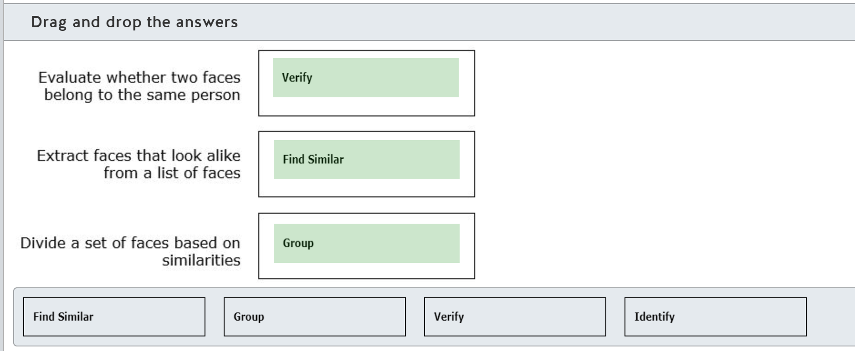

The Verify operation takes a face and determines if it belongs to the same person as another face. You need to detect face(s) in an image using the Detect API. The Verify operation can then compare the two faces.  
  
The Find Similar operation takes a face you have detected and extracts faces that look alike from a list of faces that you provide. Find Similar returns a subset of the faces in the list.  
  
The Group operation creates several smaller groups from a list of faces based on the similarities of the faces. The Group operation needs between two and 1000 faces. You should not use the Group operation to evaluate two faces. You should use Verify to evaluate two faces.  
  
The Identify operation takes one or more face(s) and matches them to people. The Identify operation returns a list of possible matches with a confidence score between 0 and 1, with 1 being the most confident. You should not use the Identify operation to evaluate whether two faces belong to the same person.  
  
**References**  
  
[What is the Azure Face service?](https://docs.microsoft.com/azure/cognitive-services/face/overview)  
  
[Face recognition concepts](https://docs.microsoft.com/azure/cognitive-services/face/concepts/face-recognition)

 Previous

### Question 94 bing visual search

Question 94: Which of the following services would you use to find the recipe for a food dish in an image?

Choose the correct answer

Bing Visual Search

Text Analytics

Computer Vision

Custom Vision

**Explanation**

Web Search consists of a number of Search APIs. One of the Search APIs is the Bing Visual Search API. Bing Visual Search will find web pages that are related to the image, such as sources where you can purchase the product shown, or web pages that contain recipes for making the dish shown in the image.  
  
Computer Vision can describe the image, identify objects in the image, and extract text from the image. Computer Vision cannot identify the dish or find recipes for the dish.  
  
Custom Vision can classify the image and identify objects in the image. Custom Vision cannot identify the dish or find recipes for the dish.  
  
Text Analytics cannot process images. Text Analytics discovers intent and meaning from text.  
  
**References**  
  
[What are the Bing Search APIs?](https://docs.microsoft.com/azure/cognitive-services/bing-web-search/bing-api-comparison)  
  
[What is the Bing Visual Search API?](https://docs.microsoft.com/azure/cognitive-services/bing-visual-search/overview)  
  
[Images - Visual Search](https://docs.microsoft.com/rest/api/cognitiveservices/bingvisualsearch/images/visualsearch)  
  
[What is the Text Analytics API?](https://docs.microsoft.com/azure/cognitive-services/text-analytics/overview)

 Previous

### Question 95 form recognizer

Question 95: To complete the following sentence, select the appropriate option from the drop-down menu.

Choose the correct options

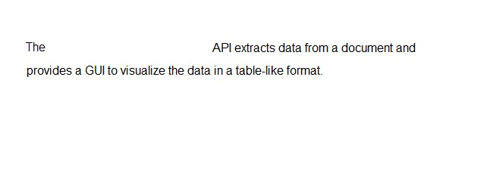



**Explanation**

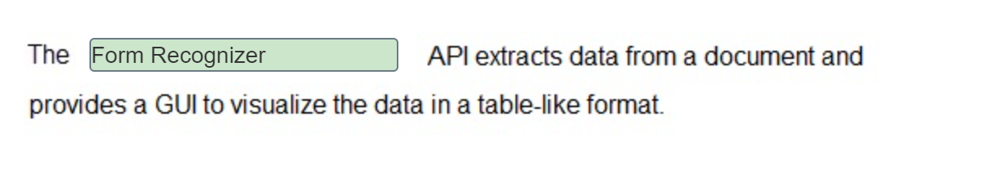

The Form Recognizer API extracts text, key/value pairs, and table data from documents. Using the Layout service, text and table structures can be extracted from documents. Form Recognizer provides a GUI to visualize this data in a table-like format.  
  
The Optical Character Recognition (OCR) API detects text in an image and extracts the recognized characters into a machine-usable character stream. The OCR API can only extract simple text strings.  
  
The Read API is optimized for text-heavy images and multi-page, mixed language, and mixed printed and handwritten documents. The Read API extracts text strings.  
  
**References**  
  
[What is Form Recognizer?](https://docs.microsoft.com/azure/cognitive-services/form-recognizer/overview)  
  
[Optical Character Recognition (OCR)](https://docs.microsoft.com/azure/cognitive-services/computer-vision/concept-recognizing-text)

 Previous

### Question 96 form recognizer

Question 96: You need to use Azure cognitive service to automate data extraction from scanned copies of sales receipts minimizing development efforts.  
  
What Azure cognitive service should you use?

Choose the correct answer

Custom Vision

Form Recognizer

Computer Vision

Text Analytics

**Explanation**

You should use Form Recognizer. Azure Form Recognizer is a cognitive service that can identify and extract text, key-value pairs and table data from form documents. It provides prebuilt models for data extraction from sales receipts and business cards to significantly minimize development efforts.  
  
You should not use Computer Vision. It is an Azure cognitive service with a rich set of image processing functionalities to detect objects, brands or faces, describe image content, generate thumbnails, etc. It also includes optical character recognition (OCR) capabilities to extract printed and handwritten text from images. OCR can process sales receipts, but it would require a greater development effort to process structured data from the receipt forms than the prebuilt model provided by Form Recognizer.  
  
You should not use Custom Vision. It is an Azure cognitive service that lets you build and deploy image classifier trained on your custom set of images. Custom Vision cannot be used to extract data from form documents like sales receipts.  
  
You should not use Text Analytics. It is a cognitive service that can perform sentiment analysis, key phrase extraction, language detection and named entity recognition. However, text analytics cannot work directly with images, such as scanned copies of sales receipts. Besides, it requires input to be in a raw text format instead.  
  
**References**  
  
[Receipt concepts](https://docs.microsoft.com/en-us/azure/cognitive-services/form-recognizer/concept-receipts)  
  
[What is Computer Vision?](https://docs.microsoft.com/en-us/azure/cognitive-services/computer-vision/home)  
  
[What is Custom Vision?](https://docs.microsoft.com/en-gb/azure/cognitive-services/custom-vision-service/home)  
  
[What is the Text Analytics API?](https://docs.microsoft.com/en-us/azure/cognitive-services/text-analytics/overview)

### Question 97 computer vision vs face

Question 97: Which two Azure cognitive services can be used to analyze faces within an image? Each correct answer presents a complete solution.

Choose the correct answers

Form Recognizer

Computer Vision

Personalizer

Face

Text Analytics

**Explanation**

Azure Computer Vision and Azure Face cognitive services can be used to analyze faces within an image. Computer Vision can detect human faces and predict their age and gender. Face service can be used for a more detailed analysis: identify head pose, estimate gender, age and emotion, detect presence of facial hair or glasses, and even evaluate whether two faces belong to the same person.  
  
Form Recognizer is a cognitive service that can identify and extract key-value pairs and table data from a form document, such as sales receipt. However, it cannot be used to analyze faces within an image.  
  
Personalizer is a cognitive service that can learn about user preferences from their collective real-time behavior, and then choose the best items, such as specific movies or certain products as a recommendation for each user. However, it is not designed to work with images and analyze faces.  
  
Text Analytics cannot work with images to analyze faces. On the contrary, it is a cognitive service that processes raw text to perform sentiment analysis, key phrase extraction, language detection or named entity recognition.  
  
**References**  
  
[Face detection with Computer Vision](https://docs.microsoft.com/en-us/azure/cognitive-services/computer-vision/concept-detecting-faces)  
  
[What is the Azure Face service?](https://docs.microsoft.com/en-us/azure/cognitive-services/face/overview)  
  
[What is Form Recognizer?](https://docs.microsoft.com/en-us/azure/cognitive-services/form-recognizer/overview)  
  
[What is Personalizer?](https://docs.microsoft.com/en-us/azure/cognitive-services/personalizer/what-is-personalizer)  
  
[What is the Text Analytics API?](https://docs.microsoft.com/en-us/azure/cognitive-services/text-analytics/overview)

 Previous

### Question 98 – custom vision

Question 98: You need to build a butterfly image classifier using your own set of images and labels.  
  
Which Azure cognitive service should you use?

Choose the correct answer

Video Indexer

Custom Vision

Computer Vision

Bing Image Search

**Explanation**

You should use Custom Vision. It is an Azure cognitive service that lets you build and deploy image classifier trained on your custom set of images and labels, such as butterflies.  
  
You should not use Computer Vision. It is an Azure cognitive service with a rich set of image processing functionalities to detect objects, brands or faces, describe image content, generate thumbnails, etc. Computer Vision can identify butterflies using pretrained classifier model. However, you cannot use it to build a custom classifier with your own set of images and labels.  
  
You should not use Bing Image Search. It is a service that exposes Bing’s image search capabilities via an API, so that you can reuse it in your custom application. However, Bing Image Search cannot be used to build a butterfly image classifier using your own set of images and labels.  
  
You should not use Video Indexer. It is an Azure cognitive service that allows you to get deep insights into large videos archives through the multi-channel (audio and visual) analysis. However, you cannot train and build custom image classifiers.  
  
**References**  
  
[What is Custom Vision?](https://docs.microsoft.com/en-gb/azure/cognitive-services/custom-vision-service/home)  
  
[What is Computer Vision?](https://docs.microsoft.com/en-us/azure/cognitive-services/computer-vision/home)  
  
[What is the Bing Image Search API?](https://docs.microsoft.com/en-us/azure/cognitive-services/Bing-Image-Search/overview)  
  
[What is Azure Media Services Video Indexer?](https://docs.microsoft.com/en-us/azure/media-services/video-indexer/video-indexer-overview)

### Question 99 form recognizer

Question 99: For each of the following statements about Form Recognizer, select Yes if the statement is true. Otherwise, select No.

|  |  |  |
| --- | --- | --- |
| **Statement** | **Yes** | **No** |
| Prebuilt business card model can extract information from business cards in English. |  |  |
| Prebuilt receipt model can extract information from sales receipts in French. |  |  |
| Custom model can be trained to extract information from custom forms in Spanish. |  |  |

**Explanation**

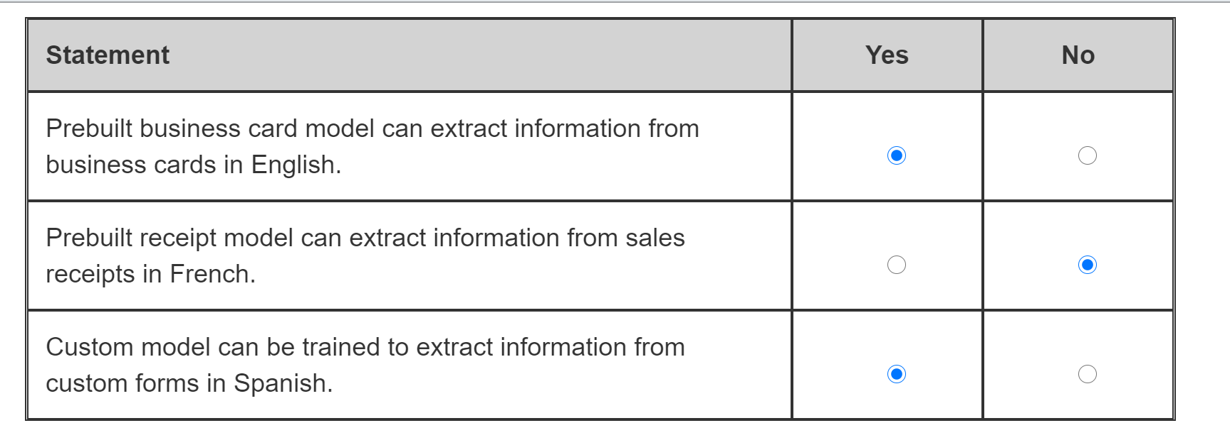

Form Recognizer’s prebuilt business card model can extract information from business cards in English. It can analyze business card’s content from the provided images or PDF documents and extract personal contact info, company name, job title, etc.  
  
Form Recognizer’s prebuilt receipt model cannot extract information from sales receipts in French. Using OCR and prebuilt receipt model, Form Recognizer can process copies of sales receipts to extract merchant name, tip, line items, total and other details. However, at the time of writing, English is the only language supported by the prebuilt receipt model.  
  
Custom model can be trained to extract information from custom forms in Spanish. Form Recognizer provides a sample labeling tool to train a custom model with manually labeled data. Spanish is now supported along with few others languages such as Simplified Chinese, Dutch, French, German, Italian and Portuguese to train custom models on.  
  
**References**  
  
[Business card concepts](https://docs.microsoft.com/en-us/azure/cognitive-services/form-recognizer/concept-business-cards)  
  
[Receipt concepts](https://docs.microsoft.com/en-us/azure/cognitive-services/form-recognizer/concept-receipts)  
  
[Train a Form Recognizer model with labels using the sample labeling tool](https://docs.microsoft.com/en-us/azure/cognitive-services/form-recognizer/quickstarts/label-tool?tabs=v2-0)  
  
[What's new in Form Recognizer?](https://docs.microsoft.com/en-us/azure/cognitive-services/form-recognizer/whats-new)

 Previous

### Question 100 computer vision vs form vs face

Question 100: Match the Azure service to a scenario.  
  
To answer, drag the appropriate Azure service to each use case scenario. An Azure service may be used once, more than once, or not at all.

Drag and drop the answers













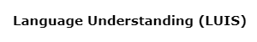

**Explanation**

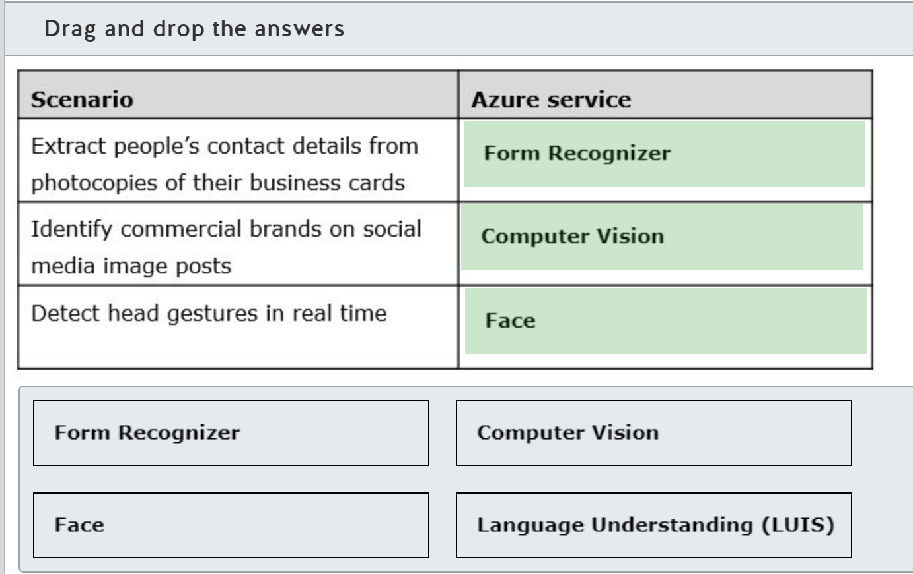

Azure Form Recognizer service can be used to extract people’s contact details from photocopies of their business cards. It comes with a prebuilt business card model, which can analyze provided images of business cards to extract key-value pairs of personal contact information, company name, job title, etc.  
  
Azure Computer Vision service can be used to identify commercial brands on social media image posts. Brand detection model uses a database of thousands of global logos to identify commercial brands in the provided images or videos.  
  
Azure Face service can be used to detect head gestures in real time. Face service can detect and analyze human faces in images or videos. By tracking changes of the HeadPose attribute of a detected face in a video stream, it is possible to detect head gestures like nodding and head shaking in real time.  
  
Language Understanding (LUIS) is an Azure service that applies machine learning to the conversational, natural language text to predict the meaning and extract detailed information from it. LUIS works with the text data and is not applicable to any of the provided computer vision use case scenarios.  
  
**References**  
  
[What is Form Recognizer?](https://docs.microsoft.com/en-us/azure/cognitive-services/form-recognizer/overview)  
  
[What is Computer Vision?](https://docs.microsoft.com/en-us/azure/cognitive-services/computer-vision/home)  
  
[Use the HeadPose attribute](https://docs.microsoft.com/en-us/azure/cognitive-services/face/face-api-how-to-topics/how-to-use-headpose)  
  
[What is Language Understanding (LUIS)?](https://docs.microsoft.com/en-us/azure/cognitive-services/luis/what-is-luis)

### Question 101 – computer vision

Question 101: You need to identify dominant colors in online images to check if they influence the popularity of the featured products.  
  
Which Azure cognitive service should you use?

Choose the correct answer

Form Recognizer

Personalizer

Computer Vision

Custom Vision

**Explanation**

You should use Computer Vision to identify dominant colors in online images to check if they influence the popularity of the featured products. It is an Azure cognitive service with a rich set of image processing functionalities to detect objects, brands or faces, describe image content or generate thumbnails. Computer Vision can also analyze colors in an image to provide three different attributes: the dominant foreground or background colors as well as the set of dominant colors for the input image as a whole.  
  
You should not use Custom Vision. It is an Azure cognitive service that lets you build and deploy image classifier trained on your custom set of images and labels. However, it cannot be used to identify dominant colors in an image.  
  
You should not use Form Recognizer. It is an Azure cognitive service to identify and extract key-value pairs and table data from form documents. However, it is not designed to analyze color schemes in images.  
  
You should not use Personalizer. It is an Azure cognitive service that can learn about user preferences from their collective real-time behavior, and can choose then the best items, such as specific products to recommend to each user. However, it cannot identify dominant colors in an image.  
  
**References**  
  
[What is Computer Vision?](https://docs.microsoft.com/en-us/azure/cognitive-services/computer-vision/home)  
  
[Detect color schemes in images](https://docs.microsoft.com/en-us/azure/cognitive-services/computer-vision/concept-detecting-color-schemes)  
  
[What is Custom Vision?](https://docs.microsoft.com/en-gb/azure/cognitive-services/custom-vision-service/home)  
  
[What is Form Recognizer?](https://docs.microsoft.com/en-us/azure/cognitive-services/form-recognizer/overview)  
  
[What is Personalizer?](https://docs.microsoft.com/en-us/azure/cognitive-services/personalizer/what-is-personalizer)

# Describe features of Natural Language Processing (NLP) workloads on Azure

## Identify features of common NLP Workload Scenarios

### Question 102

Question 102: For each of the following statements about natural language processing, select Yes if the statement is true. Otherwise, select No.

|  |  |  |
| --- | --- | --- |
| **Statement** | **Yes** | **No** |
| Key phrase extraction performs better on smaller amounts of text. |  |  |
| Sentiment analysis performs better on smaller amounts of text. |  |  |
| Speech Synthesis Markup Language (SSML) is based on JSON format. |  |  |

**Explanation**

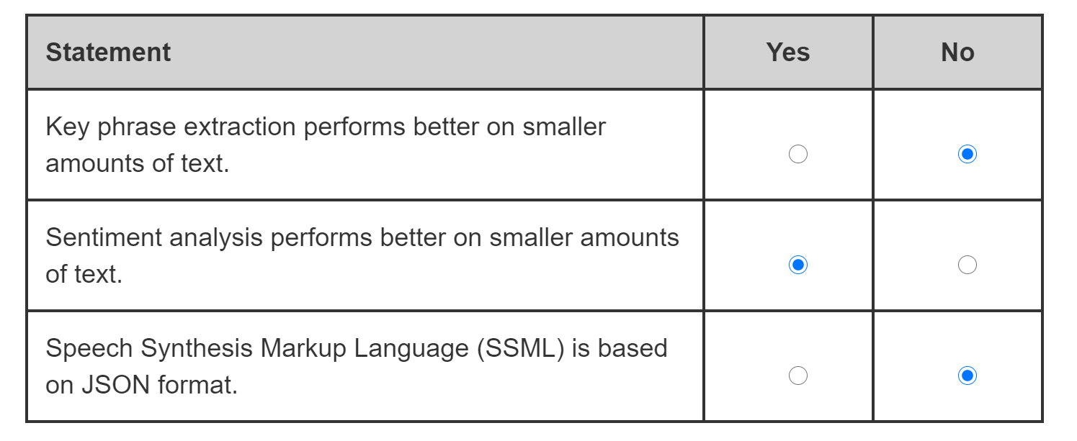

Key phrase extraction does not perform better on smaller amounts of text. On the contrary, it works better when you provide it with bigger amounts of text to work on.  
  
Sentiment analysis performs better on smaller amounts of text. Less words means less distractors for the sentiment analysis model, and for that reason, it produces a higher-quality results with smaller amounts of text.  
  
SSML is not based on JSON format but XML as per the World Wide Web Consortium's standard. SSML lets you improve quality of speech synthesis by fine-tuning the pitch, pronunciation, speaking rates and other parameters of the text-to-speech output.  
  
**References**  
  
[Example: How to extract key phrases using Text Analytics](https://docs.microsoft.com/en-us/azure/cognitive-services/text-analytics/how-tos/text-analytics-how-to-keyword-extraction)  
  
[How to: Detect sentiment using the Text Analytics API](https://docs.microsoft.com/en-us/azure/cognitive-services/text-analytics/how-tos/text-analytics-how-to-sentiment-analysis?tabs=version-3)  
  
[What is text-to-speech?](https://docs.microsoft.com/en-us/azure/cognitive-services/speech-service/text-to-speech)  
  
[Improve synthesis with Speech Synthesis Markup Language (SSML)](https://docs.microsoft.com/en-us/azure/cognitive-services/speech-service/speech-synthesis-markup?tabs=csharp)

 Previous

### Question 103

Question 103:

For each of the following statements about Sentiment Analysis, select Yes if the statement is true. Otherwise, select No.

|  |  |  |
| --- | --- | --- |
| **Statement** | **Yes** | **No** |
| Sentiment Analysis returns sentiment labels and scores for the entire document. |  |  |
| Sentiment Analysis returns sentiment labels and scores for each sentence within a document. |  |  |
| Confidence scores range from -1 to 1. |  |  |

**Explanation**

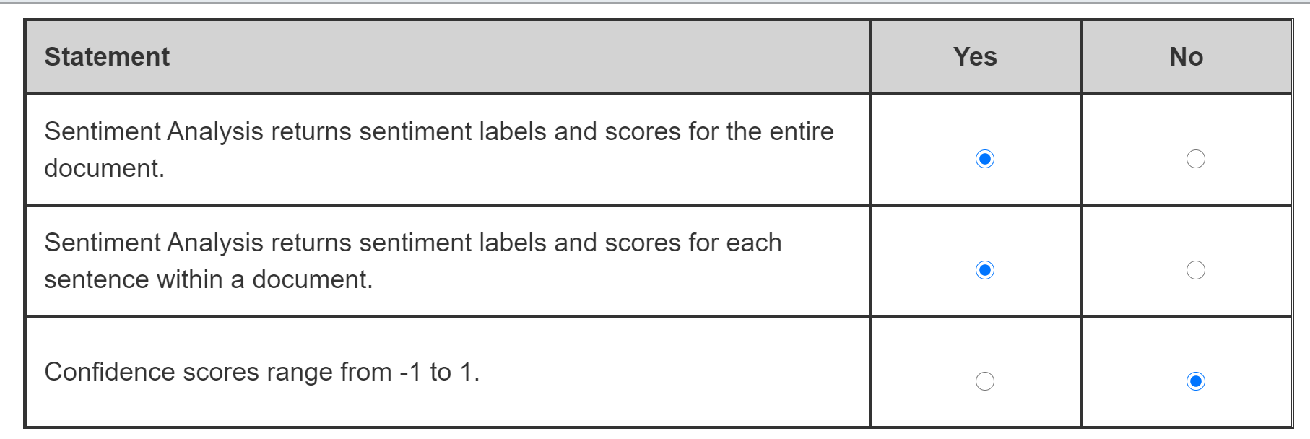

Sentiment Analysis returns sentiment labels and scores for the entire document. It evaluates text and then returns sentiment labels such as negative, neutral or positive. It scores at both the sentence and document levels.  
  
Sentiment analysis returns sentiment labels and scores for each sentence within a document. As part of sentiment analysis, sentiment labels are applied to text and at a sentence and document levels, giving a confidence score for each label: positive, negative or neutral.  
  
Confidence scores do not range from -1 to 1, but from 0 to 1. Scores closer to 0 indicate lower confidence, while scores closer to 1 indicate higher confidence in the relevant label classification. Confidence scores for the entire document and each sentence within it add up to 1. For example, the positive label may have confidence score of 0.8, the neutral label of 0.15 and the negative label of 0.05, with the sum of all three scores being equal to 1.  
  
**References**  
  
[How to: Detect sentiment using the Text Analytics API](https://docs.microsoft.com/en-us/azure/cognitive-services/text-analytics/how-tos/text-analytics-how-to-sentiment-analysis?tabs=version-3)

### Question 104

Question 104: AI solution identifies the main points in a set of blog posts.  
  
Which Natural Language Processing (NLP) workload is this an example of?

Choose the correct answer

Sentiment analysis

Named entity recognition

Key phrase extraction

Speech recognition

**Explanation**

AI solution identifying the main points in a set of blog posts is an example of a key phrase extraction workload. It is an NLP process that automatically extracts key phrases to identify the main points in a collection of documents, such as a set of blog posts.  
  
Named entity recognition identifies entities in a provided text and categorizes them into predefined classes or types, such as people, products, events, etc. However, it cannot identify key phrases for the determination of the blog post’s main points.  
  
Sentiment analysis evaluates a provided text for detecting positive or negative sentiments. It then returns sentiment labels and confidence scores, which ranges from 0 to 1, at the sentence and document levels. While it can detect sentiment in blog posts, it still cannot identify the main points in them.  
  
Speech recognition recognizes and transcribes human speech. However, it cannot work with text data like blog posts and requires input to be provided in audio format instead.  
  
**References**  
  
[Example: How to extract key phrases using Text Analytics](https://docs.microsoft.com/en-us/azure/cognitive-services/text-analytics/how-tos/text-analytics-how-to-keyword-extraction)  
  
[How to use Named Entity Recognition in Text Analytics](https://docs.microsoft.com/en-us/azure/cognitive-services/text-analytics/how-tos/text-analytics-how-to-entity-linking?tabs=version-3)  
  
[How to: Detect sentiment using the Text Analytics API](https://docs.microsoft.com/en-us/azure/cognitive-services/text-analytics/how-tos/text-analytics-how-to-sentiment-analysis?tabs=version-3)  
  
[Get started with speech-to-text](https://docs.microsoft.com/en-gb/azure/cognitive-services/speech-service/speech-to-text-basics?tabs=script&pivots=programming-language-csharp)

### Question 105

Question 105: AI solution processes customer feedback and classifies it as positive, neutral or negative.  
  
Which Natural Language Processing (NLP) workload is this an example of?

Choose the correct answer

Sentiment analysis

Speech translation

Named entity recognition

Speech synthesis

**Explanation**

AI solution processing customer feedback and classifying it as positive, neutral or negative is an example of a sentiment analysis workload. Sentiment analysis evaluates a provided text to detect positive or negative sentiments. It returns then sentiment labels and confidence scores, which are ranged from 0 to 1, at the sentence and document levels.  
  
Named entity recognition identifies entities in a provided text and categorizes them into predefined classes or types, such as people, products, events, etc. However, it cannot classify the content as positive, neutral or negative.  
  
Speech synthesis can generate human-like synthesized speech based on the input text. Speech synthesis is available in multiple languages, and can be customized to adjust pitch, add pauses, improve pronunciation, etc. by using speech synthesis markup language (SSML). It is not designed to classify input text as positive, neutral or negative.  
  
Speech translation provides real-time, multilingual translation of audio files or streams. However, speech translation cannot perform sentiment analysis as required in this scenario.  
  
**References**  
  
[How to: Detect sentiment using the Text Analytics API](https://docs.microsoft.com/en-us/azure/cognitive-services/text-analytics/how-tos/text-analytics-how-to-sentiment-analysis?tabs=version-3)  
  
[How to use Named Entity Recognition in Text Analytics](https://docs.microsoft.com/en-us/azure/cognitive-services/text-analytics/how-tos/text-analytics-how-to-entity-linking?tabs=version-3)  
  
[What is text-to-speech?](https://docs.microsoft.com/en-gb/azure/cognitive-services/speech-service/text-to-speech)  
  
[What is the Translator?](https://docs.microsoft.com/en-us/azure/cognitive-services/translator/translator-info-overview)

 Previous

### Question 106

Question 106: Match the natural language processing (NLP) workload to a scenario.  
  
To answer, drag the appropriate NLP workload to each relevant scenario. An NLP workload may be used once, more than once, or not at all.

Drag and drop the answers















**Explanation**

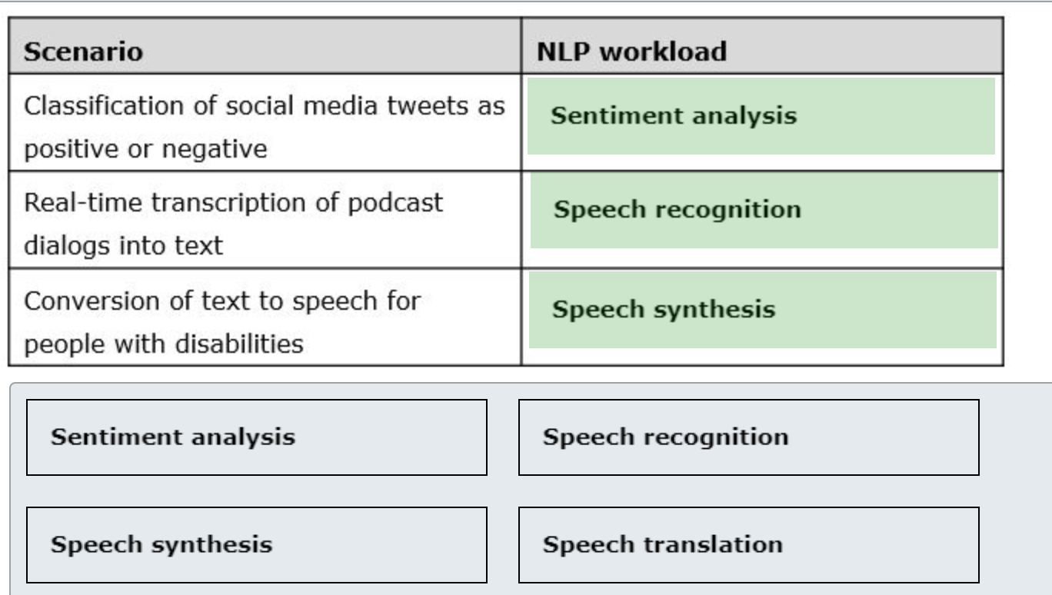

You should use sentiment analysis to classify social media tweets as positive or negative. As part of its workload, sentiment analysis solution can evaluate text of social media tweets and return sentiment labels as positive, neutral or negative, and confidence scores for each tweet and each sentence within it.  
  
You should use speech recognition to do a real-time transcription of podcast dialogs into text. As a part of its workload, speech recognition can recognize human speech and transcribe it by creating text output.  
  
You should use speech synthesis to convert text to speech for people with disabilities. It can support people with vision impairment by converting input text into human-like synthesized speech.  
  
Speech translation enables real-time, multilingual translation of audio files or streams. It can be used in combination with the sentiment analysis, speech recognition or speech synthesis. However, on its own it cannot evaluate sentiments of tweets, transcribe podcasts or synthesize speech from text.  
  
**References**  
  
[How to: Detect sentiment using the Text Analytics API](https://docs.microsoft.com/en-us/azure/cognitive-services/text-analytics/how-tos/text-analytics-how-to-sentiment-analysis?tabs=version-3)  
  
[What is speech-to-text?](https://docs.microsoft.com/en-gb/azure/cognitive-services/speech-service/speech-to-text)  
  
[What is text-to-speech?](https://docs.microsoft.com/en-gb/azure/cognitive-services/speech-service/text-to-speech)  
  
[What is speech translation?](https://docs.microsoft.com/en-gb/azure/cognitive-services/speech-service/speech-translation)

 Previous

### Question 107

Question 107: To complete the sentence, select the appropriate option from the drop-down menu.

Choose the correct options

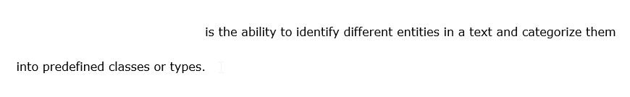



**Explanation**

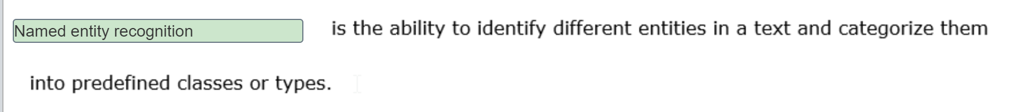

Named entity recognition is the ability to identify different entities in a text and categorize them into predefined classes or types. For example, in the sentence 'John is on a business trip to New York', entity recognition solution can classify John as a person, business trip as an event and New York as a location entity type.  
  
Language detection can evaluate text input to determine which language is used. It also returns a score that reflects the model’s confidence in its language prediction results. Language detection cannot identify entities in a provided text to classify them as people, product, organization and other predefined classes or types.  
  
Speech translation enables real-time, multilingual speech-to-speech or speech-to-text translation. It cannot work with texts and it requires its input to be in audio format instead, such as a file or a real-time stream. It cannot be used for the named entity recognition.  
  
**References**  
  
[How to use Named Entity Recognition in Text Analytics](https://docs.microsoft.com/en-us/azure/cognitive-services/text-analytics/how-tos/text-analytics-how-to-entity-linking?tabs=version-3)  
  
[Example: Detect language with Text Analytics](https://docs.microsoft.com/en-us/azure/cognitive-services/text-analytics/how-tos/text-analytics-how-to-language-detection)  
  
[What is speech translation?](https://docs.microsoft.com/en-gb/azure/cognitive-services/speech-service/speech-translation)

 Previous

### Question 108

Question 108: To complete the following sentence, select the appropriate option from the drop-down menu.

Choose the correct options

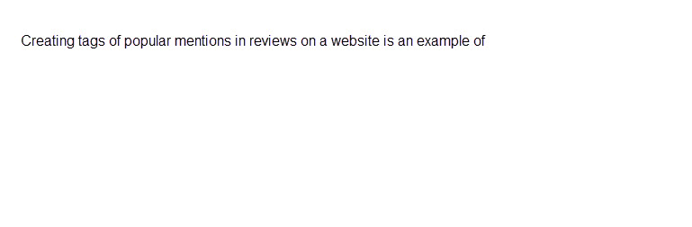



**Explanation**



Key phrase extraction evaluates a piece of text and identifies the key talking points or popular mentions contained in the text. You can extract key phrases from all the website reviews and then add these as tags to allow website users to filter reviews.  
  
Entity recognition finds the use of people, places, organizations, and other known items contained in a piece of text. The entities it returns are from a set of known named entities.  
  
Sentiment analysis evaluates a piece of text and determines if the text has positive or negative feelings or emotions.  
  
**References**  
  
[Get started with Text Analytics on Azure](https://docs.microsoft.com/learn/modules/analyze-text-with-text-analytics-service/2-get-started-azure)  
  
[Example: How to extract key phrases using Text Analytics](https://docs.microsoft.com/azure/cognitive-services/text-analytics/how-tos/text-analytics-how-to-keyword-extraction)  
  
[What is the Text Analytics API?](https://docs.microsoft.com/azure/cognitive-services/text-analytics/overview)

 Previous

### Question 109:

Question 109: Which two of the following can be found in a text document by using entity recognition? Each correct answer presents a complete solution.

Choose the correct answers

Dates and times of a day

Intent and actions

Passport number

Main talking points

Emotion expressed

**Explanation**

Entity recognition detects the use of people, places, organizations, personal information and other known items in a piece of text. Entity recognition can also find a date, a time, or a date range in the text. Besides, entity recognition can detect personal information including social security numbers, driver license numbers, and passport numbers for various countries around the world.  
  
The emotion expressed in a text is an example of sentiment analysis, not entity recognition. Sentiment analysis evaluates a piece of text and determines if the text has positive or negative feelings and emotions.  
  
The intent and actions expressed in a text are an example of language understanding, not entity recognition. Language understanding extracts the overall meaning from the text.  
  
Main talking points contained in a text is an example of key phrase extraction, not entity recognition. Key phrase extraction evaluates the text and identifies the key talking points in the text.  
  
**References**  
  
[Get started with Text Analytics on Azure](https://docs.microsoft.com/learn/modules/analyze-text-with-text-analytics-service/2-get-started-azure)  
  
[What is the Text Analytics API?](https://docs.microsoft.com/azure/cognitive-services/text-analytics/overview)  
  
[Supported entity categories in the Text Analytics API v3](https://docs.microsoft.com/azure/cognitive-services/text-analytics/named-entity-types%20)  
  
[What is Language Understanding (LUIS)?](https://docs.microsoft.com/azure/cognitive-services/luis/what-is-luis)

### Question 110:

Question 110: Which requirement would require you to use sentiment analysis?

Choose the correct answer

Find the use of brand names in documents.

Extract brand information from documents.

Transcribe the recording of a marketing presentation into text.

Analyze social media for a brand.

**Explanation**

Analyzing social media for a brand would require you to use sentiment analysis to determine the positive and negative mentions of a brand.  
  
Extracting brand information from documents requires named entity recognition. Entity recognition finds the use of people, places, organizations, personal information and other known items from a piece of text.  
  
Finding the use of brand names in text requires content moderation. Content moderation scans text against a list of terms that you can add your own terms to.  
  
Transcribing a recording into text requires of speech recognition. Speech recognition can convert audio into text.  
  
**References**  
  
[Get started with Text Analytics on Azure](https://docs.microsoft.com/learn/modules/analyze-text-with-text-analytics-service/2-get-started-azure)  
  
[What is the Text Analytics API?](https://docs.microsoft.com/azure/cognitive-services/text-analytics/overview)  
  
[Example user scenarios for the Text Analytics API](https://docs.microsoft.com/en-us/azure/cognitive-services/text-analytics/text-analytics-user-scenarios)  
  
[How to use Named Entity Recognition in Text Analytics](https://docs.microsoft.com/azure/cognitive-services/text-analytics/how-tos/text-analytics-how-to-entity-linking)  
  
[What is Azure Content Moderator?](https://docs.microsoft.com/azure/cognitive-services/content-moderator/overview)  
  
[What is speech-to-text?](https://docs.microsoft.com/azure/cognitive-services/speech-service/speech-to-text)

### Question 111

Question 111:

For each of the following statements about language modeling, select Yes if the statement is true. Otherwise, select No.

|  |  |  |
| --- | --- | --- |
| **Statement** | **Yes** | **No** |
| Language modeling can determine the emotion in a text statement. |  |  |
| Language modeling can discover the meaning in a text statement. |  |  |
| Language modeling can detect the language the text is written in. |  |  |

**Explanation**

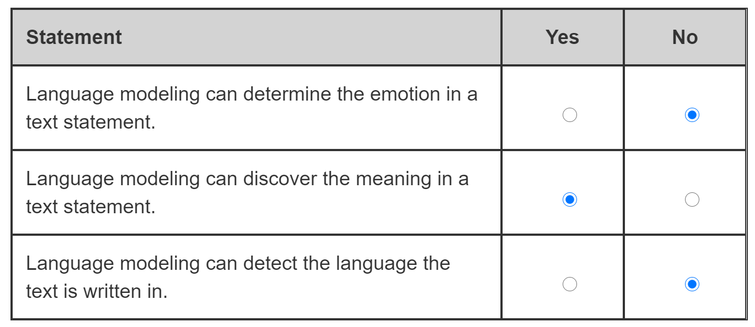

Determining the emotion in a text statement is an example of sentiment analysis, not language modeling. Sentiment analysis can determine the positive and negative emotions in a text statement.  
  
Language modeling aims to interpret the intent from a text statement and extract key information to discover the overall meaning from the text.  
  
Detecting the language the text is written in is an example of language detection, not language modeling. Language modeling can be performed in many languages but only one language at a time.  
  
**References**  
  
[Introduction](https://docs.microsoft.com/learn/modules/create-language-model-with-luis/1-introduction)  
  
[What is Language Understanding (LUIS)?](https://docs.microsoft.com/azure/cognitive-services/luis/what-is-luis)  
  
[What is the Text Analytics API?](https://docs.microsoft.com/azure/cognitive-services/text-analytics/overview)  
  
[Language and region support for LUIS](https://docs.microsoft.com/azure/cognitive-services/luis/luis-language-support)

 Previous

### Question 112

Question 112: To complete the following sentences, select the appropriate options from the drop-down menus.

Choose the correct options

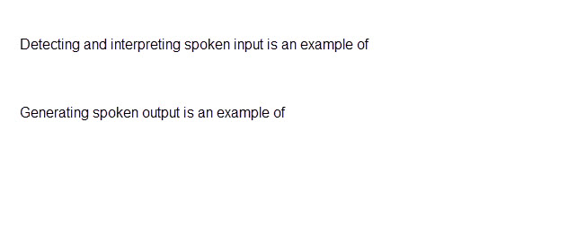





**Explanation**

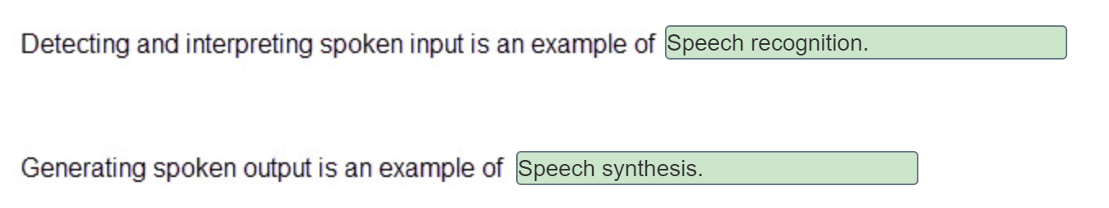

Speech recognition is the ability to detect and interpret spoken input and turn it into data so it can be processed as text. Speech is analyzed to find patterns that are mapped to words. An acoustic model is used to convert the audio stream into phonemes, which are representations of specific sounds and a language model maps these phonemes to words using statistical algorithms to predict the probable sequence of words.  
  
Speech synthesis is the ability to generate spoken output by converting text into audio speech. Speech synthesis assigns phonetic sounds to each word and then creates phonemes, which are representations of specific sounds. The phonemes are synthesized as audio by applying a chosen voice.  
  
Translation is the conversion of either text or audio speech from one language into another.  
  
OCR extracts text from an image. OCR can recognize individual shapes as letters, numerals, punctuation, and other elements of text.  
  
**References**  
  
[Introduction](https://docs.microsoft.com/learn/modules/recognize-synthesize-speech/1-introduction)  
  
[What is speech translation?](https://docs.microsoft.com/azure/cognitive-services/speech-service/speech-translation)  
  
[Get started with OCR on Azure](https://docs.microsoft.com/learn/modules/read-text-computer-vision/2-ocr-azure)

 Previous

### Question 113

Question 113: Which two of these sources can you translate from one language into another? Each correct answer presents a complete solution.

Choose the correct answers

Handwriting

Video

Speech

Image

Text

**Explanation**

Text translation translates the text documents from one language into another language.  
  
Speech translation translates spoken audio from one language into another language.  
  
Converting handwriting to text is an example of Optical character recognition (OCR). OCR extracts handwritten text from an image. You can use text translation with the output from OCR.  
  
Extracting the text in an image is also an example of Optical character recognition (OCR). OCR can recognize individual shapes as letters, numerals, punctuation, and other elements of text. OCR extracts the recognizable text from an image. You can use text translation with the output from OCR.  
  
Videos can be analyzed and the spoken audio transcribed into text with media services. You can use text translation with the output from media services.  
  
**References**  
  
[Introduction](https://docs.microsoft.com/learn/modules/translate-text-with-translation-service/1-introduction)  
  
[Get started with OCR on Azure](https://docs.microsoft.com/learn/modules/read-text-computer-vision/2-ocr-azure)  
  
[What is Computer Vision?](https://docs.microsoft.com/azure/cognitive-services/Computer-vision/Home)  
  
[Azure Media Services v3 overview](https://docs.microsoft.com/azure/media-services/latest/media-services-overview)

 Previous

### Question 114

Question 114: Match the natural language processing workload to a scenario. To answer, drag the appropriate workload to each scenario. A workload may be used once, more than once, or not at all.

Drag and drop the answers



















**Explanation**

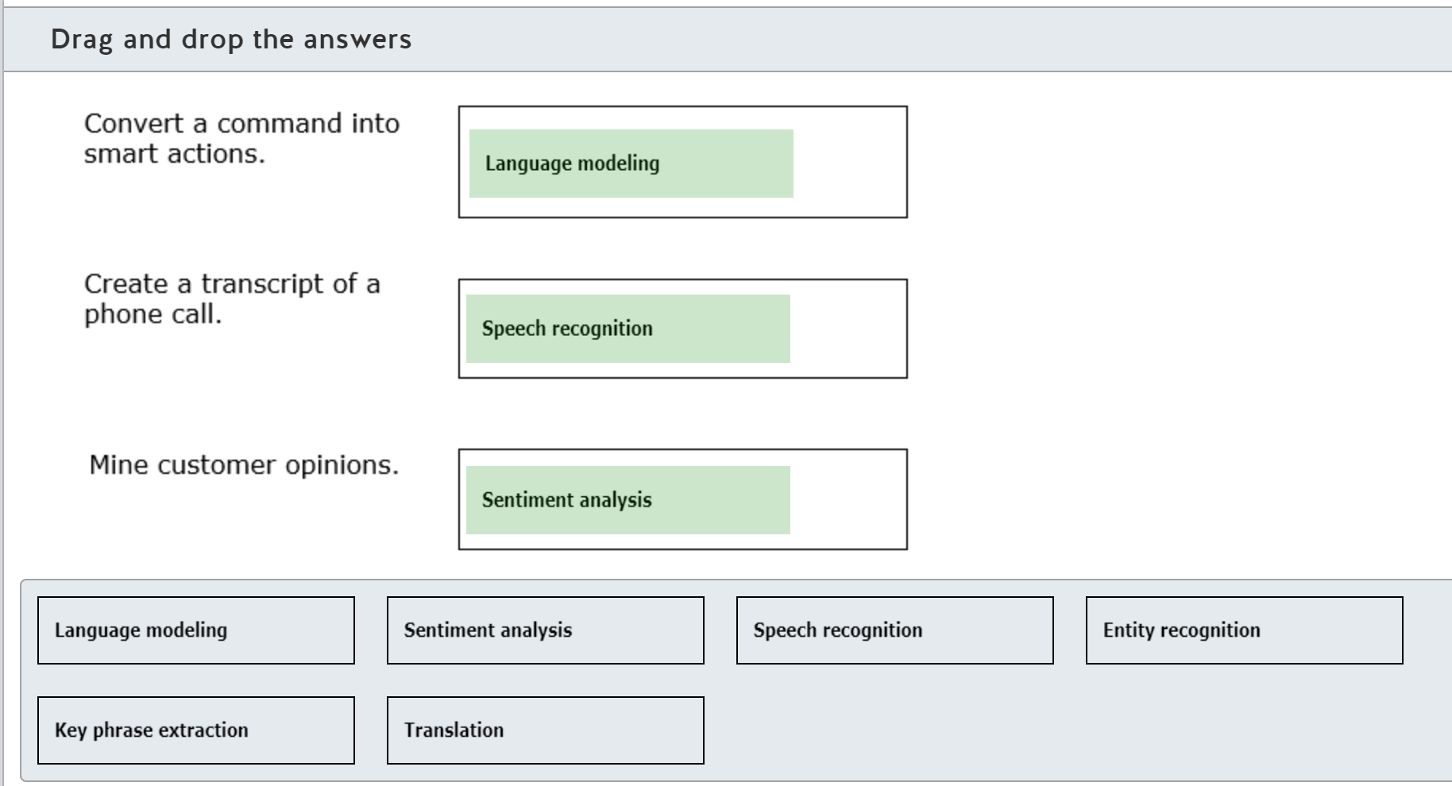

Converting a command into smart actions is an example of language modeling. Language modelling interprets the intent of a text command and turns that command into an intent which can be converted into a smart action for a device.  
  
Creating a transcript of a phone call is an example of speech recognition. The audio in the call recording is analyzed to find patterns that are mapped to words. Speech recognition interprets audio and turns it into text data.  
  
Mining customer opinions is an example of sentiment analysis. Sentiment analysis explores customers’ perception of products or services.  
  
Entity recognition detects the use of people, places, organizations, and other known items from a piece of text.  
  
Key phrase extraction evaluates a piece of text and identifies the key talking points contained in the text.  
  
Translation is the conversion of either text or audio speech from one language into another.  
  
**References**  
  
[Language Understanding](https://azure.microsoft.com/services/cognitive-services/language-understanding-intelligent-service)  
  
[Introduction](https://docs.microsoft.com/learn/modules/recognize-synthesize-speech/1-introduction)  
  
[Text Analytics](https://azure.microsoft.com/services/cognitive-services/text-analytics)  
  
[Get started with Text Analytics on Azure](https://docs.microsoft.com/learn/modules/analyze-text-with-text-analytics-service/2-get-started-azure)  
  
[Get started translation in Azure](https://docs.microsoft.com/learn/modules/translate-text-with-translation-service/2-get-started-azure)

 Previous

## Identify Azure tools and services for NLP workloads

### Question 115: You need to build an AI solution that can identify and disambiguate entities in your input texts using Wikipedia as its knowledge base. What Azure cognitive service should you use?

Choose the correct answer

Custom Vision

Bing Autosuggest

Form Recognizer

Text Analytics

**Explanation**

You should use Text Analytics. One of its features is entity linking, which can identify and disambiguate the identities of entries found in a provided text. Entity linking uses Wikipedia as its knowledge base and can determine from the context whether for example Mars refers to the planet or the company brand.  
  
You should not use Bing Autosuggest. It is a cognitive service in Azure’s Search APIs family that allows you to send a partial search term to the Bing search engine and get back a list of suggested queries. This can help to improve user’s search experience, but cannot remove uncertainty in the meaning of the entities within the input text, nor use Wikipedia as a primary knowledge base.  
  
You should not use Custom Vision. It is a cognitive service that allows you to train and deploy custom image classifiers using your own set of images and labels. It is not designed to work with texts to identify and disambiguate meaning of entities.  
  
You should not use Form Recognizer. It is a cognitive service that ingests text from forms and extracts key-value pairs and table data from them. It is useful to extract key information from invoices, sales receipts, business cards, etc. However, it cannot help with the identification and disambiguation of entities in the input texts. Form Recognizer cannot use Wikipedia as a knowledge base either.  
  
**References**  
  
[How to use Named Entity Recognition in Text Analytics](https://docs.microsoft.com/en-us/azure/cognitive-services/text-analytics/how-tos/text-analytics-how-to-entity-linking?tabs=version-3)  
  
[What is Bing Autosuggest?](https://docs.microsoft.com/en-us/azure/cognitive-services/bing-autosuggest/get-suggested-search-terms)  
  
[What is Custom Vision?](https://docs.microsoft.com/en-us/azure/cognitive-services/Custom-Vision-Service/home)  
  
[What is Form Recognizer?](https://docs.microsoft.com/en-us/azure/cognitive-services/form-recognizer/overview)

### Question 116: You need to build an AI solution that can determine the broader meaning of a user's intentions from their utterances. Which Azure cognitive service should you use?

Choose the correct answer

Form Recognizer

Language Understanding Intelligence Service (LUIS)

Bing Local Business Search

Text Translator

**Explanation**

You should use LUIS. LUIS can analyze a user's utterance (text in the user's own words) to determine a user’s intention.  
  
You should not use Bing Local Business Search. Bing Local Business Search can help to find information about local businesses through the Bing search engine from a query. Search results are limited to the business contact details and locations. Bing Local Business Search is not designed to process a user's utterances to determine the broader meaning of their intentions.  
  
You should not use Form Recognizer. Form Recognizer is an Azure service that ingests text from forms and extracts key-value pairs and table data from them. It is useful for the extraction of key information from invoices, sales receipts, business cards, etc. However, it cannot determine A user’s intention from their utterances.  
  
You should not use Text Translator. Text Translator is an Azure service that translates text in near real-time. To determine a user’s intention from their utterances, you should use LUIS instead.  
  
**References**  
  
[What is Language Understanding (LUIS)?](https://docs.microsoft.com/en-us/azure/cognitive-services/luis/what-is-luis)  
  
[What is Bing Local Business Search?](https://docs.microsoft.com/en-us/azure/cognitive-services/bing-local-business-search/overview)  
  
[What is Form Recognizer?](https://docs.microsoft.com/en-us/azure/cognitive-services/form-recognizer/overview)  
  
[What is Translator?](https://docs.microsoft.com/en-us/azure/cognitive-services/translator/translator-info-overview)

 Previous

### Question 117: You need to enhance your chat application’s functionality to enable English to Korean translation in near real-time. Which Azure cognitive service should you use?

Choose the correct answer

Text Translator

Language Understanding Intelligence Service (LUIS)

Form Recognizer

Speech Translator

**Explanation**

You should use Text Translator. Text Translator is an Azure cognitive service that can enable text translation in your chat application in near real-time. Text Translator supports translation into and out of more than 70 languages, including Korean and English.  
  
You should not use Form Recognizer. Form Recognizer is an Azure service that ingests text from forms and extracts key-value pairs and table data from them. It is useful for the extraction of key information from invoices, sales receipts, business cards, etc. Form Recognizer cannot enhance teh functionality of your custom chat application to enable multilingual text translation.  
  
You should not use LUIS. LUIS can analyze user utterances (text in the user's own words) to determine their intention. LUIS has built-in support for multiple languages, including, but very limited, Korean. However, it cannot be used as a proper text-to-text translation service from English to Korean in near real-time.  
  
You should not use Speech Translator. Speech Translator is an Azure cognitive service that can provide multilingual English to Korean translation in near real-time. However, Speech Translation expects input to be in audio format, i.e. as a file or audio stream. It does not support text as an input, and that is why it cannot be used to translate messages in your custom chat application.  
  
**References**  
  
[What is Translator?](https://docs.microsoft.com/en-us/azure/cognitive-services/translator/translator-info-overview)  
  
[Language and region support for text and speech translation](https://docs.microsoft.com/en-us/azure/cognitive-services/Translator/language-support)  
  
[What is Form Recognizer?](https://docs.microsoft.com/en-us/azure/cognitive-services/form-recognizer/overview)  
  
[What is Language Understanding (LUIS)?](https://docs.microsoft.com/en-us/azure/cognitive-services/luis/what-is-luis)  
  
[What is speech translation?](https://docs.microsoft.com/en-us/azure/cognitive-services/speech-service/speech-translation)

 Previous

### Question 118: Move the appropriate Azure service to the answer area to match it with the relevant use in each scenario. An Azure service may be used once, more than once, or not at all.

Drag and drop the answers















**Explanation**

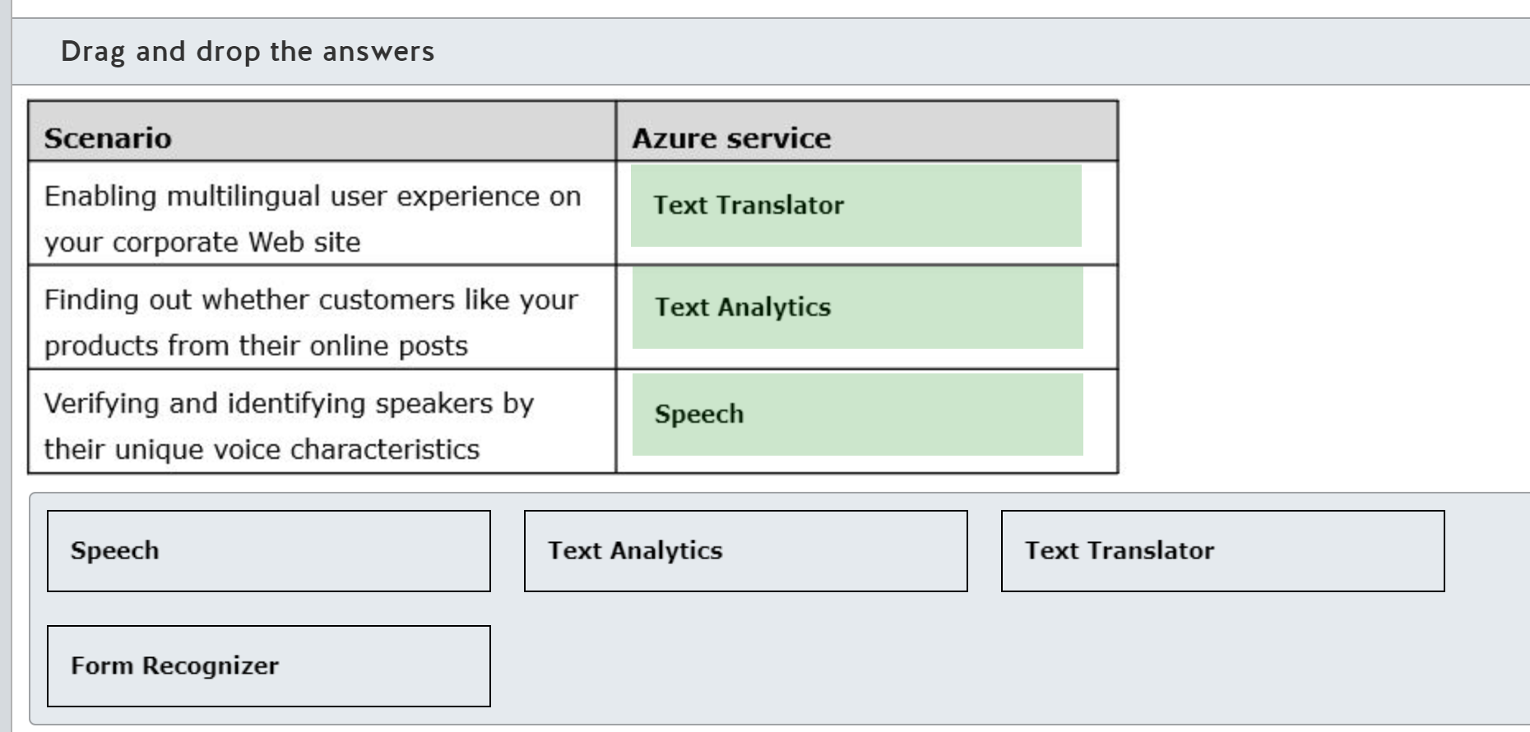

Text Translator can be used to enable multilingual user experience on your corporate website. Text Translator is an Azure cognitive service that is easy to integrate with your applications and websites to add text-to-text translation in more than 70 supported languages.  
  
Text Analytics can be used to find out whether customers like your products from their online posts. Sentiment analysis functionality within the set of Text Analytics services can analyze raw text for clues about positive or negative sentiment.  
  
Speech service can be utilized to verify and identify speakers by their unique voice characteristics. Speech service requires audio training data for the machine learning model to learn about the unique characteristics of each speaker. Then, it checks with the new samples if it is the same person or identifies whether a new voice sample matches a group of enrolled speaker profiles.  
  
Form Recognizer is an Azure cognitive service that can identify and extract key-value pairs and table data from form documents like sales receipts and invoices. Form Recognizer cannot be used on its own to enable any of the listed use case scenarios.  
  
**References**  
  
[What is Translator?](https://docs.microsoft.com/en-us/azure/cognitive-services/translator/translator-info-overview)  
  
[What is the Text Analytics API?](https://docs.microsoft.com/en-us/azure/cognitive-services/text-analytics/overview)  
  
[What is the Speech service?](https://docs.microsoft.com/en-gb/azure/cognitive-services/speech-service/overview)  
  
[What is Form Recognizer?](https://docs.microsoft.com/en-us/azure/cognitive-services/form-recognizer/overview)

### Question 119: Move the appropriate Azure service to the answer area to match it with the relevant use in each scenario. An Azure service may be used once, more than once, or not at all.

Drag and drop the answers















**Explanation**

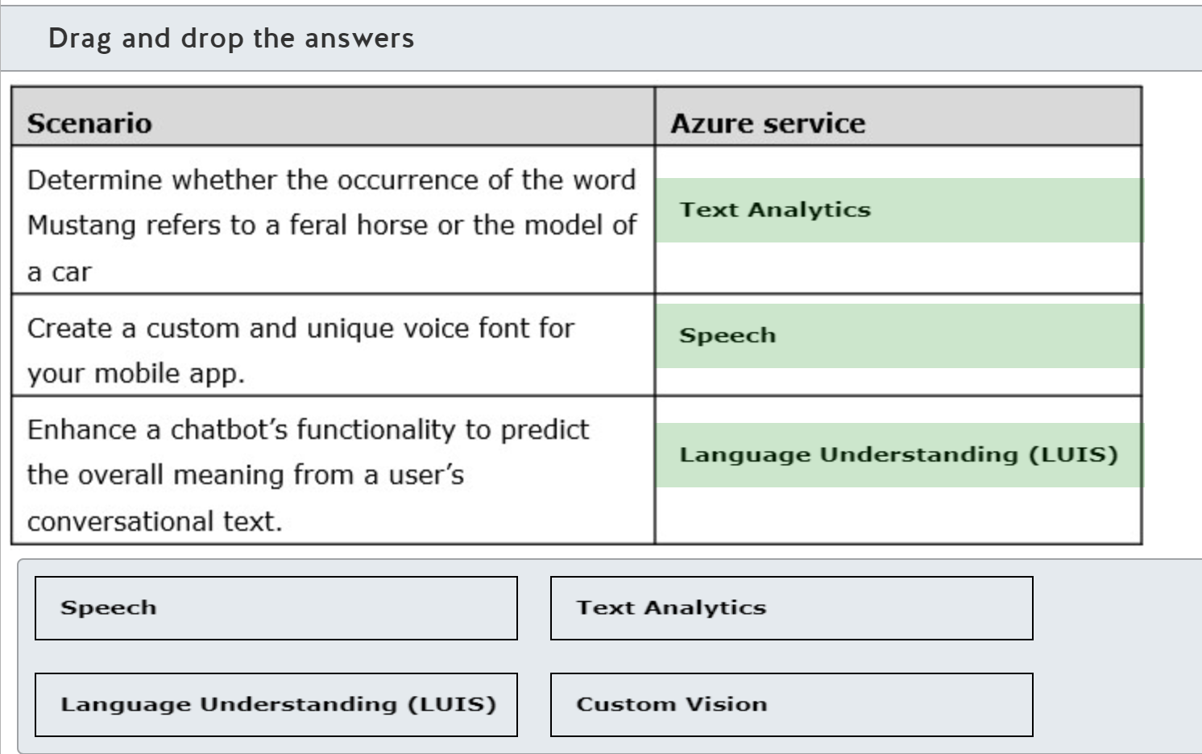

Text Analytics can be utilized to determine whether the occurrence of the word Mustang refers to a feral horse or a car model. Entity linking capability of Text Analytics can identify and clarify the meaning of an entity found in provided text, using Wikipedia as a knowledge base.  
  
Speech service can be utilized to create a custom and unique voice font for your mobile app. It offers the option of training private and custom-tuned models, so that you can produce recognizable, unique voice for your text-to-speech mobile app.  
  
Language Understanding Intelligence Service (LUIS) can be utilized to enhance a chatbot’s functionality to predict the overall meaning from a user’s conversational text. LUIS can provide intelligence to your chatbot by processing user utterances (text in the user's own words) and sending back to the chatbot its prediction of the overall meaning.  
  
Custom Vision is an Azure cognitive service that lets you build and deploy a custom image classifier using your own set of images and labels. It cannot be used to support any of the listed scenarios.  
  
**References**  
  
[What is the Text Analytics API?](https://docs.microsoft.com/en-us/azure/cognitive-services/text-analytics/overview)  
  
[What is the Speech service?](https://docs.microsoft.com/en-gb/azure/cognitive-services/speech-service/overview)  
  
[What is Language Understanding (LUIS)?](https://docs.microsoft.com/en-us/azure/cognitive-services/luis/what-is-luis)  
  
[What is Custom Vision?](https://docs.microsoft.com/en-us/azure/cognitive-services/Custom-Vision-Service/home)

 Previous

### Question 120: For each of the following statements, select Yes if the statement is true. Otherwise, select No.

|  |  |  |
| --- | --- | --- |
| **Statement** | **Yes** | **No** |
| To use the Speech service, you need to build a custom speech model. |  |  |
| The Speech service can transcribe audio streams in real time. |  |  |
| The Speech service can transcribe audio files asynchronously. |  |  |

**Explanation**

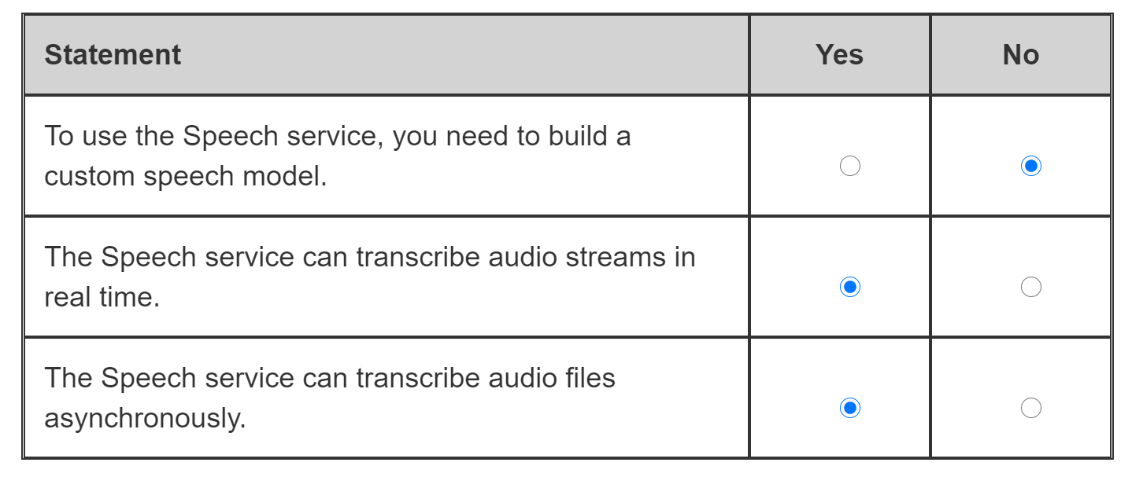

To use the Speech service, you do not need to build a custom speech model. If your application uses generic language and works in an environment with little or no background noise, you can utilize a baseline model pretrained on Microsoft-owned data that is already deployed in the cloud. A custom speech model is a better fit when you need to adapt the Speech service to specific noise or language.  
  
The Speech service can transcribe audio streams and even local files in real time. It can be used in combination with other cognitive services, such as Language Understanding Intelligence Service (LUIS), to enable real-time interaction with users, e.g. to understand their voice commands and perform required operations.  
  
The Speech service can transcribe audio files asynchronously. Large amounts of audio files can be uploaded to Azure storage and processed asynchronously by the Speech service through the RESTful batch speech-to-text interface.  
  
**References**  
  
[Speech to Text frequently asked questions](https://docs.microsoft.com/en-us/azure/cognitive-services/speech-service/faq-stt)  
  
[What is the Speech service?](https://docs.microsoft.com/en-gb/azure/cognitive-services/speech-service/overview)

 Previous

### Question 121: Which two Azure cognitive services can you combine to recognize intents in voice commands? Each correct answer presents part of the solution.

Choose the correct answers

Language Understanding

Text Translator

Speaker Recognition

Form Recognizer

Speech

**Explanation**

You can combine the functionality of the Speech service and Language Understanding Intelligence Service (LUIS) to recognize intents in voice commands. The Speech service enables the real-time transcription of voice commands from an audio stream into text. LUIS can then process the user’s conversational text to predict the overall meaning and return detected intents back to your application.  
  
Form Recognizer is a cognitive service that can identify and extract key-value pairs and table data from a form document, such as a sales receipt. It cannot work with data in audio format and is therefore not applicable to the voice command recognition scenario.  
  
Speaker recognition is a cognitive service that can identify and verify speakers. Its model can learn about the unique characteristics of ta speaker’s voice. However, it cannot be used to identify the meaning of the voice commands.  
  
Text Translator is a cognitive service that enables text-to-text multilingual translation in more than 70 supported languages. It cannot process audio data, and even if it is fed text data from the Speech service, it cannot be used to recognize intents in voice commands.  
  
**References**  
  
[What is speech-to-text?](https://docs.microsoft.com/en-gb/azure/cognitive-services/speech-service/speech-to-text)  
  
[How to recognize intents from speech using the Speech SDK for C#](https://docs.microsoft.com/en-gb/azure/cognitive-services/speech-service/how-to-recognize-intents-from-speech-csharp)  
  
[What is Language Understanding (LUIS)?](https://docs.microsoft.com/en-us/azure/cognitive-services/luis/what-is-luis)  
  
[What is Form Recognizer?](https://docs.microsoft.com/en-us/azure/cognitive-services/form-recognizer/overview)  
  
[What is Speaker Recognition?](https://docs.microsoft.com/en-us/azure/cognitive-services/speech-service/speaker-recognition-overview)  
  
[What is Translator?](https://docs.microsoft.com/en-us/azure/cognitive-services/translator/translator-info-overview)

### Question 122: For each of the following statements about the Azure Cognitive Services Text Analytics service, select Yes if the statement is true. Otherwise, select No.

|  |  |  |
| --- | --- | --- |
| **Statement** | **Yes** | **No** |
| The results from the Key Phrases operation in Text Analytics includes a confidence score between 0 and 1. |  |  |
| The Text Analytics API can be used with C#. |  |  |
| Text Analytics can be used by Power App canvas apps to analyze text. |  |  |

**Explanation**

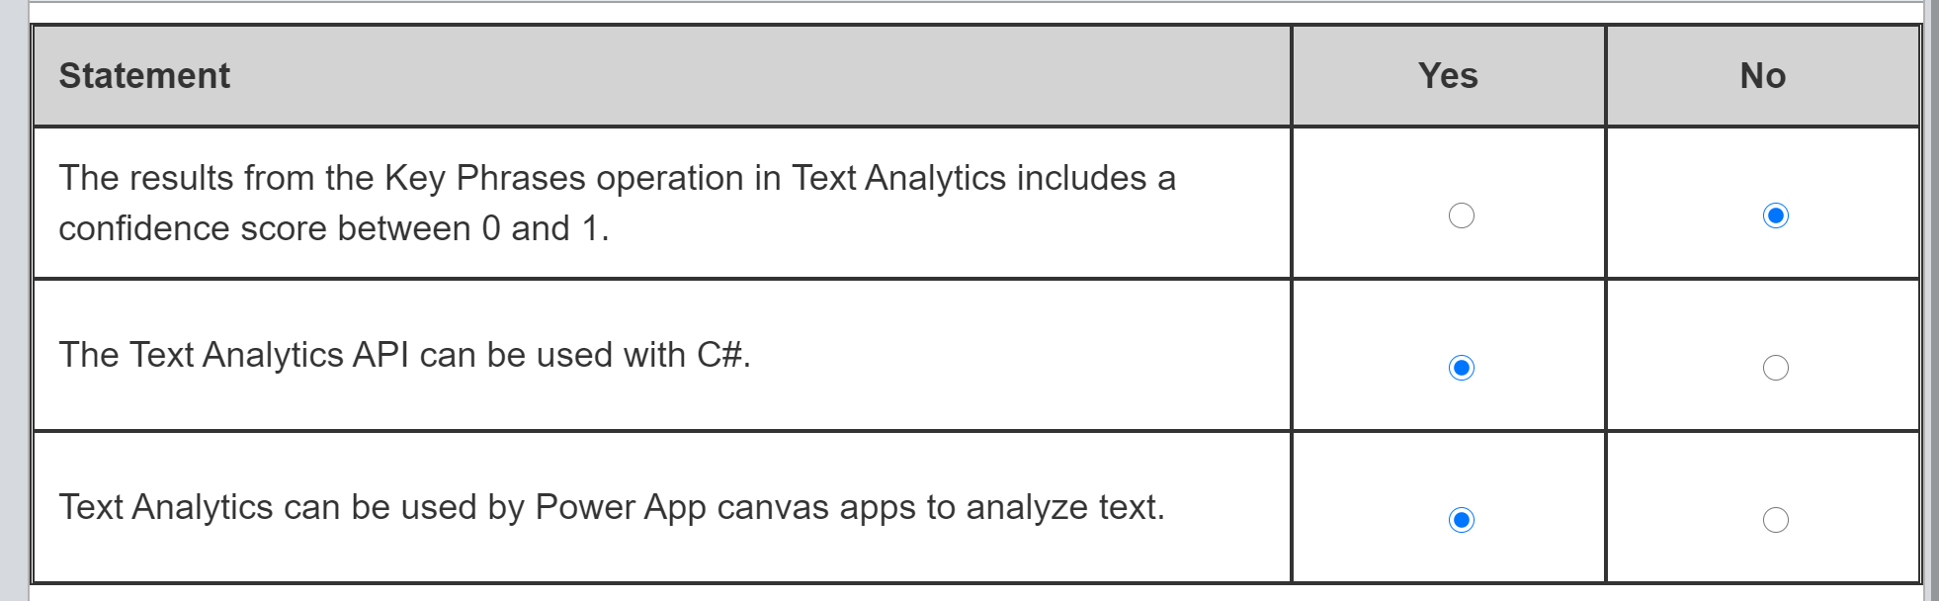

Some operations from the Text Analytics API include a confidence score between 0 and 1, with 1 being the highest confidence, but not all operations do. Sentiment Analysis, Language Detection, and Entity Detection return a confidence score. The Key Phrases operation does not include a confidence score. Key Phrases simply returns a list of phrases extracted from the text.  
  
Text Analytics has a REST API. There is a client library available for .NET, so you can use C# with the Text Analytics API. There are also client libraries for Java, Python, JavaScript, Ruby, and Go.  
  
Text Analytics can be used with Power Apps to analyze text. There is a Text Analytics connector that can be used to call Text Analytics from a canvas app.  
  
**References**  
  
[What is the Text Analytics API?](https://docs.microsoft.com/azure/cognitive-services/text-analytics/overview)  
  
[Text Analytics API (v3.0)](https://westus.dev.cognitive.microsoft.com/docs/services/TextAnalytics-v3-0/operations/KeyPhrases)  
  
[Quickstart: Use the Text Analytics client library](https://docs.microsoft.com/azure/cognitive-services/text-analytics/quickstarts/text-analytics-sdk)  
  
[Use Cognitive Services in Power Apps](https://docs.microsoft.com/powerapps/maker/canvas-apps/cognitive-services-api)  
  
[Text Analytics](https://docs.microsoft.com/connectors/cognitiveservicestextanalytics/)

 Previous

### Question 123: What information do you need to use in a published Language Understanding model to find the meaning in a text statement?

Choose the correct answer

Endpoint and key of a Text Analytics resource

Subscription ID and resource ID of a Language Understanding Intelligence Service (LUIS) resource

App Id, Authoring endpoint and Authoring key of a Language Understanding Intelligence Service (LUIS) app

App Id, Prediction endpoint and Prediction key of a Language Understanding Intelligence Service (LUIS) app

**Explanation**

There are two resources in a LUIS app: the authoring resource used to build, manage, train, test and publish your LUIS model, and a prediction resource to query the model. To use a LUIS model to find the intent of a text statement, you need the ID of the LUIS app and the endpoint and key for the Prediction resource, but not the Authoring resource.  
  
The endpoint and the key of a Text Analytics resource are required if you want to use the Text Analytics API. However, they are not used to query a LUIS model.  
  
The subscription ID and the resource ID of a LUIS resource enable you to manage a LUIS resource but they do not enable you to query the LUIS model.  
  
**References**  
  
[Create LUIS resources](https://docs.microsoft.com/azure/cognitive-services/luis/luis-how-to-azure-subscription)  
  
[Quickstart: Query prediction runtime with user text](https://docs.microsoft.com/azure/cognitive-services/luis/luis-get-started-get-intent-from-browser)  
  
[Quickstart: Use cURL and REST to get intent](https://docs.microsoft.com/azure/cognitive-services/luis/luis-get-started-rest-get-intent)  
  
[Create a Cognitive Services resource using the Azure portal](https://docs.microsoft.com/azure/cognitive-services/cognitive-services-apis-create-account)

### Question 124: Match the requirement to a Speech service API. To answer, drag the appropriate API to each requirement. An API may be used once, more than once, or not at all.

Drag and drop the answers

















**Explanation**

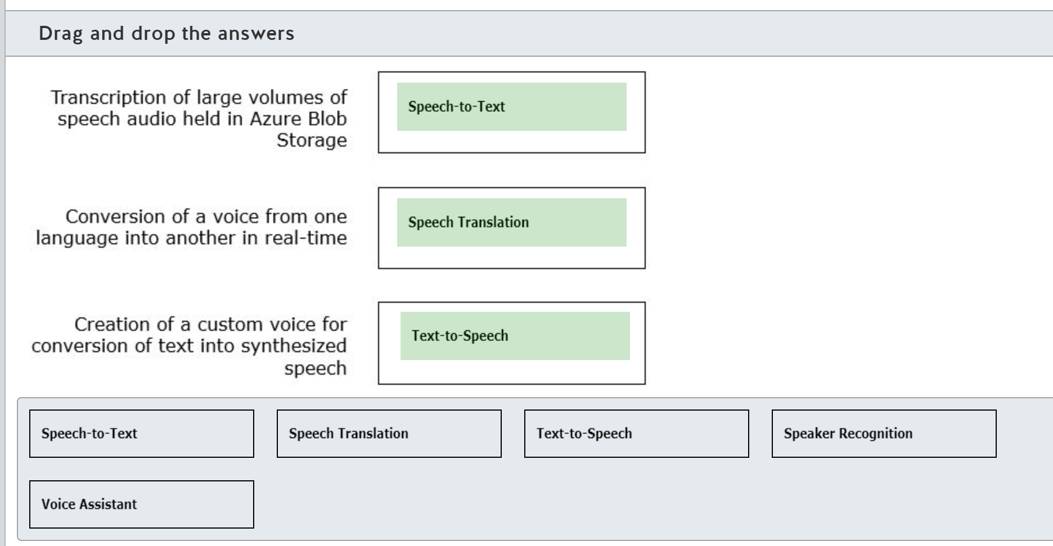

The speech-to-text API can be used synchronously (Real-Time) or asynchronously (Batch). Batch Speech-to-text can transcribe large volumes of speech audio recordings stored in Azure Blob Storage.  
  
The speech translation API performs multi-language translation of speech in real-time. The API can perform speech-to-text and speech-to-speech translations.  
  
The speech service contains an acoustic model and a language model for each language. The text-to-speech API converts text into synthesized speech. You can choose from neural voices, standard voices, or a custom voice. The text-to-speech API can create custom voices.  
  
The Speaker Recognition service identifies the person who is speaking using their voice characteristics.  
  
Voice assistants perform speech-to-text and text-to-speech processing for bots created with the Azure Bot service.  
  
**References**  
  
[What is the Speech service?](https://docs.microsoft.com/azure/cognitive-services/speech-service/overview)  
  
[How to use batch transcription](https://docs.microsoft.com/azure/cognitive-services/speech-service/batch-transcription)  
  
[What is speech translation?](https://docs.microsoft.com/azure/cognitive-services/speech-service/speech-translation)  
  
[What is text-to-speech?](https://docs.microsoft.com/azure/cognitive-services/speech-service/text-to-speech)  
  
[Language and voice support for the Speech service](https://docs.microsoft.com/azure/cognitive-services/speech-service/language-support)  
  
[What is Speaker Recognition?](https://docs.microsoft.com/azure/cognitive-services/speech-service/speaker-recognition-overview)  
  
[What is a voice assistant?](https://docs.microsoft.com/azure/cognitive-services/speech-service/voice-assistants)

 Previous

### Question 125: To complete the following sentence, select the appropriate option from the drop-down menu.

Choose the correct options

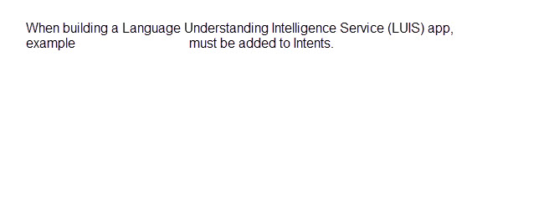



**Explanation**

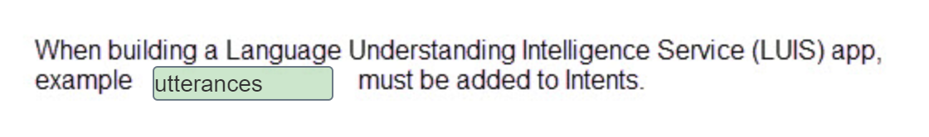

Utterances are user inputs that LUIS needs to interpret. To train LUIS, you add example utterances to each Intent you have added to your model.  
  
Intents are the required outcome from an utterance and are linked to actions. Entities are data in an utterance. Entities are the information needed to perform the action identified in the Intent.  
  
Features provide LUIS with hints, not hard rules, for LUIS to use when finding intents and entities.  
  
**References**  
  
[Language Understanding](https://azure.microsoft.com/services/cognitive-services/language-understanding-intelligent-service/)  
  
[Understand what good utterances are for your LUIS app](https://docs.microsoft.com/azure/cognitive-services/luis/luis-concept-utterance)  
  
[Intents in your LUIS app](https://docs.microsoft.com/azure/cognitive-services/luis/luis-concept-intent)  
  
[Design with intent and entity models](https://docs.microsoft.com/azure/cognitive-services/luis/luis-concept-model)  
  
[Extract data with entities](https://docs.microsoft.com/azure/cognitive-services/luis/luis-concept-entity-types)  
  
[Machine-learning features](https://docs.microsoft.com/azure/cognitive-services/luis/luis-concept-feature)

### Question 126: Match the requirement to a Language Understanding Intelligence Service (LUIS) prebuilt model type. To answer, drag the appropriate prebuilt model to each requirement. A prebuilt model may be used once, more than once, or not at all.

Drag and drop the answers













**Explanation**

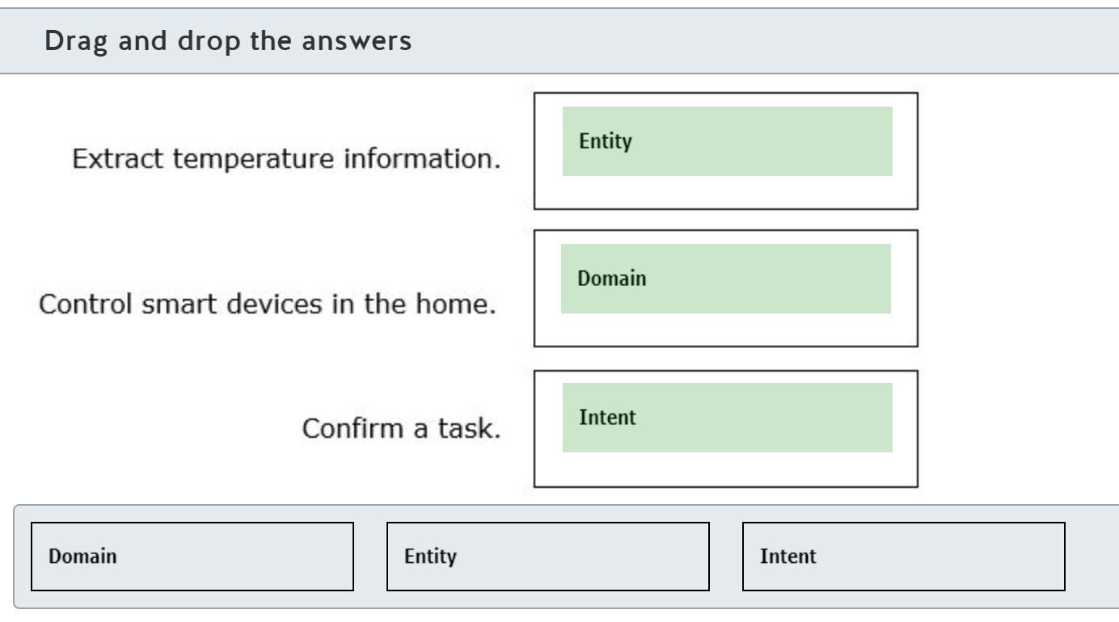

Prebuilt entities contain only an entity trained to extract specific data. The temperature entity extracts the temperature number and temperature scale, such as Celsius and Fahrenheit.  
  
Prebuilt domains contain intents, utterances, and entities. The HomeAutomation domain contains the common utterances for controlling smart devices such as lights and appliances, with intents such as TurnOn and TurnOff, and entities such as light.  
  
Prebuilt intents contain intents and utterances, but not entities. You can add the intents from the prebuilt domains without adding the entire domain model. The Todo.Confirm intent contains utterances that confirm that a task should be performed.  
  
**References**  
  
[What is Language Understanding (LUIS)?](https://docs.microsoft.com/azure/cognitive-services/luis/what-is-luis)  
  
[Prebuilt models](https://docs.microsoft.com/azure/cognitive-services/luis/luis-concept-prebuilt-model)  
  
[Entities per culture in your LUIS model](https://docs.microsoft.com/azure/cognitive-services/luis/luis-reference-prebuilt-entities)  
  
[Add prebuilt models for common usage scenarios](https://docs.microsoft.com/azure/cognitive-services/LUIS/howto-add-prebuilt-models)  
  
[Prebuilt domain reference for your LUIS app](https://docs.microsoft.com/azure/cognitive-services/luis/luis-reference-prebuilt-domains)

 Previous

### Question 127: For each of the following statements about the Translator service, select Yes if the statement is true. Otherwise, select No.

|  |  |  |
| --- | --- | --- |
| **Statement** | **Yes** | **No** |
| The Translator service uses Statistical Machine Translation (SMT) technology. |  |  |
| The Translator service can simultaneously translate from one language into multiple other languages. |  |  |
| The Translator service supports translation into language variants such as French and Canadian French. |  |  |

**Explanation**

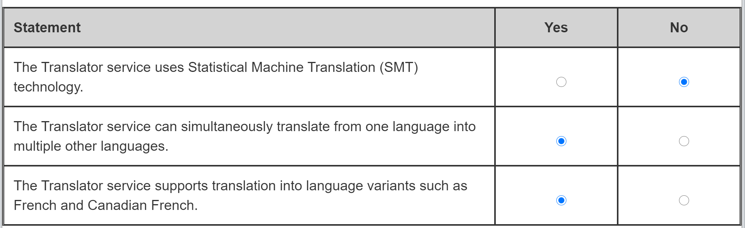

The Translator service uses Neural Machine Translation (NMT). NMT uses neural networks and deep learning to translate whole sentences. SMT technology uses statistical analysis to estimate the best possible translations for a word given the context of a few neighboring words. Translator replaced SMT with NMT in 2016.  
  
The Translator service translates text from one language to another language. The Translator service allows you to specify multiple languages, so you can simultaneously translate into multiple languages.  
  
The Translator service allows you to specify a cultural variant when translating into a language. You append the cultural code to the language code, for example, fr-CA for Canadian French.  
  
**References**  
  
[What is machine translation?](https://www.microsoft.com/translator/business/machine-translation)  
  
[Get started translation in Azure](https://docs.microsoft.com/learn/modules/translate-text-with-translation-service/2-get-started-azure)  
  
[What is the Translator service?](https://docs.microsoft.com/azure/cognitive-services/translator/translator-info-overview)  
  
[Language and region support for text and speech translation](https://docs.microsoft.com/azure/cognitive-services/Translator/language-support)

# Describe features of conversational AI workloads on Azure

## Identify common use cases for conversational AI

### Question 128: A customer calling a support line number gets an AI-generated voice prompt with options to choose from. Which conversational AI is this an example of?

Choose the correct answer

Telephone voice menu

Webchat bot

Personal digital assistant

**Explanation**

The scenario where a customer calling a support line number gets an AI-generated voice prompt with options to choose from is an example of a telephone voice menu. This type of conversational AI can reduce the workload on human operators by providing generic instructions to customers, automatically transfering calls to the relevant teams, or managing the waiting queue, all of which helps to support business operations even during non-working hours and holidays.  
  
A personal digital assistant is a conversational AI solution that provides management, retrieval and update of a user's personal or business information to keep them informed and productive. It can run across devices and platforms with access to electronic calendars, e-mail, contact lists, and other applications to enable personalized assistance with routine tasks, for example, booking a new meeting with a client. It is different from the support line telephone voice menu solution, which provides a more generalized service without access to the customer’s device and personal/business data.  
  
A chatbot is a conversational AI solution that can utilize cognitive services and knowledge bases to conduct a real-time conversation with humans using text, speech, and other available communication channels. Webchat bot is a specific type of chatbot that communicates via a web channel and is typically integrated with web-enabled applications.  
  
**References**  
  
[What are Cloud auto attendants?](https://docs.microsoft.com/en-us/microsoftteams/what-are-phone-system-auto-attendants)  
  
[Cortana Skills Kit](https://docs.microsoft.com/en-us/cortana/skills/overview)  
  
[How bots work](https://docs.microsoft.com/en-us/azure/bot-service/bot-builder-basics?view=azure-bot-service-4.0&tabs=csharp)

 Previous

### Question 129: An app is embedded in a travel site to interact with online customers and help with the real-time booking of their trips. Which conversational AI is this an example of?

Choose the correct answer

Webchat bot

Telephone voice menu

Personal digital assistant

**Explanation**

An app that is embedded in a travel site to interact with online customers and help with the real-time booking of their trips is an example of a webchat bot. A webchat bot is a conversational AI solution that can utilize cognitive services and knowledge bases to conduct real-time conversations with humans via web channels and is typically integrated with web-enabled applications.  
  
A telephone voice menu is a conversational AI that can reduce workload on the human operators, provide generic instructions to the customers, automatically transfer calls to the relevant teams or manage the waiting queue, supporting business operations even during non-working hours and holidays. It is integrated with the phone system and supports interaction through a phone keypad or speech recognition. It does not support direct integration with the Web site to facilitate the trip booking process.  
  
A personal digital assistant is a conversational AI solution that provides management, retrieval and update of users’ personal or business information to keep them informed and productive. It can run across devices and platforms with access to electronic calendars, e-mail, contact lists and other applications to enable personalized assistance with routine tasks, for example, sending a text message to friend. It can interact programmatically with websites, for example, to help with booking a trip. However, it cannot be embedded directly into a website and run on its own to book new trips for the site’s online customers.  
  
**References**  
  
[What are Cloud auto attendants?](https://docs.microsoft.com/en-us/microsoftteams/what-are-phone-system-auto-attendants)  
  
[Cortana Skills Kit](https://docs.microsoft.com/en-us/cortana/skills/overview)  
  
[How bots work](https://docs.microsoft.com/en-us/azure/bot-service/bot-builder-basics?view=azure-bot-service-4.0&tabs=csharp)

 Previous

### Question 130: To complete the following sentence, select the appropriate option from the drop-down menu.

Choose the correct options

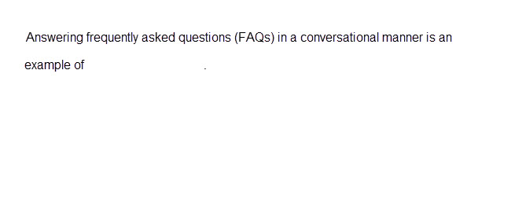



**Explanation**

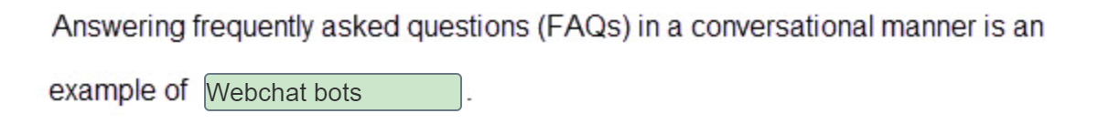

Webchat bots are conversational AI agents that can use natural language processing to understand questions and find the most appropriate answer from a knowledge base.  
  
Object detection identifies and tags individual visual features (objects) in an image. Object detection can recognize many different types of objects.  
  
Speech recognition is the ability to detect and interpret spoken input and turn it into text. Speech is analyzed to find patterns that are mapped to words.  
  
**References**  
  
[Get started with QnA Maker and Azure Bot Service](https://docs.microsoft.com/learn/modules/build-faq-chatbot-qna-maker-azure-bot-service/2-get-started-qna-bot)  
  
[What is the Bot Framework SDK?](https://docs.microsoft.com/azure/bot-service/bot-service-overview-introduction)  
  
[Get started with object detection on Azure](https://docs.microsoft.com/learn/modules/detect-objects-images-custom-vision/2-object-detection-azure)  
  
[What is speech-to-text?](https://docs.microsoft.com/azure/cognitive-services/speech-service/speech-to-text)

 Previous

### Question 131: What is the most common use of a bot?

Choose the correct answer

Identifying the main points in a document uploaded by a customer

Interpreting an image uploaded by a customer

Prioritizing customer emails by performing statistical analysis of the email's content

Providing first-line automated customer service to customers across multiple channels

**Explanation**

Bots can provide automated responses to customers. Bots can manage the conversation using a combination of natural language and predefined responses to guide the customer to a resolution. Bots can be deployed over many channels, including Web Chat, Facebook, and Microsoft Teams. Providing an automated first-line response to customers over multiple channels is the most common experience users will have with chatbots.  
  
Identifying the main points in a document uploaded by a customer is an example of Key Phrase Extraction, which is a feature of Text Analytics. Key Phrase Extraction evaluates text and identifies the key talking points from the text.  
  
Interpreting an image uploaded by a customer is an example of Object Detection, which is a feature of Computer Vision. Object detection identifies and tags individual visual features (objects) in an image.  
  
Prioritizing customer emails by performing statistical analysis of the email's content is an example of Text Analytics. Text Analytics is a service that performs various types of processing, such as Key Phrase Extraction, Sentiment Analysis, and Language Detection.  
  
**References**  
  
[Introduction](https://docs.microsoft.com/learn/modules/build-faq-chatbot-qna-maker-azure-bot-service/1-introduction)  
  
[What is the Bot Framework SDK?](https://docs.microsoft.com/azure/bot-service/bot-service-overview-introduction)  
  
[Connect a bot to channels](https://docs.microsoft.com/azure/bot-service/bot-service-manage-channels)  
  
[What is the Text Analytics API?](https://docs.microsoft.com/azure/cognitive-services/text-analytics/overview)  
  
[Get started with object detection on Azure](https://docs.microsoft.com/learn/modules/detect-objects-images-custom-vision/2-object-detection-azure)

### Question 132: In which two scenarios could you use a bot? Each correct answer presents a complete solution.

Choose the correct answers

Assembly of vehicles on a production line

Customer online ordering

Autonomous vehicles

Human Resources-related questions from an employee

**Explanation**

Online ordering is an example where web chatbots could be used. A bot can clarify the products that the customer wants to order by using text and interactive cards. The bot can interface with the ordering system to place the order. A web chatbot could also use a knowledge base of question and answer pairs and natural language processing to understand and answer human resources-related questions from an employee.  
  
Assembly of vehicles on a production line is an example of a robot. Robots are physical machines that perform repetitive tasks. A robot is not a bot, which is a computer program that performs repetitive tasks.  
  
Autonomous vehicles are an example of semantic segmentation where the AI system must understand its environment to safely integrate into existing traffic.  
  
**References**  
  
[Get started with QnA Maker and Azure Bot Service](https://docs.microsoft.com/learn/modules/build-faq-chatbot-qna-maker-azure-bot-service/2-get-started-qna-bot)  
  
[What is the Bot Framework SDK?](https://docs.microsoft.com/azure/bot-service/bot-service-overview-introduction)  
  
[Understanding the Difference Between a Bot, a Chatbot, and a Robot](https://blog.hubspot.com/customers/understanding-the-difference-between-a-chat-bot-and-robot)  
  
[An overview of semantic image segmentation](https://www.jeremyjordan.me/semantic-segmentation/)

### Question 133: To complete the following sentence, select the appropriate option from the drop-down menu.

Choose the correct options

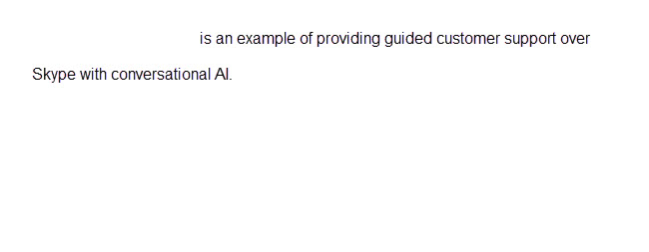



**Explanation**

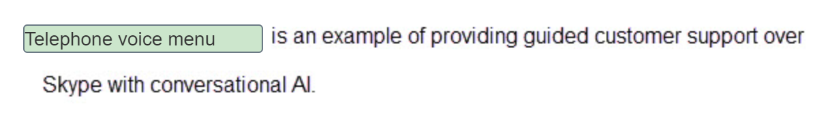

Automated customer interaction over the telephone can be performed by a bot over Skype, Skype for Business, and Microsoft Teams. The bot can use speech services and language understanding to recognize spoken customer responses and respond intelligently in a telephone voice menu.  
  
Personal digital assistants respond to customers using Cortana and third-party services.  
  
Web chat responds to customers using the web chat channel in a web browser.  
  
**References**  
  
[Interactive Voice Response Bot](https://docs.microsoft.com/azure/architecture/solution-ideas/articles/interactive-voice-response-bot)  
  
[What are Cloud auto attendants?](https://docs.microsoft.com/microsoftteams/what-are-phone-system-auto-attendants)  
  
[Connect a bot to channels](https://docs.microsoft.com/azure/bot-service/bot-service-manage-channels)

 Previous

### Question 134: For each of the following statements about personal digital assistants, select Yes if the statement is true. Otherwise, select No.

|  |  |  |
| --- | --- | --- |
| **Statement** | **Yes** | **No** |
| A personal digital assistant has knowledge of a user's needs and preferences. |  |  |
| A personal digital assistant acts on a user's behalf to perform intelligent actions. |  |  |
| A personal digital assistant has text only responses. |  |  |

**Explanation**

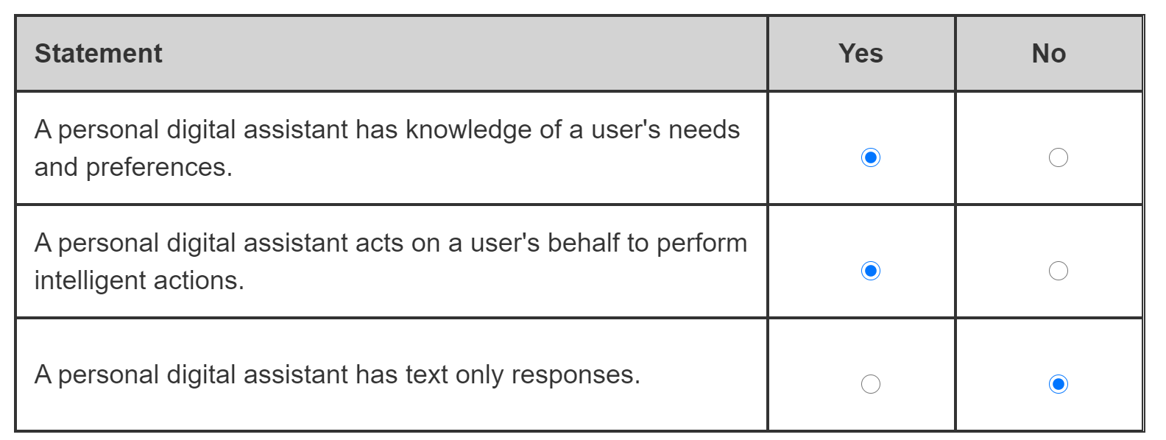

A personal digital assistant is a type of bot that has knowledge of a user's needs and preferences, and the capability to act on those needs and preferences.  
  
A personal digital assistant has the capability to act on a user's behalf applying the user's needs and preferences to perform intelligent actions.  
  
By default, a personal digital assistant will respond in the same way as it is queried. A personal digital assistant will respond with text to text input, and with speech to speech input. You can also configure a personal digital assistant to respond with speech.  
  
**References**  
  
[AI and bot terms](https://docs.microsoft.com/style-guide/a-z-word-list-term-collections/term-collections/ai-bot-terms%20)  
  
[Cortana Skills Bot Scenario](https://docs.microsoft.com/azure/bot-service/bot-service-scenario-cortana-skill)

### Question 135: Match the conversational AI workload to the scenario. To answer, drag the appropriate workload to each scenario. A workload may be used once, more than once, or not at all.

Drag and drop the answers













**Explanation**

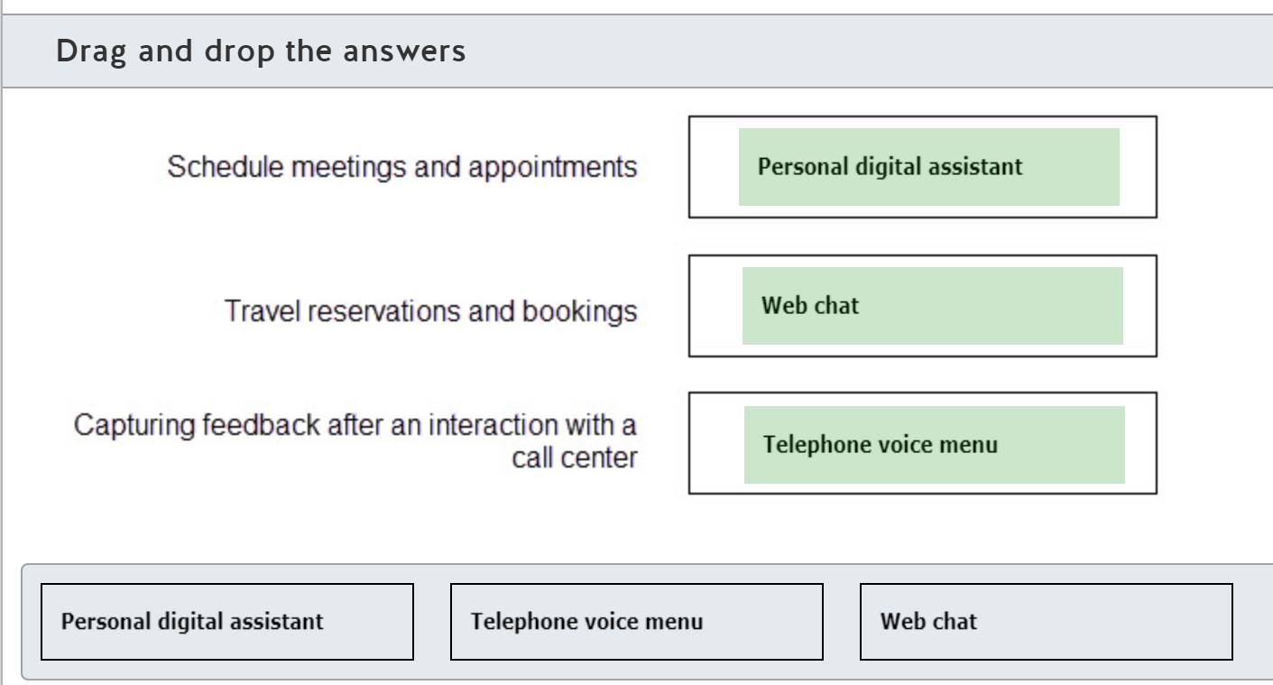

A personal digital assistant is a type of bot that has knowledge of a user's needs and preferences, and the ability to act on those needs and preferences. A personal digital assistant is able to schedule meetings and appointments on behalf of a user as it is able to view the calendar and respond with available time slots to emails containing a request for a meeting.  
  
A customer can use a web chat bot to make reservations for flight, hotel and other travel bookings. The bot can use text and interactive cards such as hero and receipt cards to confirm the customer's details and requirements.  
  
A customer can respond to pre and post surveys in a telephone call to a call center. A telephone voice menu bot can use speech services and language understanding to recognize spoken customer responses and capture the true voice of the customer.  
  
**References**  
  
[Bot scenarios](https://docs.microsoft.com/azure/bot-service/bot-service-scenario-overview)  
  
[AI and bot terms](https://docs.microsoft.com/style-guide/a-z-word-list-term-collections/term-collections/ai-bot-terms)  
  
[Cortana Skills Bot Scenario](https://docs.microsoft.com/azure/bot-service/bot-service-scenario-cortana-skill)  
  
[Virtual Assistant Overview](https://docs.microsoft.com/azure/bot-service/bot-builder-virtual-assistant-introduction)  
  
[Add rich card attachments to messages the v3 C# SDK](https://docs.microsoft.com/azure/bot-service/dotnet/bot-builder-dotnet-add-rich-card-attachments)  
  
[5 Conversational AI Use Cases](https://www.csgi.com/insights/5-conversational-ai-use-cases/)  
  
[Interactive Voice Response Bot](https://docs.microsoft.com/azure/architecture/solution-ideas/articles/interactive-voice-response-bot)

 Previous

### Question 136: An AI solution on your smartphone can understand your voice command and send text messages while you drive a car. Which conversational AI is this an example of?

Choose the correct answer

Telephone voice menu

Personal digital assistant

Webchat bot

**Explanation**

An AI solution on your smartphone that can understand your voice command and send text messages while you drive a car is an example of a personal digital assistant (PDA). A PDA is a conversational AI solution that provides management, retrieval, and update of users’ personal or business information to keep them informed and productive. It can run across devices and platforms with access to electronic calendar, e-mail, contact lists and other applications to enable personalized assistance with the routine tasks, e.g. booking a new meeting with a client. It can also use speech recognition to understand your intents and perform certain operations on your behalf, e.g. compile and send a text message to your contact while you drive a car.  
  
Telephone voice menu is a conversational AI that can reduce the workload on human operators, providing generic instructions to customers, automatically transfering calls to the relevant teams, or managing the waiting queue, all of which supports business operations even during non-working hours and holidays. It is integrated with the phone system and supports interaction through a phone keypad or speech recognition. It does not provide a personalized service to understand your voice commands and send messages to your personal contacts on your behalf.  
  
Webchat bot is a conversational AI solution that can utilize cognitive services and knowledge bases to conduct a real-time conversation with humans via web channels and is typically integrated with web-enabled applications. It is not intended to run on smartphones and perform the tasks of personal digital assistants to keep you informed and productive.  
  
**References**  
  
[What are Cloud auto attendants?](https://docs.microsoft.com/en-us/microsoftteams/what-are-phone-system-auto-attendants)  
  
[Cortana Skills Kit](https://docs.microsoft.com/en-us/cortana/skills/overview)  
  
[How bots work](https://docs.microsoft.com/en-us/azure/bot-service/bot-builder-basics?view=azure-bot-service-4.0&tabs=csharp)

### Question 137: To complete the sentence, select the appropriate option from the drop-down menu.

Choose the correct options

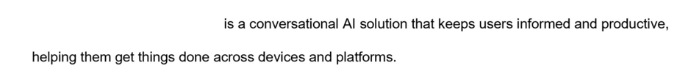



**Explanation**



A personal digital assistant (PDA) is a conversational AI solution that keeps users informed and productive, helping them get things done across devices and platforms. A PDA can run across various devices and operating platforms with access to electronic calendars, e-mail, contact lists, and other applications to enable a personalized assistance with routine tasks.  
  
A telephone voice menu is a conversational AI that can reduce the workload on human operators, providing generic instructions to customers, automatically transfering calls to the relevant teams, or managing the waiting queue, al of which supports  business operations even during non-working hours and holidays. It is integrated with the phone system and supports interaction through a phone keypad or speech recognition.  
  
A webchat bot is a conversational AI solution that can utilize cognitive services and knowledge bases to conduct real-time conversations with humans via web channels and is typically integrated with web-enabled applications.  
  
**References**  
  
[What are Cloud auto attendants?](https://docs.microsoft.com/en-us/microsoftteams/what-are-phone-system-auto-attendants)  
  
[Cortana Skills Kit](https://docs.microsoft.com/en-us/cortana/skills/overview)  
  
[How bots work](https://docs.microsoft.com/en-us/azure/bot-service/bot-builder-basics?view=azure-bot-service-4.0&tabs=csharp)

 Previous

### Question 138: Match the conversational AI solution to a scenario. To answer, drag the appropriate conversational AI solution to each relevant scenario. A conversational AI solution may be used once, more than once, or not at all.

Drag and drop the answers

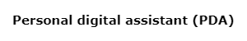











**Explanation**

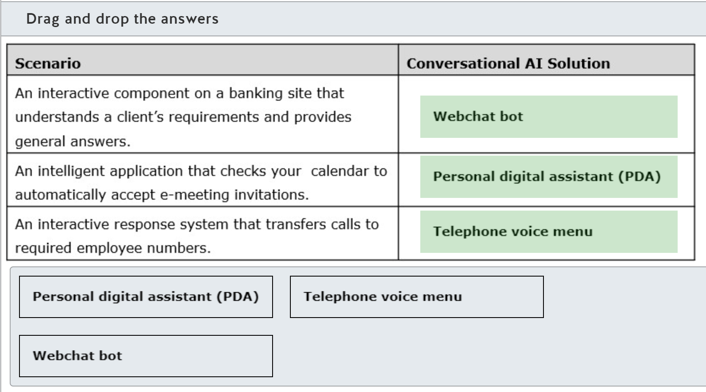

You should use a webchat bot as an interactive component on a banking site to understand a client's requirements and provide general answers. A chatbot is a conversational AI solution that can utilize cognitive services and knowledge bases, integrate with websites and other applications, and conduct a real-time conversation with humans using text, speech, and other available communication channels.  
  
You should use a PDA as an intelligent application that checks your calendar to automatically accept e-meeting invitations. A PDA is a conversational AI solution that provides management, retrieval, and update of users’ personal or business information to keep them informed and productive. It can run across devices and platforms with access to electronic calendars, e-mail, contact lists and other applications to enable a personalized assistance with routine tasks, for example, automatically accepting e-meeting invitations.  
  
You should use a telephone voice menu as an interactive response system that transfers calls to required employee numbers. A telephone voice menu is a conversational AI that can reduce the workload on human operators, provide generic instructions to customers, automatically transfer calls to the relevant teams, or manage the waiting queue, all of which business operations even during non-working hours and holidays.  
  
**References**  
  
[What are Cloud auto attendants?](https://docs.microsoft.com/en-us/microsoftteams/what-are-phone-system-auto-attendants)  
  
[Cortana Skills Kit](https://docs.microsoft.com/en-us/cortana/skills/overview)  
  
[How bots work](https://docs.microsoft.com/en-us/azure/bot-service/bot-builder-basics?view=azure-bot-service-4.0&tabs=csharp)

 Previous

### Question 139: For each of the following statements about a telephone voice menu, select Yes if the statement is true. Otherwise, select No.

|  |  |  |
| --- | --- | --- |
| **Statement** | **Yes** | **No** |
| The caller can interact with a telephone voice menu via the phone keypad. |  |  |
| The caller can interact with a telephone voice menu via speech recognition. |  |  |
| The caller needs to know the recipient’s extension number to get connected. |  |  |

**Explanation**

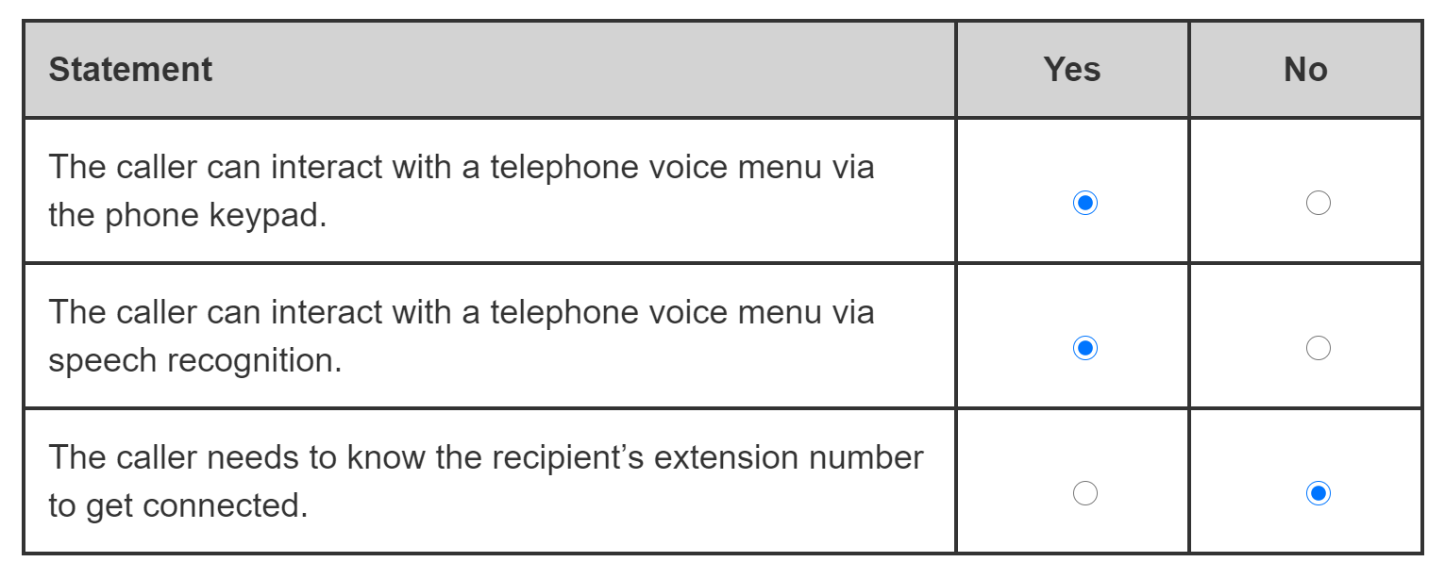

The caller can interact with telephone voice menu via the phone keypad. Dual-tone multi-frequency (DTMF) converts digits and symbols selected on a phone keypad into audible sound so that it can be sent over the telephone line. Audio signal is then converted back into original text format by a telephone voice menu AI solution to understand the caller’s choice.  
  
The caller can interact with a telephone voice menu via speech recognition. The speech recognition capability of a telephone voice menu AI solution can transcribe the caller’s speech into text format to understand the caller’s intents and selected options.  
  
The caller does not need to know the recipient’s extension number to get connected. A telephone voice menu AI solution can provide a directory search option so that the recipient can be found by name, or it can transfer the call to a human operator for further assistance.  
  
**References**  
  
[What are Cloud auto attendants?](https://docs.microsoft.com/en-us/microsoftteams/what-are-phone-system-auto-attendants)  
  
[DTMF Signaling](https://ptolemy.berkeley.edu/eecs20/week2/dtmf.html)  
  
[What is speech-to-text?](https://docs.microsoft.com/en-us/azure/cognitive-services/speech-service/speech-to-text)

 Previous

## Identify Azure services for conversational AI

### Question 140: In which two ways could you natively populate a QnA Maker knowledge base? Each correct answer presents a complete solution.

Choose the correct answers

Using a SharePoint list

Using a SQL database

Using a PDF document

Manually adding question and answer pairs

**Explanation**

You can upload PDF and Word documents containing information, FAQs, and other information into the QnA Maker portal. QnA Maker will analyze the document and extract question and answer pairs.  
  
You can also edit the knowledge base manually in the QnA Maker portal and add question and answer pairs. An editorial source indicates the QnA pair was added in the QnA portal manually.  
  
QnA Maker cannot use a SQL database as a source for the knowledge base. Only files and URLs can be used as a data source for the knowledge base.  
  
QnA Maker cannot use a SharePoint list as a source for the knowledge base. SharePoint resources must be files, not web pages. SharePoint Lists are web pages. If the URL ends with .ASPX, it will not import into QnA Maker from SharePoint.  
  
**References**  
  
[What is the QnA Maker service?](https://docs.microsoft.com/azure/cognitive-services/qnamaker/overview/overview)  
  
[Get started with QnA Maker and Azure Bot Service](https://docs.microsoft.com/learn/modules/build-faq-chatbot-qna-maker-azure-bot-service/2-get-started-qna-bot)  
  
[Importing from data sources](https://docs.microsoft.com/azure/cognitive-services/qnamaker/concepts/knowledge-base)  
  
[Content types of documents you can add to a knowledge base](https://docs.microsoft.com/azure/cognitive-services/qnamaker/concepts/content-types)  
  
[Edit QnA pairs in your knowledge base](https://docs.microsoft.com/azure/cognitive-services/qnamaker/how-to/edit-knowledge-base)

### Question 141: Which two Azure resources are created when a new QnA Marker service is created? Each correct answer presents part of the solution.

Choose the correct answers

Azure Key Vault

Web App Bot

App Service

Azure Cognitive Search

**Explanation**

QnA Maker service requires an App Service. The App Service runs the QnA Maker queries.  
  
QnA Maker service also requires Azure Cognitive Search. The Search service indexes the knowledge base and performs intelligent searches on the knowledge base.  
  
QnA Maker does not use Azure Key Vault to hold its keys and secrets. Authoring and query endpoint keys can be found in the Azure portal and QnA Maker portal.  
  
A Web App Bot is not created when a new QnA Marker service is created. You can create a bot for the QnA Maker knowledge base after publishing the knowledge base.  
  
**References**  
  
[Get started with QnA Maker and Azure Bot Service](https://docs.microsoft.com/learn/modules/build-faq-chatbot-qna-maker-azure-bot-service/2-get-started-qna-bot)  
  
[Azure resources for QnA Maker](https://docs.microsoft.com/azure/cognitive-services/qnamaker/concepts/azure-resources)  
  
[Manage QnA Maker resources](https://docs.microsoft.com/azure/cognitive-services/qnamaker/how-to/set-up-qnamaker-service-azure)

### Question 142: Which file format do you use for uploading a chit-chat personality to a QnA Maker knowledge base?

Choose the correct answer

XLS

PDF

CSV

TSV

**Explanation**

Chit-chat files use the Tab Separated Value (TSV) format.  
  
Files in the Comma Separated Files (CSV), PDF, or Excel (XLS) format cannot be uploaded for chit-chat.  
  
**References**  
  
[Add Chit-chat to a knowledge base](https://docs.microsoft.com/azure/cognitive-services/qnamaker/how-to/chit-chat-knowledge-base)  
  
[Content types of documents you can add to a knowledge base](https://docs.microsoft.com/azure/cognitive-services/qnamaker/concepts/content-types)

### Question 143: Match the Azure Bot Service tool to the requirement. To answer, drag the appropriate tool to each requirement. A tool may be used once, more than once, or not at all.

Drag and drop the answers

















**Explanation**

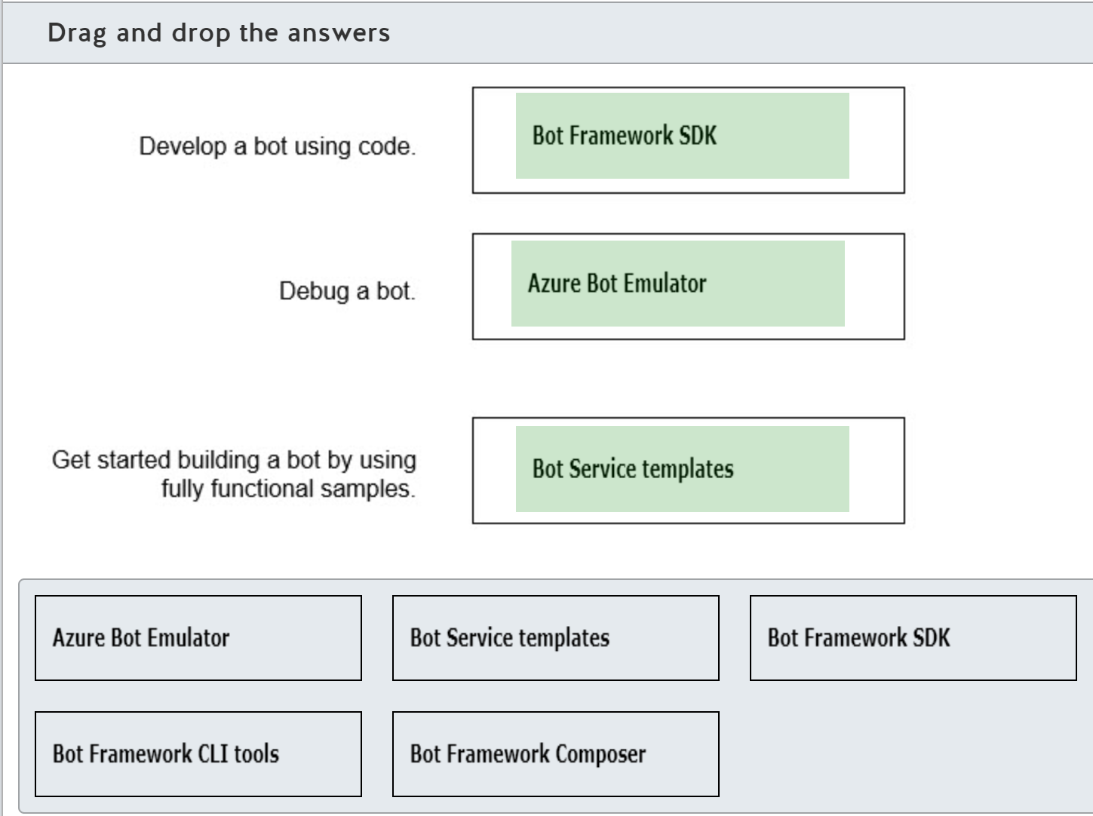

The Bot Framework SDK is required to develop bots using code. There are SDKs for C#, JavaScript, Typescript, and Python. The Bot Framework SDK allows developers to send and receive messages with users on the configured channels.   
  
The Azure Bot Emulator is a desktop application that allows developers to test and debug bots on their local computer.  
  
The Bot Service includes five templates to help developers get started with building bots.  
  
The Bot Framework CLI tools manage bots and related services and are used in DevOps pipelines when deploying bots in enterprises.  
  
The Bot Framework Composer is a tool to build bots without code. The Bot Framework Composer uses a visual user interface to create dialogs and bot logic. The Bot Framework Composer can be installed on Windows, Linux, and MacOS.  
  
**References**  
  
[What is the Bot Framework SDK?](https://docs.microsoft.com/azure/bot-service/bot-service-overview-introduction)  
  
[Debug with the emulator](https://docs.microsoft.com/azure/bot-service/bot-service-debug-emulator)  
  
[Bot Service templates](https://docs.microsoft.com/azure/bot-service/bot-service-concept-templates)  
  
[Bot Framework SDK for .NET](https://docs.microsoft.com/azure/bot-service/dotnet/bot-builder-dotnet-overview)  
  
[Bot Framework CLI tool](https://docs.microsoft.com/azure/bot-service/bf-cli-overview)  
  
[Introduction to Bot Framework Composer](https://docs.microsoft.com/composer/introduction)  
  
[3 Different Flavors For Building Chatbots With Microsoft](https://arinti.ai/3-different-flavors-for-building-chatbots-with-microsoft/)

### Question 144: To complete the following sentence, select the appropriate option from the drop-down menu.

Choose the correct options

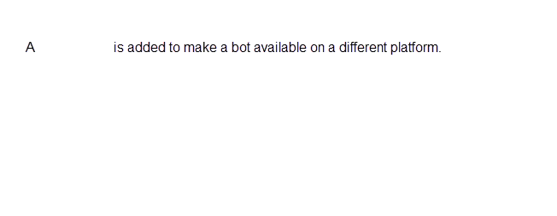



channel

**Explanation**

The Azure Bot Framework separates the logic of the bot from the communication with different apps and platforms. When you create a bot, the bot is available for Web Chat. You can add additional channels to make the bot available on the related platforms. There are channels for Facebook, Email, Microsoft Teams, Slack, and others.  
  
An Azure bot can both consume other bots and be consumed itself by another bot. A skill is a bot that performs tasks for another bot. You add a skill when you want to reuse or extend a bot.  
  
An Azure bot communicates by receiving and sending messages. A turn handles the received message and sends a message back to the user. You add new turns when you want to handle different messages.  
  
**References**  
  
[What is the Bot Framework SDK?](https://docs.microsoft.com/azure/bot-service/bot-service-overview-introduction)  
  
[Connect a bot to channels](https://docs.microsoft.com/azure/bot-service/bot-service-manage-channels)  
  
[How bots work](https://docs.microsoft.com/azure/bot-service/bot-builder-basics)  
  
[Skills overview](https://docs.microsoft.com/azure/bot-service/skills-conceptual)

### Question 145: For each of the following statements about Azure Bot Services, select Yes if the statement is true. Otherwise, select No.

|  |  |  |
| --- | --- | --- |
| **Statement** | **Yes** | **No** |
| A bot created with the Azure Bot Framework SDK can be integrated with Language Understanding (LUIS). |  |  |
| A bot created with the Azure Bot Framework SDK can be integrated with QnA Maker. |  |  |
| A bot created with the Azure Bot Framework SDK can be integrated with Power Virtual Agents. |  |  |

**Explanation**

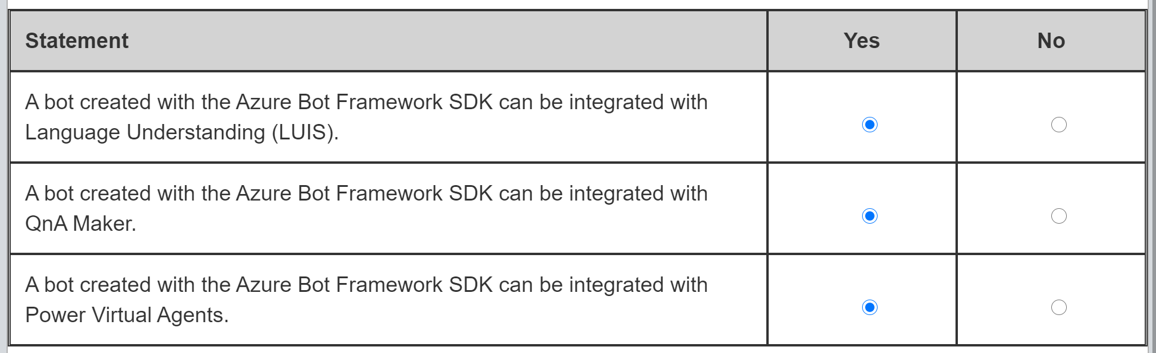

A bot created with the Azure Bot Framework SDK can be integrated with LUIS. You can add LUIS to your bot when you create the bot, or add LUIS later. You use the Dispatch tool to route messages from the bot to LUIS.  
  
A bot created with the Azure Bot Framework SDK can be integrated with QnA Maker knowledge bases. You use the Dispatch tool to route messages from the bot to QnA Maker. Your bot can choose which has the best response for the user.  
  
A bot created with the Azure Bot Framework SDK can be integrated with bots created using Power Virtual Agents. You use the Dispatch tool to configure your bot to work with a Power Virtual Agent bot.  
  
**References**  
  
[What is the Bot Framework SDK?](https://docs.microsoft.com/azure/bot-service/bot-service-overview-introduction)  
  
[Use Cognitive Services with natural language processing (NLP) to enrich bot conversations](https://docs.microsoft.com/azure/cognitive-services/qnamaker/choose-natural-language-processing-service)  
  
[Use multiple LUIS and QnA models](https://docs.microsoft.com/azure/bot-service/bot-builder-tutorial-dispatch)  
  
[Use a Microsoft Bot Framework bot with Power Virtual Agents](https://docs.microsoft.com/power-virtual-agents/advanced-use-dispatcher)

### Question 146: For each of the following statements about the QnA Maker knowledge base, select Yes if the statement is true. Otherwise, select No.

|  |  |  |
| --- | --- | --- |
| **Statement** | **Yes** | **No** |
| The QnA Maker app can only use one knowledge base. |  |  |
| A knowledge base supports multiple languages. |  |  |
| A knowledge base consists of question and answer pairs. |  |  |

**Explanation**

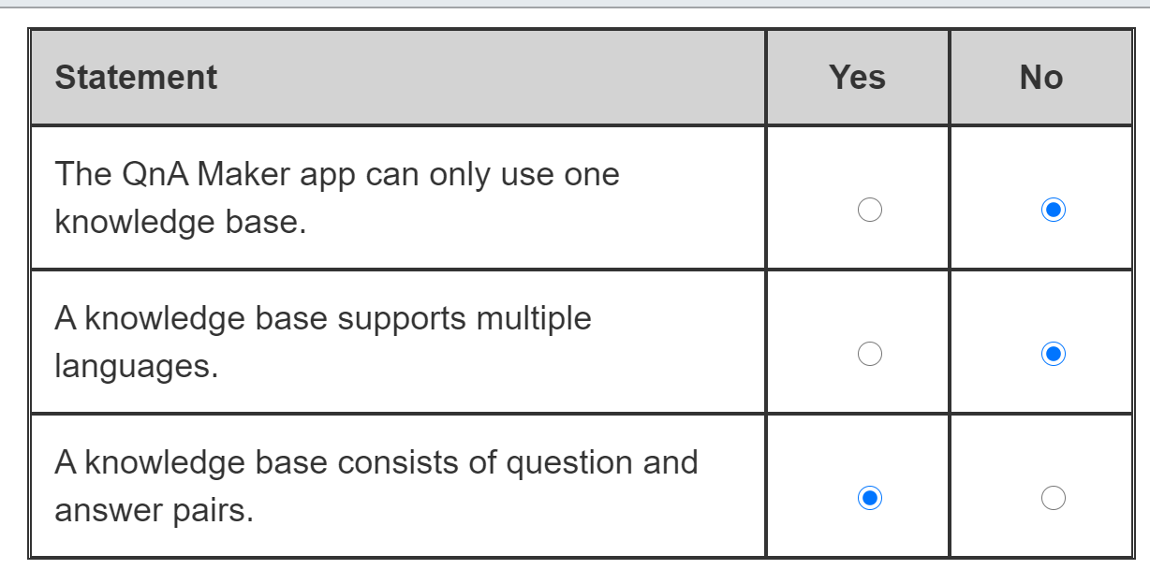

The QnA Maker app can use multiple knowledge bases. The total number of knowledge bases is determined by the pricing tier of the Azure Cognitive Search resource, that in turn will define the number of supported indexes**. Cognitive Search keeps one index as a test index, and the rest correlate to the number of published knowledge bases.**  
  
A knowledge base supports only one language. It is explicitly set at the creation of the first knowledge base and cannot be changed afterwards. If you require multilingual support for your content, you can either utilize the Translation Text service or create a separate QnA Maker resource and knowledge bases for each required language.  
  
A knowledge base consists of question and answer (QnA) pairs. Each pair has a question (text of user query) and an answer (response returned to the matched question). Optionally, each pair can also include an alternate form of the question, metadata to filter QnA pairs, and multi-turn prompts to enable a multi-turn conversation.  
  
**References**  
  
[Plan your QnA Maker app](https://docs.microsoft.com/en-us/azure/cognitive-services/QnAMaker/concepts/plan)  
  
[Design knowledge base for content language](https://docs.microsoft.com/en-us/azure/cognitive-services/QnAMaker/concepts/design-language-culture)  
  
[Question and answer pair concepts](https://docs.microsoft.com/en-us/azure/cognitive-services/QnAMaker/concepts/question-answer-set)

### Question 147: Match each Azure resource to a purpose. To answer, drag the appropriate Azure resource to each purpose within the QnA Maker app. An Azure resource may be used once, more than once, or not at all.

Drag and drop the answers





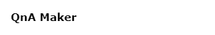









**Explanation**

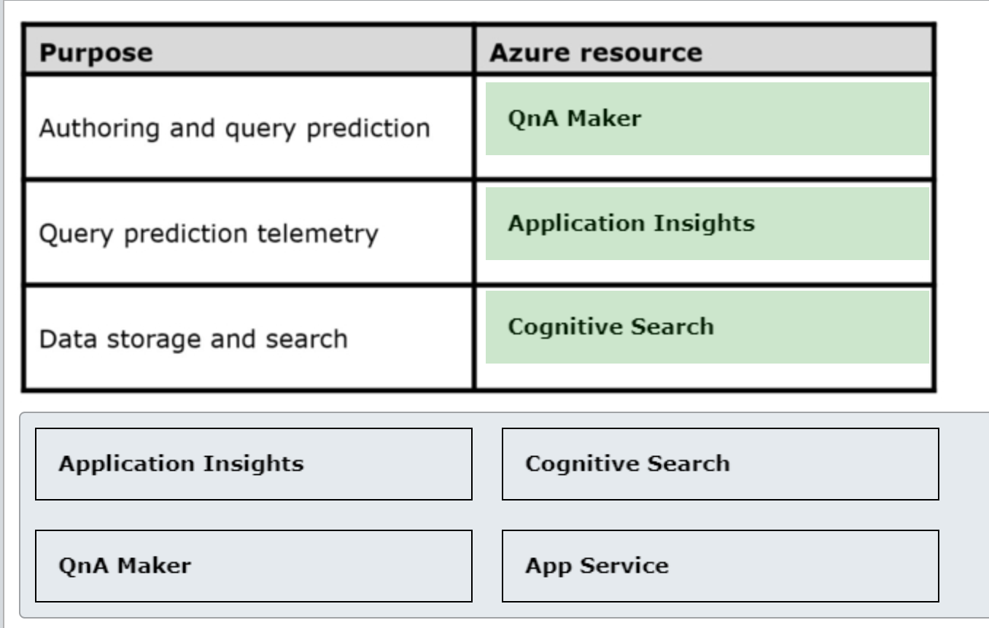

You should use QnA Maker for authoring and query prediction. It provides access to the authoring and publishing APIs of the QnA Maker service. It also uses natural language processing (NLP) capabilities to learn about specifics of questions in the knowledge base and predict at runtime which QnA pair matches as the best answer.  
  
You should use Application Insights for query prediction telemetry. Application Insights can collect chatbot’s logs and telemetry. It also includes powerful analytics tool to diagnose potential issues and process telemetry data with KQL (Kusto Query Language).  
  
You should use Cognitive Search for data storage and search. Cognitive Search stores the QnA pairs and maintains indexes for all published knowledge bases. When a new query is raised by QnA Maker resource, Cognitive Service handles its execution to provide rich search experience.  
  
You should not use App Service for any of the listed purposes. App Service enables access to the published knowledge bases of QnA Maker service via runtime query prediction endpoints.  
  
**References**  
  
[Plan your QnA Maker app](https://docs.microsoft.com/en-us/azure/cognitive-services/QnAMaker/concepts/plan)  
  
[Azure resources for QnA Maker](https://docs.microsoft.com/en-us/azure/cognitive-services/QnAMaker/concepts/azure-resources)

### Question 148: Which two Azure cognitive services should you combine so that your chatbot can determine user’s intentions and find answers from a custom knowledge base? Each correct answer presents part of the solution.

Choose the correct answers

QnA Maker

Language Understanding Intelligence Service (LUIS)

Text Translator

Speaker Recognition

Form Recognizer

**Explanation**

You should combine the functionality of QnA Maker and LUIS so that your chatbot can determine user’s intentions and find answers from a custom knowledge base. QnA Maker uses a knowledge base with the question and answer (QnA) pairs to answer chatbot user's questions. LUIS can further complement QnA Maker capability to process texts received by chatbot and determine user’s intention.  
  
You should not use Form Recognizer, Speaker Recognition or Text Translator. Form Recognizer can identify and extract key/value pairs and table data from a form document, for example an invoice. Speaker recognition can identify and verify speakers. Text Translator enables text-to-text multilingual translation. However, none of these cognitive services can enrich your chatbot’s functionality to determine user’s intentions or find the answers from a custom knowledge base.  
  
**References**  
  
[Use Cognitive Services with natural language processing (NLP) to enrich bot conversations](https://docs.microsoft.com/en-us/azure/cognitive-services/QnAMaker/choose-natural-language-processing-service)  
  
[What is Form Recognizer?](https://docs.microsoft.com/en-us/azure/cognitive-services/form-recognizer/overview)  
  
[What is Speaker Recognition?](https://docs.microsoft.com/en-us/azure/cognitive-services/speech-service/speaker-recognition-overview)  
  
[What is the Translator service?](https://docs.microsoft.com/en-us/azure/cognitive-services/translator/translator-info-overview)

### Question 149: For each of the following statements about skills in the Bot Framework, select Yes if the statement is true. Otherwise, select No.

|  |  |  |
| --- | --- | --- |
| **Statement** | **Yes** | **No** |
| A skill is a bot. |  |  |
| A skill manifest is an XML file. |  |  |
| Users can interact with a root bot. |  |  |

**Explanation**

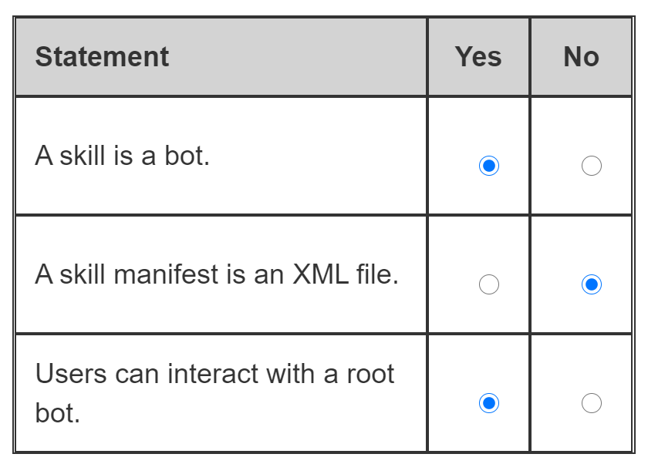

A skill is a bot. In the Bot Framework a skill is a bot that can extend the functionality of another bot by performing a set of tasks for it.  
  
A skill manifest is a JSON file, not an XML file. You use the skill manifest to describe what actions can be performed by the skill, what input parameters it expects, what output parameters it returns and what endpoints the skill can be accessed at.  
  
Users can interact with a root bot. A root bot is a user-facing bot that is also a skill consumer. This means that it can call other bots (skills) to delegate the execution of specific tasks or actions.  
  
**References**  
  
[Skills overview](https://docs.microsoft.com/en-us/azure/bot-service/skills-conceptual?view=azure-bot-service-4.0)  
  
[About skill bots](https://docs.microsoft.com/en-us/azure/bot-service/skills-about-skill-bots?view=azure-bot-service-4.0)  
  
[About skill consumers](https://docs.microsoft.com/en-us/azure/bot-service/skills-about-skill-consumers?view=azure-bot-service-4.0)

 Previous

### Question 150: Which channel is automatically configured for a bot that was created with the Framework Bot Service?

Choose the correct answer

Skype

Email

Microsoft Teams

Web Chat

**Explanation**

The Web Chat channel is automatically configured for a bot that was created with the Framework Bot Service. It allows your bot to communicate with users in a web page.  
  
Bot Framework supports bot integration with Office 365 email through the Email channel. Bots can be manually configured to access specific email accounts and get notifications when new emails arrive. You can then design the business logic to respond to the new emails accordingly.  
  
A bot can be manually configured to use Microsoft Teams. It allows your bot to be part of the teams, personal and group chat conversations.  
  
A bot can also be manually configured to use Skype. Skype users can then interact with your bot through the Skype interface.  
  
**References**  
  
[Connect a bot to Web Chat](https://docs.microsoft.com/en-us/azure/bot-service/bot-service-channel-connect-webchat?view=azure-bot-service-4.0)  
  
[Connect a bot to Office 365 email](https://docs.microsoft.com/en-us/azure/bot-service/bot-service-channel-connect-email?view=azure-bot-service-4.0)  
  
[Connect a bot to Microsoft Teams](https://docs.microsoft.com/en-us/azure/bot-service/channel-connect-teams?view=azure-bot-service-4.0)  
  
[Connect a bot to Skype](https://docs.microsoft.com/en-us/azure/bot-service/bot-service-channel-connect-skype?view=azure-bot-service-4.0)

 Previous

### Question 151: For each of the following statements about Bot Framework Composer, select Yes if the statement is true. Otherwise, select No.

|  |  |  |
| --- | --- | --- |
| **Statement** | **Yes** | **No** |
| Composer is an open source solution. |  |  |
| Composer is a command line program. |  |  |
| Composer can publish bots to Azure Web App and Azure Functions. |  |  |

**Explanation**

Composer is an open source solution. It is available for download as a desktop application for Windows, Linux or MacOS. Alternatively, Bot Framework Composer can be manually built from the source code available on the public GitHub repository.  
  
Composer is not a command line program. It is a visual authoring tool, which allows bots development in a graphical user interface (GUI).  
  
Composer can publish bots to Azure Web App and Azure Functions. It includes the required scripts and libraries to enable integration with the Azure environment. Bot Framework Composer supports the provisioning of new azure webapp and azure function instances, as well as the deployment to the existing Azure resources.  
  
**References**  
  
[Introduction to Bot Framework Composer](https://docs.microsoft.com/en-us/composer/introduction)  
  
[Install Bot Framework Composer](https://docs.microsoft.com/en-us/composer/setup-yarn)  
  
[Create your first bot](https://docs.microsoft.com/en-us/composer/quickstart-create-bot)  
  
[Publish a bot](https://docs.microsoft.com/en-us/composer/how-to-publish-bot)